**KURUNAGALA MOTORS MANAGEMENT INFORMATION SYSTEM**

Yasasiri MGRP

E1947056

Faculty of Information Technology

University of Moratuwa

Sri Lanka

August - 2022

**KURUNAGALA MOTORS MANAGEMENT INFORMATION SYSTEM**

Yasasiri MGRP

E1947056

Dissertation submitted to the Faculty of Information Technology, University of

Moratuwa, Sri Lanka in partial fulfillment of the requirements of the Degree of Bachelor

of Information Technology (External) in Information Technology

Augest-2022

# Declaration, copyright statement and statement of supervisor

This report, to the best of my knowledge and belief, does not contain any previously published or written by another person material, except where the acknowledgement is made in the text. I hereby declare that this is my own work and that no material previously submitted for a degree or diploma in any other university or institution of higher learning has been included without acknowledgment. Additionally, I hereby grant University of Moratuwa the non-exclusive right to reproduce and disseminate my report in whole or in part on paper, electronically, or through any other means. I reserve the right to incorporate this material, in whole or in part, into my future works.

Signature:  Date: 2022/08/12

Supervised by

Name of the Supervisor: Mr. Wiraj Wickramaarachchi

Signature of the Supervisor:………….. Date: ………..

# 

# Abstract

It is very difficult to manage motorcycle service places using manual these days. Garage manager and employee are facing a number of problems because of this. Provide high quality service to protect employee jobs and retain customers due to current problems in the country. But under the current system, there are certain issues that Kurunegala Motors Corporation is having. Accurate information regarding the volume of labor performed by the staff is difficult to come by. That information will help pay salaries and see the progress of the employees. Consumers may miss out on charging for motorcycles that are not paid in full. This is why the company is at losses. Lack of update information on spare parts store. Missing out on re-ordering until spares last. It is difficult to find information about services provided later. This is why it's hard to get information about the service when customers return.

Through the Kurunagala Motors Management system, it is hope to make the Kurunagala Motors garage fully operational and efficient and to make the motorcycle garage a fully covered system. Kurunagala Motors Management system is hoped that the current financial, reporting and stock manage will be done through a computerized system. Motorcycle service, engine repair, reconditioning, spare parts and fiber and paints like separate five duties are added together through this system. If the parts are low in stock, manager can view it. A job card is linked for each service or repair. It include information about used for the job and the employee, parts. Given bonuses on merit to employees based a service repair.

Employees’ enrolled under three roles. Transport and health allowance added. Employees can get salary loan. In addition to paying the full amount and taking the bill, customers can also pay a portion and pay the balance later. Offering pending services to regular customers. Notify the customers who provided the email address by email after the service is start, completed and pending payments. Customers can view service details online and view spare parts. Display information related to charts. It facilitates comparison with past details. Being able to see past the services related to the bike. Ability to obtain reports, notification emails and search details.

# Acknowledgement

I would like to express my sincere appreciation to all those who provided me the possibility to carrying the project work and completing this report. A special gratitude I offer towards my final year project supervisor, Mr Wiraj Wicramaarachchi, whom will guide me throughout the project development in contribution of stimulating suggestions and encouragement, to coordinate the work successfully especially in writing this report.

I am highly indebted to CODL of University of Moratuwa for their guidance and constant supervision as well as for providing necessary information regarding the project & their support in each and every phase of project developing cycle to be professionals in the IT field. As well as many thanks go to the Mr. Wiraj Wicramaarachchi the module coordinator for project in course module, whom gave his full effort in guiding us in achieving the goal. I have to appreciate the guidance given by other evaluators in the panels of evaluation for their comment and advices as especially I had adapt my project according to their comments and my supervisor's advice.

Last by not least I would like to express my gratitude towards my parents & friends for their kind support and encouragement which help me in the past procedures of this project.

# Table of content

Declaration, copyright statement and statement of supervisor i

Acknowledgement ii

Abstract ii

Table of content iv

LIST OF FIGURE vii

LIST OF TABLE ix

LIST OF ABBREVIATION x

LIST OF APPENDIX xi

Chapter 1 - Introduction 1

1.1.Introduction 1

1.2.Problem statement 1

1.3.Motivation and Significance of Project 2

1.4.Aims and Objectives 3

1.5 Project Beneficiaries 3

1.6 Scope of the project 4

1.7 Approach used in carrying out the project 4

1.8 Assumptions on work based 5

1.9 Summary 5

Chapter 2 - Background 6

2.1 Introduction 6

2.2 The wider context of the project 6

2.3 Problem that has been identified 6

2.4 Stakeholders in the problem area 7

2.4.1 Manager 7

2.4.2 Cashier 8

2.4.3 Customer 8

2.5 Constraints on the approach to be adopted 8

2.6 Existing solutions relevant to the problem area 8

2.7 Summary 10

Chapter 3 - Specification & Design 11

3.1. Introduction 11

3.2. Data types 11

3.3 Tools 11

3.4. Programming language 11

3.6. Dynamic Behavior of the System 12

3.6.1. Manager Functions 12

3.6.2. Cashier Functions 13

3.6.3. Customer Functions 14

3.7. Non-Functional Requirement 15

3.7.1. Performance Requirements 15

3.7.2. Safety Requirements 15

3.7.3. Security Requirement 15

3.7.4. Software Quality Attributes 15

3.8. Architecture of the system 16

3.9. er diagram 17

3.10 Class diagram 18

3.11 use case diagram 19

3.12. Summary 35

Chapter 4 - Implementation 36

4.1. Introduction 36

4.2. Problems during implementations 36

4.2.1. Software component and tasks 36

4.2.2. Database Component 37

4.2.3. Hardware Component 37

4.3. Code Segment 37

4.3.1. Database Connection 37

4.3.2. Database Implementation 38

4.4 Summery 44

Chapter 5 - Results and Evaluation 44

5.1. Introduction 44

5.2. Plan of Evaluation 44

5.3. Testing Methods 44

5.4. Black Box Testing 44

5.5 White Box Testing 45

5.6 Test plan and Test cases 45

5.6.1. System Login module 45

5.6.2. New user register 46

5.6.3 Create new service-repair 47

5.6.4 Add new employee 47

5.6.5. Add role 48

5.6.6. Add salary 49

5.6.7. Add leave 49

5.6.8. Add loan 50

5.6.9. Add attendance 51

5.6.10. Add allowance 51

5.7. Some User Interface in System 52

5.8. Summery 74

Chapter 6 - Conclusions 75

6.1 Introduction 75

6.2 Conclusion 75

6.3. Future Expandability 76

6.4. Summary 77

Reference 78

Appendix A – Activity diagram 79

Appendix B – DFD diagram 88

Appendix C – SRS 89

# LIST OF FIGURE

Figure 1: Er diagram 17

Figure 2: class diagram 18

Figure 3 use case diagram 19

Figure 4: Database connection source code - .env file 37

Figure 5: Database tables 38

Figure 6: New User Registration source code 38

Figure 7: Give allowance source code 39

Figure 8: Mark attendance source code 39

Figure 9: add brand source code 40

Figure 10: Contact form source code 40

Figure 11: Customer source code 41

Figure 12: Customer Vehicle register source code 41

Figure 13: Add employee source code 42

Figure 14: service repair source code 42

Figure 15: Good new received source code 43

Figure 16: employee leave source code 43

Figure 17: login page interface 52

Figure 18: register page interface 53

Figure 19: Cashier dashboard interface 53

Figure 20: Manager Dashboard interface 54

Figure 21: Home page 54

Figure 22: Add user page interface 55

Figure 23: Customer bike register interface 55

Figure 24: Customer pending service interface 56

Figure 25: Customer pending payment interface 56

Figure 26: Add service interface 57

Figure 27: Job - service interface 57

Figure 28: Used products for job interface 58

Figure 29: Service-repair page interface 59

Figure 30: Complete job page interface 59

Figure 31: Add role interface 60

Figure 32: Employee page interface 60

Figure 33: Employee salary interface 61

Figure 34: Employee leave interface 61

Figure 35: Employee loan interface 62

Figure 36: Employee performance interface 62

Figure 37: Attendance interface 63

Figure 38: Allowance interface 63

Figure 39: Product interface 64

Figure 40: Bike model interface 65

Figure 41: Brand 65

Figure 42: Stock 66

Figure 43: Damage spare part interface 66

Figure 44: Recondition spare parts interface 67

Figure 45: Goods received new interface 67

Figure 46: Working days interface 68

Figure 47: Calendar interface 68

Figure 48: User profile 69

Figure 49: Password update interface 70

Figure 50: Contact-us form manager interface 70

Figure 51: Customer home page interface 71

Figure 52: Customer service repair details page 71

Figure 53: Customer bike register page 72

Figure 54: Customer pending service page interface 72

Figure 55: Customer product view interface 73

Figure 56: Contact us form 73

Figure 57: Add new employee activity diagram 79

Figure 58: Add pending service details 80

Figure 59: Add new product activity diagram 81

Figure 60: Add role activity diagram 82

Figure 61: Add service activity diagram 83

Figure 62: Calculate salary activity diagram 84

Figure 63: Add new user activity diagram 85

Figure 64: add service repair activity diagram 86

Figure 65: Add customer vehicle activity diagram 87

Figure 66: DFD diagram 88

Figure 67: Dfd diagram 27

Figure 68: Login page for proposed system 37

Figure 69: Register page for proposed system 37

Figure 70: Admin dashboard for proposed system 37

Figure 71: Cashier dashboard for proposed system 38

Figure 72: Customer dashboard for proposed system 38

Figure 73: Use case diagram 41

Figure 74: Class diagram 42

Figure 75: Add new employee activity diagram 43

Figure 76: Add new product activity diagram 44

Figure 77: Add role activity diagram 45

Figure 78: Add service activity diagram 46

Figure 79: Calculate salary activity diagram 47

Figure 80: Add new user activity diagram 48

Figure 81: add service repair activity diagram 49

Figure 82: Add customer vehicle activity diagram 50

Figure 83 Add pending service activity diagram 51

Figure 84 ER diagram 52

# LIST OF TABLE

Table 1: Critical evaluation of selected existing solution 9

Table 2: login use case description 20

Table 3: create user description 21

Table 4: Logout use case description 21

Table 5: Add employee use case description 22

Table 6: Add role use case description 22

Table 7: Calculate salary use case description 22

Table 8: Mark leave use case description 23

Table 9: Give loan use case description 23

Table 10: Mark attendance use case description 24

Table 11: give allowance use case description 24

Table 12: Add bike use case description 25

Table 13: Add product use case description 25

Table 14: Add Service use case description 26

Table 15: Add service repair use case description 26

Table 16: Calculate income use case description 26

Table 17: Add brand use case description 27

Table 18: Register customer use case description 27

Table 19: Register customer bike use case description 27

Table 20: Download (employee performance) report use case description 28

Table 21: Add pending service use case description 28

Table 22: Add stock use case description 29

Table 23: Damage spare part use case description 29

Table 24: Recondition spare part use case description 29

Table 25: Check employee performance use case description 29

Table 26: View spare parts use case description 30

Table 27: View damage product use case description 30

Table 28: View recondition product use case description 30

Table 29: View service use case description 31

Table 30: View goods received new product use case description 31

Table 31:View pending payment use case description 31

Table 32: Add goods received new product use case description 32

Table 33: View job details use case description 32

Table 34: Send email use case description 32

Table 35: View complete job use case description 33

Table 36: View used product for job use case description 33

Table 37: View service for job use case description 33

Table 38: Change profile use case description 33

Table 39: Use contact us form use case description 34

Table 40: Add working hour use case description 34

Table 41: View calendar use case description 34

Table 42: View pending service use case description 35

Table 43: View user bike details use case description 35

Table 44: View bike model use case description 35

Table 45: User login module test case 46

Table 46: Sign up new user test case test case 47

Table 47: Create new service repair test case 47

Table 48: Add new employee test case 48

Table 49: Add role test case 49

Table 50: Add salary test case 49

Table 51: Add leave test case 50

Table 52: Add loan test case 51

Table 53: Add attendance test case 51

Table 54: Add allowance test case 52

# LIST OF ABBREVIATION

|  |  |  |  |
| --- | --- | --- | --- |
| Abbreviations | | Description | |
| HTML | | Hypertext Markup Language | |
| SRS | | Software Requirement Specification | |
| CSS | | Cascading Style Sheet | |
| XAMPP | | Cross-platform/Apache/MySQL/PHP/Perl | |
| MYSQL | | My Structured Query Language | |
| PHP | | Hypertext Preprocessor | |
| RAM | | Random Access Memory | |
| GB | | Giga Byte | |
| LIST OF APPENDIX | **Description** | |  | |
| Appendix – A | Activity Diagrams | | 78 | |
| Appendix – B | DFD diagram | | 87 | |
| Appendix – C | SRS | | 88 | |

# Chapter 1 - Introduction

## Introduction

Kurunegala Motors garage is located in Galenbidunuwewa, Anuradhapura area. Currently that garage handles documents and information by manual system using papers. The garage which has only 12 employees. Main service types are fiber, paint, body wash, spare parts and repair. kurunagala motors is the Honda-powered marketing agency [3]. Handling all their documents and information by hand. They are looking to switch to a web-based system to improve efficiency and service levels.

The main objective of the project is to create a system that helps manage motorcycle garage services effective and efficient. The Manager can easily manage the garage. Calculate employee salary, give allowance, give loans can be done through the system and mark employee attendance, taking leaves, helps monitor performance of employees. Manager can add role and assign employee to a role. New customers and cashiers can also do registration, stock management etc. in stock management, manager can add, edit ,delete the products, bike models, brands, damage spare parts, recondition spare and goods received new. Some manager’s duties can be done by the cashier. Cashier can be performed through this system to provide service-repair and customer related duties. Providing necessary spare parts for services, registration of customers and motorcycles, add new service-repair and issuing relevant bills can be done through the system. Also cashier and manager can add customer next service, view complete jobs, customer messages via contact us form, view customer pending payment and send reminder emails. They can view the job calendar and change own profile.

Customer can also login to the system and get information about services, spare parts, and information about their key services through the system. Customer can be received emails. Consumer can search for spare parts and get information about working hours, product and brand and bike model online. Customer can view own pending service and payment details.

## Problem statement

Lot of motorcycles are used in Sri Lanka [1]. Garages are wide nationwide for service and maintenance for these motorcycles [2]. Most of the motorcycle garages are doing business covering day-to-day activities using account books. The price will be decided by collecting the spare parts and the employee cost. These are the major problems within existing manual management system.

* Time waste and inflexible data finding with paper work.
* No proper employee and customer history details.
* All calculations done by hand.
* Poor communication with customers.
* Complex to monitor service station works.

Kurunegala Motors is also a company capable of providing services for any type of motorcycle. They also handle all the documents manually. Kuruunagala motors faced lot of problems today

One of the current problems here is the difficulty of managing all the existing parts (fiber, paint, repair, stock) at once. Issue spare parts when only 10-15 motorcycles come to get serviced at once. Some of the spare parts are misplaced. It is difficult to get correct information about the amount of work done by an employee. That information will help pay salaries and see the progress of the employees. missed collecting employee loans. Management of used spare parts is not done properly. Lack of updated information on spare parts store Problems arise when re-ordering. It is difficult to get details about used spare parts for a service repair. It is difficult to find information about customer service history. This is the reason it's hard to get data about the service when customers return. Skipping a customer's pending payment is a huge loss.

Kurunegala Motor Company is not satisfied with the existing management systems. They need a system to manage the garage completely. Hoping to switch to a web based system to mitigate problems, improve efficiency and service levels. These problems solved through new system.

## Motivation and Significance of Project

The system will help manage the motorcycle garage completely. Cashiers will help prevent all duties from turning to the manager. Will make it easier for customers to access their services through this too. The system will help the manager calculate employees' salaries, give loans, mark attendance, mark leaves, enroll role and give allowances. Manage customer details, customer vehicles and view their service-repairs separately. View the money earned by an employee, view the spare parts used for a service-repair, will make it easier to view the progress in the services. Customers received notification emails regarding loans, service-repair start, end and next service. Able to download report about customer payments, income, employee’s performance, spare part used for a service, complete job and etc. Chart used to display some details.

Cashiers will be allowed to issue bills, register customers and motorcycles, issue spare parts for service. Allows customers to set up accounts and sign in the system. This will allow view spare parts, get information about next service, get details about pending payment (loan), and look at the service history and ongoing service-repair details. The new management system will be able to access a number of difficult services that are using today's garage management systems. This will make the garages and associated people able to do their job easily. The system will help provide effective services to any motorcycle service station.

## Aims and Objectives

Aim of the project is, to build a web based system that fully controls and monitors a motorbike garage through an effective and efficient information system.

The objectives of the project shown below.

* To design and develop efficient financial operations and analysis reports.
* To design and develop system for managing employees.
* To design and develop customer management system.
* To design and develop a system for managing motorcycle repair.
* To design and develop stock management system.

## 1.5 Project Beneficiaries

Kurunegala Motors Management Information System can access online 365 days of the year. Managing any motorcycle service station through this. Manager, cashier, customers are able to log into the system according to the privileges given. Unregistered users can view products, services working hours, use contact us form. Registered customer can view own details.

Beneficiaries for manager

* Reduce manual paper works
* Flexible of finding details like employee performance, use spare parts for a service-repair.
* Strong communication with customers. Manager can send emails to customers.
* Manager can manage employees easy. Mark attendance, give loan through system.
* Manage customer, bike, stock and service-repair details efficiently.
* easy to download reports
* Easy to calculate payment bill for service, employee salary.

Beneficiaries for cashier

* Strong communication with customers like send remind email.
* Reduce manual workload.
* Easy to manage service-repair and customer details.
* Issue payment bill through the system.
* Maintain profile details.
* View stock details via online.

Beneficiaries for customer

* Create and update profile
* View spare parts, brand, model and service detail via online
* Easy to view pending service, pending payment and own service history
* Reduce manual workload.
* Received email (start and complete service-repair/ pending payment/ pending service)

## 1.6 Scope of the project

The scope of this project is to develop an online motorbike service management information system. This offers a user-friendly interface and educates the user on all of the system's usefulness indications. This system's user-friendly interface makes it possible to understand all of the system's usability aspects. This system has three types of users. That's the manager, cashier and customer and employees cannot login to the system. Some of the key scopes can be explained here like this. Customers, motorcycles, service-repairs registered and keeping information. Providing information to customers through email messages. Letting customers take care of their information easily. Keeping up the working information of the employees. Planning to download records correctly. Management of spare parts properly. Interface creation can be shown for the information that needs to be received soon. Based on history, the system helps to perform service-repairs more efficiently. Cashier can only view stock details and cashier cannot edit, delete and create. Cashier cannot access to manage employee details.

## 1.7 Approach used in carrying out the project

The project management methodology employed in this case is the waterfall method. The Waterfall Approach was the first commonly used SDLC Model in software engineering to ensure project success. Here is how the system was created using this paradigm. First, the system was reviewed with the Motors Garage management in Kurunegala. Realized the facilities they expect through the system. Discussed the statues needed to solve the existing issues. Then planned how the system should be set. Interim report and SRS report preparation was done accordingly. Later after that stage was over the system began to adjust. Prototype was created for the system and then finished the system. Several investigations were conducted to ensure that each event is functioning. Once the system is given to the company, it should be updated.

## 1.8 Assumptions on work based

The system is designed to be user-friendly. Passwords will be validated by a role-based defensive mechanism, which will also guard against unwanted access. Before entering the system, however, we must make some assumptions. A notice about the customer's registration appears when he registers with the system. Also, when a new service repair is started, it will eventually send email messages. Also, customers will be notified by email if they have credit payments and their next service date has been notified. This is why the customer is assuming the correct email address in those situations. System in English medium requires knowledge to read and understand English. Problems can arise because there is no internet facility everywhere in the country.

## 1.9 Summary

In this chapter, information discussed the difficulties caused by accounting using book help, problems arising due to service information and difficulties of managing employees as well as customers. Manager, cashier, customers were focused on the benefits of the system. There were benefits like reducing documentation work, increasing accuracy due to the calculation system, and being able to easily access information to customers online. It was described that knowledge about technology and use of English was required when using the system. And it was obvious that the technology is still advanced to some problems.

# Chapter 2 - Background

## 2.1 Introduction

Information technology makes every job easier and faster. Many manual systems were used in the past, nowadays, It is attracting to computer-based systems, with the advances of information technology. Web-based management systems can get many benefits through this. Motorcycle service station can also have many benefits by using management systems. Garage currently offers services via log books and account books. Even though some companies used management systems, they are not able to fully cover the requirements of Kurunegala motor garage. You can do customers registering, issuing bills, registering services etc. But those systems cannot make payments, employee progress separate considerations, customer affairs. Found this information in my literature review. The system helps garage manager manage employees, services management, storage management, customers. This system will help you easily solve problems caused by failures, avoidance in service supply. Employee payments, used spare parts monitoring, facilitating to monitor all services done. The system helps customers get information about their services, learn about spare parts.

## 2.2 The wider context of the project

The system will help manage the motorcycle garage completely. Cashiers will help prevent all duties from turning to the manager. Will make it easier for customers to access their services through this too. The system will help the manager calculate employees' salaries and give allowance, manage customers and identify their services separately. View the money earned by the employees, the spare stocks used, will make it easier to track the progress in the services. Customers will be issued email notifications regarding cash charges and upcoming services. Able to download information about customer payments, income, employees work performance, spare parts used etc. as reports.

Data like service-repair gives opportunity to compare with previous data. Cashiers will be allowed to issue bills, register customers and motorcycles, and manage spare parts. Allows customers to set up accounts and sign in the system. This will allow spare parts monitoring, get information about next service, get information about pending payment, and look at the service history. The new management system will be able to access a number of difficult services that are using today's garage management systems. This will make the garages and associated men able to do their job easily. The system will help provide effective services to any motorcycle service station.

## 2.3 Problem that has been identified

Lot of motorcycles are used in Sri Lanka [1]. Currently imports of vehicles are stopped but motorcycles are largely running in the country. Garages are wide nationwide for service and maintenance for these motorcycles [2]. Most of the motorcycle garages are doing business covering day-to-day expenses. Using account books for that. The price will be decided by collecting the spare parts and the employees cost. Some more garage management systems use. This includes information about spare stock sales. Able to manage customers, bill management and stock management through the current garage management systems in Sri Lanka. Kurunegala Motors is also a company capable of providing services for any type of motorcycle. They also handle all the documents today by hand. Garage Management System or Managing Repair Shopping System is a web based app to manage a garage. Garage management makes easy through this website.

This helps buy garage estimates, parts and cars. Hoping to switch to a computer based system to mitigate problems, improve efficiency and service levels. One of the current problems here,

* Difficulty to manage the existing five aspects at once. Giving out spare parts when only 10 motorcycles come to get services at once. Lots of spare parts being resigned.
* Missed customer pending payment is a huge loss.
* No update on spare parts. Problems arise when re-ordering.
* Cannot view employee daily work performance.
* Salary and loan payments problems.
* Missing customer pending payments
* All calculations done by hand.
* Poor communication with customers.

These problems should be solved through the new system. Kurunegala Motor Company is not satisfied with these existing management information systems. They need a system to manage the garage completely. Hoping to switch to a computer based system to mitigate problems, improve efficiency and service levels.

## 2.4 Stakeholders in the problem area

It was decided to create an information management system for Kurunegala Motors garage to resolve these problems. This web app has some key user roles. Garage Manager, Cashier and Customers are that interface too. Those users can implement the following tasks. The proposed computer-based system was developed to avoid flaws faced with the traditional way.

### 2.4.1 Manager

The manager can add, update and delete roles and employee details. Manager can add, update, and delete employee salary, give allowance and loans details. Also manager can mark leave and attendance. Manager can view employee performance, used spare parts for service, daily services and customer pending services. The manager can add, update, and delete product, brand and bike model details. Also manager can register customer and bike, add services, add service-repair, and send e-mails to customer. The manager can add stock product, damage parts, recondition parts, goods received new. The manager can add working hours, change user profile and view contact form messages.

### 2.4.2 Cashier

The cashier can register customer and customer bike. Added pending service and view pending payment and send emails. The cashier can add service-repair and issue bills, view used spare parts for service and view daily services. Cashier can view contact us form and update profile.

### 2.4.3 Customer

Customers can view own bike register details, next service and payment details. Customer can change profile details. Customer can view own service-repair details, used products for service and complete job details. Also customer can view product, brand and bike model details. Customer can use contact us form to message to garage. Customer received emails after service repair create, complete service repair and pending payment reminder.

## 2.5 Constraints on the approach to be adopted

There are many constraints faced while approaching this project.

* Had to learn new technologies, which suitable for this type of project.
* Had to invest lots of time to gather data regarding similar systems, before actually implement it

## 2.6 Existing solutions relevant to the problem area

These systems enable customers to get registration, vehicle registration, employee registration, records. But a garage isn't fully covered by it. Also no particular support for motorcycle garages [7]. The proposed new system has been designed for the operations of a motorcycle garage. Here explains some of the existing systems. Meanwhile csoftlanka service station management system is an example [6]. This management system can provide vehicle registration, employee management, service management, records and bills printing. But only the manager can access this system. The problem is that customers cannot login to the system. Bill payments are not recorded.

As another example, KB mogul vehicle management system can be explained. Service registration, in addition to issuing bills, several service places are affiliated. Helping manage employees. But there is no method to monitor spare parts taken into a service or monitor the progress of employees. Weaknesses are the inability to note the salary payments of employees, taking employee leave. Lanka broadband network can be described as another example of garage management system. The system contains information about the vehicles that are used by the company. Here it can manage fuel usage, driver deployment, vehicle passage routes. Reporting, Management of employees, Interface with employees is useful. But being able to manage only vehicles in the company and inability to manage spare parts through this system is weaknesses. Some more such examples are described in the below table 1 [8].

Table 1: Critical evaluation of selected existing solution

|  |  |  |
| --- | --- | --- |
|  | Pros | Cons |
| CSoftlanka | * vehicle, brand, model register * stock and inventory management * Generate reports | * customers cannot join * not specific support for motorbikes * only admin dashboard |
| KB mogul | * manage customer ,employee * manage income * preparing billing summery * Manage stock. | * employee can issue bill * cannot calculate employee performance * No spare part limits |
| Virus garage management system | * admin, customer mechanic login * records and salary management * car management * customer management | * support for cars * no email notification system * cannot calculate employee performance |
| Auto miraj | * View service details * Reports * Online appointment | * Cannot manage employees * Only service details |
| LBN system | * vehicle and fuel manage * Add employee groups * Store details about vehicle | * Only manage company vehicles * Cannot manage spare parts * Supervisors and manager can login |

Some new functions of these systems have been included in the Kurunegala Motors Management system. Meanwhile, allowing customers to pay a part of the bill and pay the rest later is one of the elements. Factors include salary payments of employees, employee leave take offs, deductions of monthly loans, able to record attendance, emailing a customer. Noted customer next service and send remind email.

## 2.7 **Summary**

We discussed the existing systems in use and its deficiencies. Also here we discussed the specifications between the parties and the system belonging to the system, what are their key functional in the system. if manager or cashier missed update record book or account book , that data missing. Observed issues with existing systems like lack of interface for customers, lack of special support for motorcycles, inability to monitor employee progress. Also, problems in Kurunegala Motors garage were observed as problems like payments of employees, taking leave, taking loans, difficulty of managing information, losses due to consumers avoiding loan payments and difficulty of getting past information. Avoiding these inconvenience leads to the need to create a new management system. Accordingly, the Kurunegala information system managing Motors will be created.

# Chapter 3 - Specification & Design

## 3.1. Introduction

This chapter discusses the information system of Kurunegala Motors Managing, including the technologies used for the growth of the system.

This chapter contains the reasons to choose those technologies among other technologies due to the importance of understanding the appropriate technologies. This chapter contains the advantages and disadvantages of used technologies, reasons for different from other technologies.

For system implementation in the server, MySQL, PHP (Laravel), and Apache are used. HTTP is the server protocol used by XAMPP-Apache Service Contributor. The back-end of this project is made using PHP (Laravel). As front-end languages, CSS, JavaScript, and boostrap frames are employed. A "WINDOWS" environment was used for the development. Use the Text Editor for Visual Studio Code here. Additionally, it safeguards the project's code base by using Github as a version control platform.

## 3.2. Data types

Primary key, foreign key used int data type. String data type is used for email, address, details. Customer table email, address can be shown for example. Date time and timestamps data types have been used to show dates and times of tables such as attendance. Service repair, income tables like charge, fix price, amount decimal data type has been used to show value.

## 3.3 Tools

To create the codes in this case, use the Visual Studio Code Text Editor. A highly powerful code editor is Visual Studio Code. The editor runs on the programming desktop and is only compatible with Windows. It includes running time and built-in support for JS as well as various languages including C++, C#, Java, Python, PHP, and Go. I'm an artist. My software system serves as a planning tool for standardizing the growth of my software system. I once used it. It's the most widely used browser-based programming tools both end-user apps and open source software. Due to the modular design and selection of multi-shaped packages available for various demands, UML, ER, and network pictures. This version of Apache Xampp is a straightforward, lightweight one that makes things incredibly easy for developers. A web server application setup kit contains everything a programmer needs. The Apache Web Server is designed to allow Web servers to serve one or more HTTP-based websites.

## 3.4. Programming language

## Laravel framework should be used here. Due to the fact that it is a published web application framework with many great syntaxes. The framework and basis for building a particular application is supplied by the web frame. As required for users to access and utilize the system effectively and efficiently, HTML was employed in this project. Designing web pages with user-friendly interfaces is made much easier with HTML. In this project, the colors, layout, and fonts of Web pages were defined using the CSS language. JavaScript is a part of web pages that, in this project, enables client-side script to interact with the user and generate dynamic pages. Both HTML5 and CSS3 were enabled by Bootstrap's coding.

## 3.6. Dynamic Behavior of the System

Kurunegala Motors Management System includes key parts of services management, employee management, storage management, customer management. Each car contains several key components related to applications, outputs, and process. Some of them meet the needs of the management system that connects each other.

Customers can create accounts. If not the manager or the employer can create the customer accounts. Customers are able to access information about services, spares online. Information on the motorcycle repairs, cash payments, next service available. Customers are notified by email messages once the motorcycle is registered, and after the service-repair is start and end, pending payment remind. The manager can assist after registering in the system. Work can be done like customer registration, customer motorcycle registration, next service registration, repair service registration, issuing bills, issuing spare parts etc. Manager can do all activities like employee payments, offers, loans payments, spare shares to the system, motorcycle registration, customer registration email messages etc.

### 3.6.1. Manager Functions

* Add employee – add personal details , ID number, basic salary and assign a role
* Add role – create, edit and delete roles
* Create employee salary – salary create using leave, loan, allowance and job amount
* Add employee leave – need to select employee, leave type and dates
* Give employee loan – need to select employee name and add loan amount, description
* View employee performance – view service-repairs done by employees.
* Mark employee attendance – need to add employee name, start and end time.
* add product – select brand name, model name and add code, spare part name
* Add bike model – need to add brand name, code, name, description.
* Add brand – add name, code, description. Slug auto filed.
* Give allowance – need to add employee name, allowance type, price and description
* User registration – add name, email, identity card number, contact number and password.
* Motorbike registration. – select customer, brand, model and give bike register number
* Add pending service – select next service and send reminder
* View pending payment – view half payment service-repairs
* View job details – view complete and not complete details
* Add service – Add code, name, price and description of service
* View service for job – service details done for a service repair
* View product for a job – product details used for a service repair
* Add service-repair – assign employee, service, add customer, issue bill.
* View complete job – view service repair complete and payment complete jobs
* Add stock details – Add damage spare part, recondition spare part and goods received new.
* View calendar – view service-repair details in the calendar
* Change profile details – update password and personal details.
* Add working hours – add day, start and end time.
* View contact form – view users messages.
* Download report – generate pdf, excel and print reports.
* Search details – search details using id number, name, code and etc.
* Send email – when, service repair start, pending payment and repair complete,

### 3.6.2. Cashier Functions

* + Customer registration – add name, email, identity card number, contact number and password
  + Motorbike registration. – select customer, brand, model and give bike register number
  + Add pending service – select next service and send reminder
  + View pending payment – view half payment service-repairs
  + View job details – view complete and not complete details
  + View service – view code, name, price and description of service
  + View service for job – service details done for a service repair
  + View product for a job – product details used for a service repair
  + Add service-repair – assign employee, service, add customer, issue bill and send email.
  + View complete job – view service repair complete and payment complete jobs
  + View stock details – view damage spare part, recondition spare part and goods received new.
  + View calendar – view service-repair details in the calendar
  + Change profile details – update password and personal details.
  + View contact form – view users messages.
* Send email – when, service repair start, pending payment and repair complete,
* Download report – generate pdf, excel and print reports.
* Search details – search details using id number, name, code and etc.

### 3.6.3. Customer Functions

* view service – view code, name, price and description of service
* View own bike details – view customer id number, name, bike brand, model, register number.
* view pending service – if customer register next service, he can view next service, reminder
* Pending payment – customer get bike without full payment. those job details display here
* Search details – search pending payment using job code, product using brand name
* view own service-repair details – view job code, service, used spare parts, prices
* view used product for service-repair – view job code, product name, start time and price
* View complete job – view job status with job code, id number, and service details.
* View product – View brand name, model name and add code, spare part name
* View bike model – View to add brand name, code, name, description.
* View brand – View name, code, description.
* view working hours – view garage open days and time
* Fill contact us form – fill name email, phone, message and send it

## 3.7. Non-Functional Requirement

### 3.7.1. Performance Requirements

### The acceptable response time for system functionality has been described by performance requirements. The load time for user interface screens must be lower than two seconds. This system needs to be able to support at least three concurrent users. Some users have administrative privileges, while others only have limited access. The system is simple for using. To obtain entry, the user must input their own email address and password. Within five seconds, the login information must be validated. Reduce the period of time that employees and customers waste. The garage service repair details are able to handle their system without wasting time. This performance contributes to an increase in service repairs.

### 3.7.2. Safety Requirements

The details must be properly maintained. Database backups must be maintained. The recovery method restores an old version of the database that was backed up to archival storage and reconstructs a more current state if there is substantial damage to a large percentage of the database due to catastrophic failure, such as an application crash. Reports can be downloaded by the cashier and manager.

### 3.7.3. Security Requirement

The Kurunagala motor management information system should be handled only by the garage manager. Only the manager has the right to assign permissions like managing employees, calculating employee salary, marking attendance, adding brand, adding bike model, adding service, and adding produce. The manager and cashier can register a user. Only authorized users can access the system with their email and password. Authorized customers can view their own service repair details, own bike register details, pending payment details, and pending service details. Unauthorized users can view only product details, brand or model details, and service details and can use the contact us form. User information needs to be safe and secure.

### 3.7.4. Software Quality Attributes

Availability: the Kurunagala motors management web based system shall be available to users all the time. This management system should be available for access from any location, with a computer and internet connection. This management system should be available for 24 hours and 365 days. There should be any time access for garage records.

Correctness: Kurunagala motors management information system should doing correct calculations in salary, service repair bill calculation. In manual process it take more hour to find employee service repair amount, allowance, loan details. Sometime very difficult to calculate employee salary amount. But using this management system make correct employee salary with correct employee details..

Efficiency: In manual process it take more hours to make different changes to the customers, so that garage staff and customer needs waste their time. The system should satisfy a maximum number of user’s needs. Using this management system customers and garage staff can get more advantages. And most important thing is manager and cashier can view the history of the customer quickly.

## Flexibility: The management information system for Kurunagala Motors should be able to accommodate the addition of new features and handle them with ease. The users of this system should find it simple and easy. A more complex system makes it harder for users to understand.

## 3.8. Architecture of the system

In this kurunagala motors management information system, there are two main component of the client server architecture as client and server. Client are the internal and external users of the system. Apache server work as the server of the system MySQL is used for database handling.

## 3.9. Er diagram

Er diagram display in figure 1.

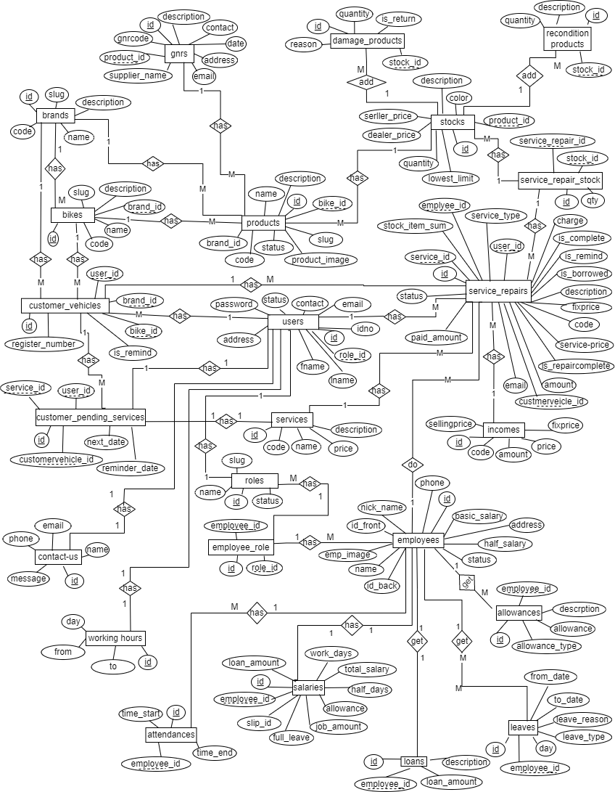

Figure 1: Er diagram

## 3.10 Class diagram

Class diagram display in below.

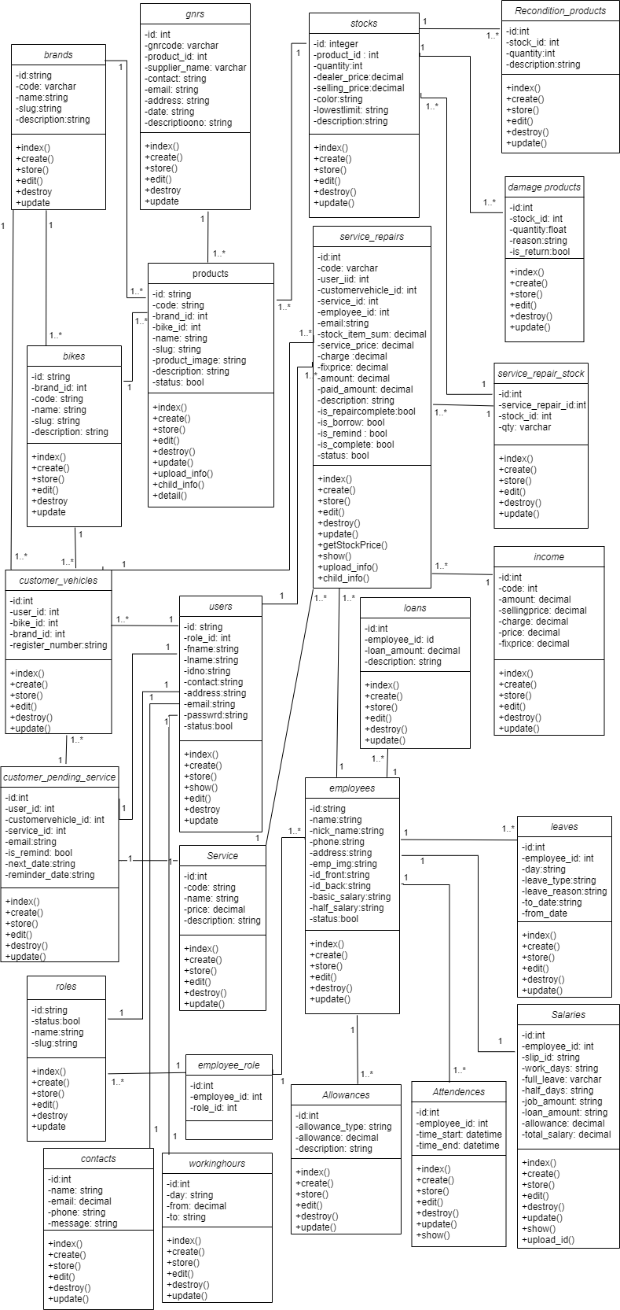

Figure 2: class diagram

## 3.11 use case diagram

Use case diagram display in figure 3.

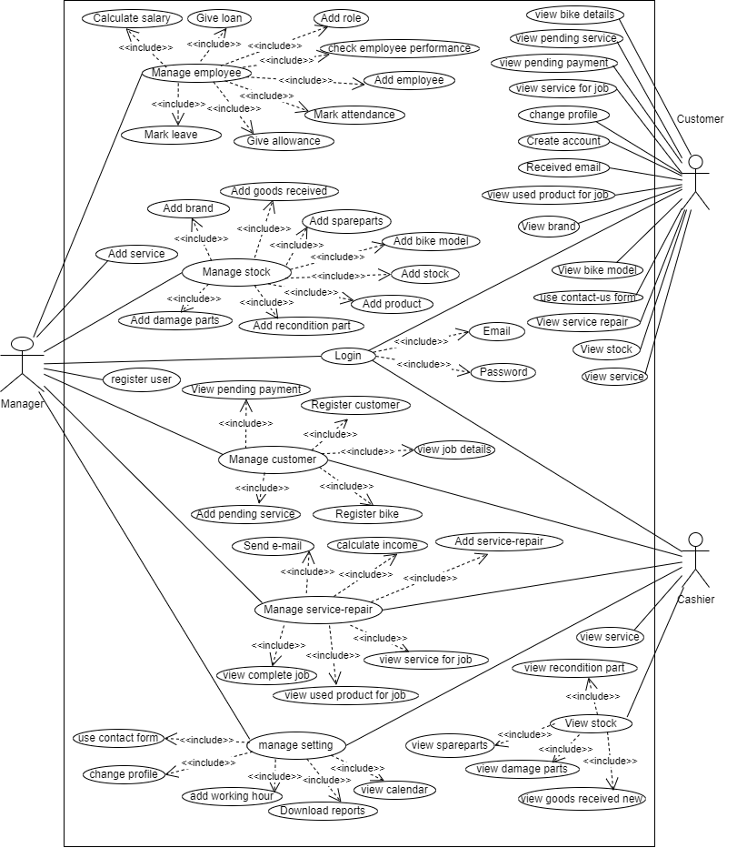

Figure 3 use case diagram

**Use case description**

These table presents the main use case description to show the interaction system users within the proposed system.

Login use case description display in table 2.

|  |  |
| --- | --- |
| Use case | Log in |
| Primary actor | Manager/ cashier/ customer |
| Goal in context | Enable user access to the system |
| Preconditions | User should open Login page. the user as valid email, password |
| Trigger | Click login button |
| scenario | 1)the user select login button  2)the user enter email  E.1: Sorry, These credentials do not match our records.  3)the user enter password  E.2: Sorry, These credentials do not match our records.  4)the user click “Log in” button |

Table 2: login use case description

Create profile user case description display in table 3.

|  |  |
| --- | --- |
| Use case | Create profile |
| Primary actor | Customer |
| Goal in context | User get permission to access to the system |
| Preconditions | User should open Sign in page |
| Trigger | Click sign in button |
| Scenario | 1. The user enter sign in button 2. the user enter first name   E1: The first name field is required.   1. the user enter last name   E2: The last name field is required.   1. the user enter ID number   E3: The ID field is required.   1. the user enter email   E4: the email already been taken   1. the user enter contact   E5: The contact field is required.   1. the user enter password   E6: The password field is required.   1. the user enter confirm password   E7: The confirm password field is required   1. the use click ‘Sign in’ button |

Table 3: create user description

Logout use case description display in table 4.

|  |  |
| --- | --- |
| Use case | Logout |
| Primary actor | Manager/ customer/ cashier |
| Goal in context | Disable user access to the system |
| Preconditions | User should click Logout page |
| Trigger | Click logout button |
| Scenario | 1)the use selects ‘logout’ button  2)the system disables access to user |

Table 4: Logout use case description

Add employee use case description display in table 5.

|  |  |
| --- | --- |
| Use case | Add employee |
| Primary actor | Manager |
| Goal in context | Add new employee |
| Preconditions | User should open employee page |
| Trigger | Click Add employee button |
| scenario | 1)the manager enter employee details  E.1: the name field is required.  E.2: the nick name field is required.  E3: The emp image field is required.  E4: the id front field is required  E5: the id back field is required.  E6: the phone field is required.  E7: the address field is required.  E8: the basic salary field is required  E9: the half salary field is required.  E10: the status field is required.  2)the user click “Save” button |

Table 5: Add employee use case description

Add role use case description display in table 6

|  |  |
| --- | --- |
| Use case | Add Role |
| Primary actor | Manager |
| Goal in context | Add new Role |
| Preconditions | User should open role page |
| Trigger | Click Add role button |
| scenario | 1)the user enter role name  E.1: the name field is required.  2)the user click “Save” button |
| exceptions | The user enters an invalid details |

Table 6: Add role use case description

Calculate salary use case description display in table 7

|  |  |
| --- | --- |
| Use case | Calculate salary |
| Primary actor | Manager |
| Goal in context | Add employee salary |
| Preconditions | User should open salary page |
| Trigger | Click Add salary button |
| scenario | 1. Select salary preparing month.   E1: please fill out this field  2) the manager select employee name  E2: Please enter the employee name!!!  3) the user click “Save” button |

Table 7: Calculate salary use case description

Mark leave use case description display in table 8.

|  |  |
| --- | --- |
| Use case | Mark leave |
| Primary actor | Manager |
| Goal in context | Add employee leave |
| Preconditions | User should open leave page |
| Trigger | Click Add leave button |
| scenario | 1. the manager select employee name   E1: Please enter the employee name!!!  2) the manager select leave type  E2: Please enter the leave type!!!  3) the manager enter from date  E3: Please enter the from date!!!  4) the manager enter to date  E4: Please enter to from date!!!  5) the user click “Save” button |

Table 8: Mark leave use case description

Give loan use case description display in table 9.

|  |  |
| --- | --- |
| Use case | Give loan |
| Primary actor | Manager |
| Goal in context | Give the loans to employee |
| Precondition | User should open loan page |
| Trigger | Click the loan button |
| Scenario | 1. the user select employee name   E1: Please enter the employee   1. the user enter loan amount   E2: Please enter loan amount   1. the user enter description |

Table 9: Give loan use case description

Mark attendance use case description display in table 10

|  |  |
| --- | --- |
| Use case | Mark attendance |
| Primary actor | Manager |
| Goal in context | Mark the attendance to employee |
| Precondition | User should open attendance page |
| Trigger | Click the attendance button |
| Scenario | 1. the user select employee name   E1: Please enter the employee   1. the user enter time start   E2: Please enter time start   1. the user enter time end   E2: Please enter time end |

Table 10: Mark attendance use case description

give allowance use case description display in table 11

|  |  |
| --- | --- |
| Use case | give allowance |
| Primary actor | Manager |
| Goal in context | give the allowance to employee |
| Precondition | User should open allowance page |
| Trigger | Click the allowance button |
| Scenario | 1. the user select employee name   E1: Please enter the employee   1. the user enter allowance   E2: Please enter allowance |

Table 11: give allowance use case description

Add bike use case description display in table 12

|  |  |
| --- | --- |
| Use case | Add bike model |
| Primary actor | Manager |
| Goal in context | Add the bike model |
| Precondition | User should open bike page |
| Trigger | Click the bike button |
| Scenario | 1. the user select brand name   E1: Please enter the name   1. the user enter code   E2: Please enter code   1. the user enter bike name   E3: Please enter name |

Table 12: Add bike use case description

Add product use case description display in table 13

|  |  |
| --- | --- |
| Use case | Add product |
| Primary actor | Manager |
| Goal in context | Add product |
| Precondition | User should open add product page |
| Trigger | Click the product button |
| Scenario | 1. the user select brand name   E1: The brand id field is required.   1. the user select bike id   E2: The bike id field is required.   1. the user enter code   E3: The code field is required.   1. the user enter product name   E4: The name field is required.   1. the user enter product image   E5: the product image is required   1. the use enter status   E6: the status field is required   1. the user enter ‘save’ button |

Table 13: Add product use case description

Add Service use case description display in table 14

|  |  |
| --- | --- |
| Use case | Add new service |
| Primary actor | Manager |
| Goal in context | Add new service |
| Preconditions | User should open service page |
| Trigger | Click Add new service button |
| scenario | 1)the manager enter service details  E1: Please Enter service Name  E2: The code field is required.  E3: The price field is required.  2)the user click “Save” button |

Table 14: Add Service use case description

Add service repair use case description display in table 15

|  |  |
| --- | --- |
| Use case | Add new service repair |
| Primary actor | Manager/ cashier |
| Goal in context | Add service repair |
| Preconditions | User should open service repair page |
| Trigger | Click Add service repair button |
| scenario | 1)the manager enter details  E1: Please enter the bike !!!  E2: Please enter the email !!!  2)the user click “Save” button |

Table 15: Add service repair use case description

Calculate income use case description display in table 16

|  |  |
| --- | --- |
| Use case | Calculate Income |
| Primary actor | Manager |
| Goal in context | Calculate income |
| Preconditions | User should open Income page |
| Trigger | Click Calculate income button |
| scenario | 1)the manager enter details  E1: the amount field is required  E2: the stock item sum field is required  E3: the charge field is required  E4: the price field is required  E5: the fix price field is required  2)the user click “Save” button |

Table 16: Calculate income use case description

Add brand use case description display in table 17

|  |  |
| --- | --- |
| Use case | Add new brand |
| Primary actor | Manager |
| Goal in context | Add new brand |
| Preconditions | User should open brand page |
| Trigger | Click Add new brand button |
| scenario | 1)the manager enter brand details  E.1: brand name empty.  2)the user click “Save” button |

Table 17: Add brand use case description

Register customer use case description display in table 18

|  |  |
| --- | --- |
| Use case | Add new customer |
| Primary actor | Manager / cashier |
| Goal in context | Register new user |
| Preconditions | User should open user page |
| Trigger | Click Add new user button |
| scenario | 1)the user enter customer details  E.1: Customer email used.  E.2: Enter invalid phone number.  2)the user click “Save” button |

Table 18: Register customer use case description

Register customer bike use case description display in table 19

|  |  |
| --- | --- |
| Use case | Add new customer bike |
| Primary actor | Manager / cashier |
| Goal in context | Register new customer vehicle |
| Preconditions | User should open customer vehicle page |
| Trigger | Click Add new customer vehicle button |
| scenario | 1)the user enter customer vehicle details  E1: The register number field is required.  E2: The bike id field is required.  2)the user click “Save” button |

Table 19: Register customer bike use case description

Download (employee performance) report use case description display in table 20

|  |  |
| --- | --- |
| Use case | Download reports - employee performance |
| Primary actor | Manager |
| Goal in context | Download employee performance report |
| Preconditions | User should open employee performance page |
| Trigger | Click pdf button |
| scenario | 1) the user click “pdf” button |

Table 20: Download (employee performance) report use case description

Add pending service use case description display in table 21

|  |  |
| --- | --- |
| Use case | Add customer pending service |
| Primary actor | Manager / cashier |
| Goal in context | Add pending service |
| Preconditions | User should open pending service page |
| Trigger | Click Add pending service button |
| scenario | 1. the user enter customer details   E.1: Please enter the customer vehicle!!!  E.2: Please enter the next date!!!  E.3: Please enter the email!!!  E.4: The reminder date required  2) the user click save button |

Table 21: Add pending service use case description

Add stock use case description display in table 22

|  |  |
| --- | --- |
| Use case | Add new stock |
| Primary actor | Manager |
| Goal in context | Add new stock loan |
| Preconditions | User should open stock page |
| Trigger | Click Add new stock button |
| scenario | 1)the user enter stock details  E1: The dealer price field is required.  E2: The quantity field is required.  E3: The selling price field is required.  E4: The lowest limit field is required.  2)the user click “Save” button |

Table 22: Add stock use case description

Damage spare part use case description display in table 23

|  |  |
| --- | --- |
| Use case | Add new damage spare part |
| Primary actor | Manager |
| Goal in context | Add new damage spare part |
| Preconditions | User should open damage spare part page |
| Trigger | Click Add new damage spare part button |
| scenario | 1)the user enter damage spare part details  E.1: the quantity field is required.  2)the user click “Save” button |

Table 23: Damage spare part use case description

Recondition spare part use case description display in table 24

|  |  |
| --- | --- |
| Use case | Add new Recondition spare part |
| Primary actor | Manager |
| Goal in context | Add new Recondition spare part |
| Preconditions | User should open Recondition spare part page |
| Trigger | Click Add new Recondition spare part button |
| scenario | 1)the user enter Recondition spare part details  E1: quantity required.  2)the user click “Save” button |

Table 24: Recondition spare part use case description

Check employee performance use case description display in table 25

|  |  |
| --- | --- |
| Use case | Check employee performance |
| Primary actor | Manager |
| Goal in context | Check employee performance |
| Preconditions | User should open employee performance |
| Trigger | Click employee performance button |
| scenario | 1) the user view employee performance |

Table 25: Check employee performance use case description

View spare parts (Stock) use case description display in table 26

|  |  |
| --- | --- |
| Use case | View spare part |
| Primary actor | customer/  cashier |
| Goal in context | View spare part |
| Preconditions | User should open stock page |
| Trigger | Click stock form button |
| scenario | 1) the user click “stock” button  2) the user views the spare part. |

Table 26: View spare parts use case description

View damage product use case description display in table 27

|  |  |
| --- | --- |
| Use case | View damage product |
| Primary actor | Cashier |
| Goal in context | View damage product |
| Preconditions | User should open damage product page |
| Trigger | Click damage product form button |
| scenario | 1) the user click “damage product” button  2) the user views the damaged product. |

Table 27: View damage product use case description

View recondition product use case description display in table 28

|  |  |
| --- | --- |
| Use case | View recondition product |
| Primary actor | Cashier |
| Goal in context | View recondition product |
| Preconditions | User should open recondition product page |
| Trigger | Click recondition product form button |
| scenario | 1) the user click “recondition product” button  2) the user views the recondition product. |

Table 28: View recondition product use case description

View service use case description display in table 29

|  |  |
| --- | --- |
| Use case | View service |
| Primary actor | Cashier, Customer |
| Goal in context | View service |
| Preconditions | User should open service page |
| Trigger | Click service form button |
| scenario | 1) the user click “service” button  2) The user views the service. |

Table 29: View service use case description

View goods received new product use case description display in table 30

|  |  |
| --- | --- |
| Use case | View goods received new product |
| Primary actor | Cashier |
| Goal in context | View goods received new product |
| Preconditions | User should open goods received new page |
| Trigger | Click goods received new form button |
| scenario | 1) the user click “goods received new” button  2) the user views the goods received new. |

Table 30: View goods received new product use case description

View pending payment use case description display in table 31

|  |  |
| --- | --- |
| Use case | View pending payment |
| Primary actor | Manager / cashier / customer |
| Goal in context | View pending payment |
| Preconditions | User should open pending payment page |
| Trigger | Click pending payment button |
| scenario | 1) the user click “pending payment” button  2) the user views the pending payment |

Table 31:View pending payment use case description

Add goods received new product use case description display in table 30

|  |  |
| --- | --- |
| Use case | Add goods received new product |
| Primary actor | Manager |
| Goal in context | Add goods received new product |
| Preconditions | User should open goods received new page |
| Trigger | Click Add goods received new button |
| scenario | 1)the user enter grn details  E1: quantity required.  E2: Please enter the supplier name!!!  E3: The contact field is required.  2)the user click “Save” button |

Table 32: Add goods received new product use case description

View job details use case description display in table 33

|  |  |
| --- | --- |
| Use case | View job details |
| Primary actor | Manager / cashier |
| Goal in context | View job details |
| Preconditions | User should open job details page |
| Trigger | Click job details button |
| scenario | 1) the user click “job details” button  2) the user views the job details |

Table 33: View job details use case description

Send email use case description display in table 34

|  |  |
| --- | --- |
| Use case | Send email – remind pending payment |
| Primary actor | Manager / cashier |
| Goal in context | Send email – remind pending payment |
| Preconditions | User should open service repair page |
| Trigger | Click not remind button |
| scenario | 1) the user click “not remind” button  2) the user views email send message |

Table 34: Send email use case description

View complete job use case description display in table 35

|  |  |
| --- | --- |
| Use case | View complete job |
| Primary actor | Manager / cashier |
| Goal in context | View complete job |
| Preconditions | User should open complete job page |
| Trigger | Click complete job button |
| scenario | 1) the user click “complete job” button  2) the user views the complete job |

Table 35: View complete job use case description

View used product for job use case description display in table 36

|  |  |
| --- | --- |
| Use case | View used product for job |
| Primary actor | Manager / cashier / Customer |
| Goal in context | View used product for job |
| Preconditions | User should open used product for job page |
| Trigger | Click used product for job button |
| scenario | 1) the user click “used product for job” button  2) the user views the used product for job |

Table 36: View used product for job use case description

View service for job use case description display in table 37

|  |  |
| --- | --- |
| Use case | View service for job |
| Primary actor | Manager / cashier / Customer |
| Goal in context | View service for job |
| Preconditions | User should open service for job page |
| Trigger | Click service for job button |
| scenario | 1) the user click “service for job” button  2) the user views the service for job |

Table 37: View service for job use case description

Change profile use case description display in table 38

|  |  |
| --- | --- |
| Use case | Change profile |
| Primary actor | Manager / cashier / Customer |
| Goal in context | Change profile |
| Preconditions | User should open user profile page |
| Trigger | Click Change profile button |
| scenario | 1) the user click “Change profile” button  2) the user click save button |

Table 38: Change profile use case description

Use contact us form use case description display in table 39

|  |  |
| --- | --- |
| Use case | use contact us form |
| Primary actor | Manager / cashier / Customer |
| Goal in context | use contact us form |
| Preconditions | User should goes to contact us form |
| Trigger | Click contact us form button |
| scenario | 1) the user click “contact us form” button  2) the user click save button |

Table 39: Use contact us form use case description

Add working hour use case description display in table 40

|  |  |
| --- | --- |
| Use case | Add working hour |
| Primary actor | Manager / cashier |
| Goal in context | Add working hour |
| Preconditions | User should open working hour page |
| Trigger | Click Add working hour button |
| scenario | 1)the user enter working hour details  E1: The day field is required.  E2: The from field is required.  E3: The to field is required.  2)the user click “Save” button |

Table 40: Add working hour use case description

View calendar use case description display in table 41

|  |  |
| --- | --- |
| Use case | View calendar |
| Primary actor | Manager / cashier |
| Goal in context | View calendar form |
| Preconditions | User should goes to view calendar |
| Trigger | Click view calendar form button |
| scenario | 1) the user click “calendar” button |

Table 41: View calendar use case description

View pending service use case description display in table 42

|  |  |
| --- | --- |
| Use case | View pending service |
| Primary actor | customer |
| Goal in context | View pending service |
| Preconditions | User should open pending service page |
| Trigger | Click pending service button |
| scenario | 1) the user click “more info” button  2) the user views the pending service |

Table 42: View pending service use case description

View user bike details use case description display in table 43

|  |  |
| --- | --- |
| Use case | View user bike details |
| Primary actor | customer |
| Goal in context | View user bike details |
| Preconditions | User should open user bike details page |
| Trigger | Click more info button |
| scenario | 1) the user click “more info” button  2) the user views the user bike details |

Table 43: View user bike details use case description

View bike model use case description display in table 44

|  |  |
| --- | --- |
| Use case | View bike model details |
| Primary actor | customer |
| Goal in context | View bike model |
| Preconditions | User should open bike model page |
| Trigger | Click more info button |
| scenario | 1) the user click “more info” button  2) the user views the bike model |

Table 44: View bike model use case description

## 3.12. Summary

This chapter is to provide a clear idea about the system planned to create according to the specifications and design shares required. What are the software tools that help in building Kurunegala Motors System, computer language, system owned dynamic behavior, architecture used to develop system, what are the images that helped to analyze rational issues and system planning Go got into this one. Here use ER, class, use case diagram and use case descriptions are describe the system

# Chapter 4 - Implementation

## 4.1. Introduction

This chapter focuses on implementation of system plans. Includes implementation of ideas and ideas developed earlier. This implementation describes the problems that arise and how they deal with them. Explains the software and hardware requirements of the system and include problems caused by the environment

## 4.2. Problems during implementations

This is a web app that allows users to have online access. Results from the management system are developed within the Windows environment, and the Apache server is used to develop the management system. And then this management system can be implemented. A single computer that allows simultaneously access. According to the above circumstances, difficulties arise during the implementation stage. These problems that are escaping system components can be divided into three key parts. Hardware, software, data

### 4.2.1. Software component and tasks

One of the main problems with the software component is the lack of knowledge and experience of the technologies used. Lack of basic knowledge of what devices are used as examples, what function they are used for, and how to use them. Lack of knowledge about languages used to implement the system is also a problem. The lack of knowledge about security machines is also a problem. So it takes some time to learn and implement them in the system. To provide an efficient and effective system to meet the non-functional needs.

* Reliability – the management system users trust the system.
* Modifiability - requirement concerning the effort needed to make changes in the software.
* Security – requirement of the assurance of the system and its data.
* Performance – requirements about response time and resource required.

Software requirement for effective and efficiency management system,

* Programming languages - PHP (laravel 5.8), HTML, CSS, jQuery, Ajax.
* Visual code use as a text editor
* Using GUI for interacting with software.
* A browser, HTML and JavaScript support.

### 4.2.2. Database Component

This management system will provide the necessary facilities to fully manage a motorcycle garage. Employee data, service data, store and customer data should be stored correctly. That data helps to get records through various tables. Data format planning is underway at this stage.

Database type: MySQL and Database name: motors

### 4.2.3. Hardware Component

The following dynamic requirements are used to implement this system. Planning this system doesn't require special scenes.

* Internet connection.
* Desktop computer or laptop.
* Processor i3 or above
* 2 GB RAM

## 4.3. Code Segment

### 4.3.1. Database Connection

Database connection file display in figure 4.

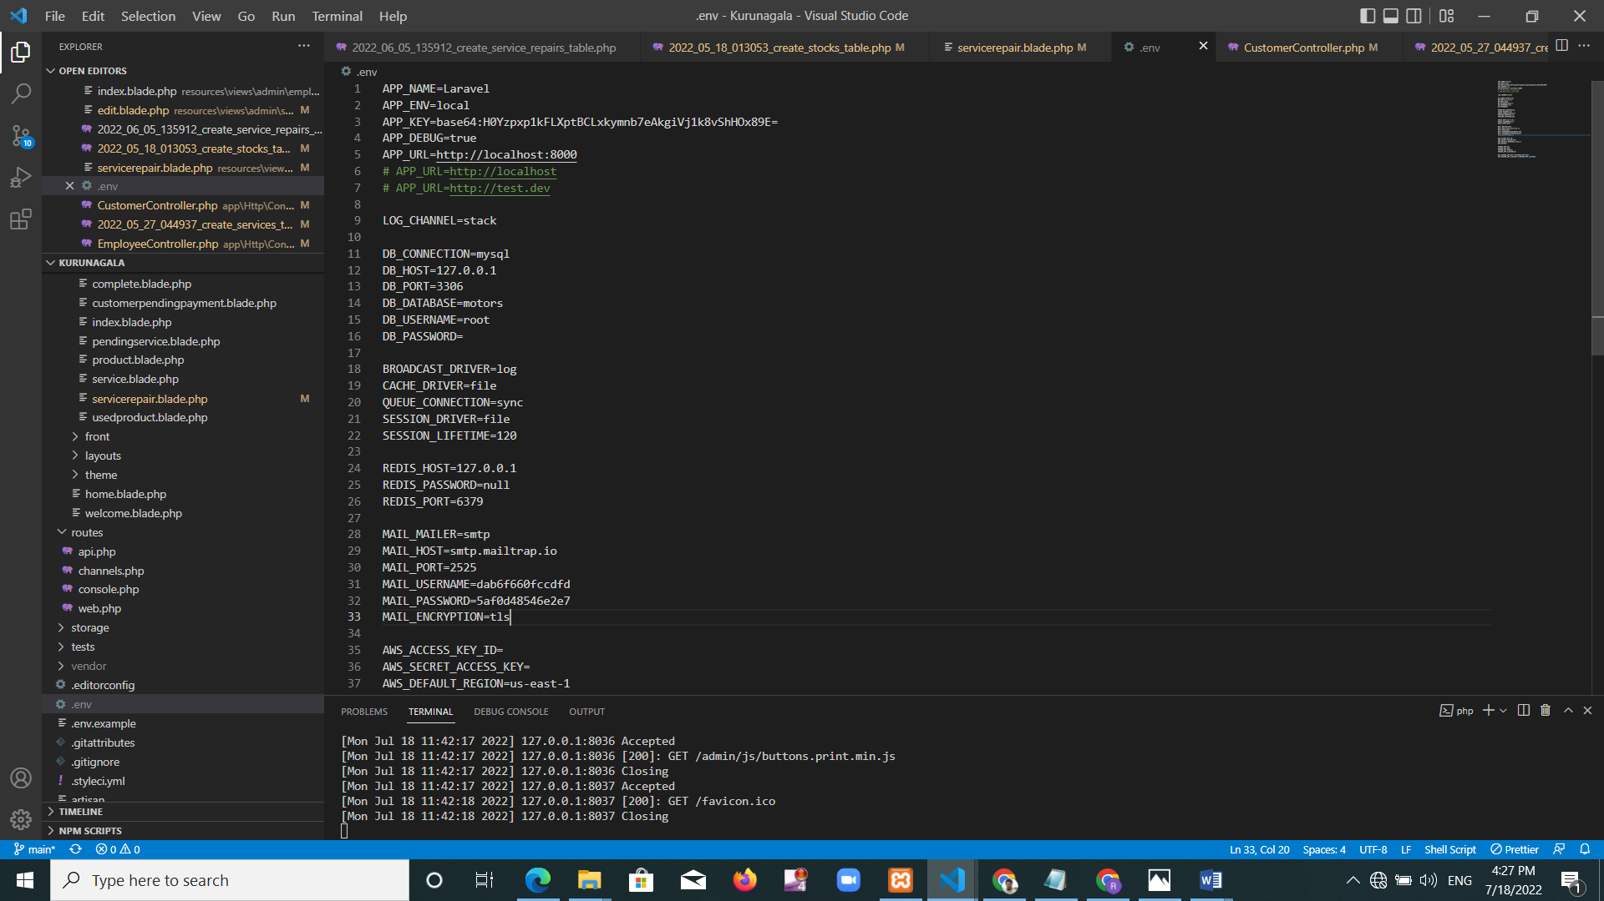

Figure 4: Database connection source code - .env file

### 4.3.2. Database Implementation

Database display in figure 5.

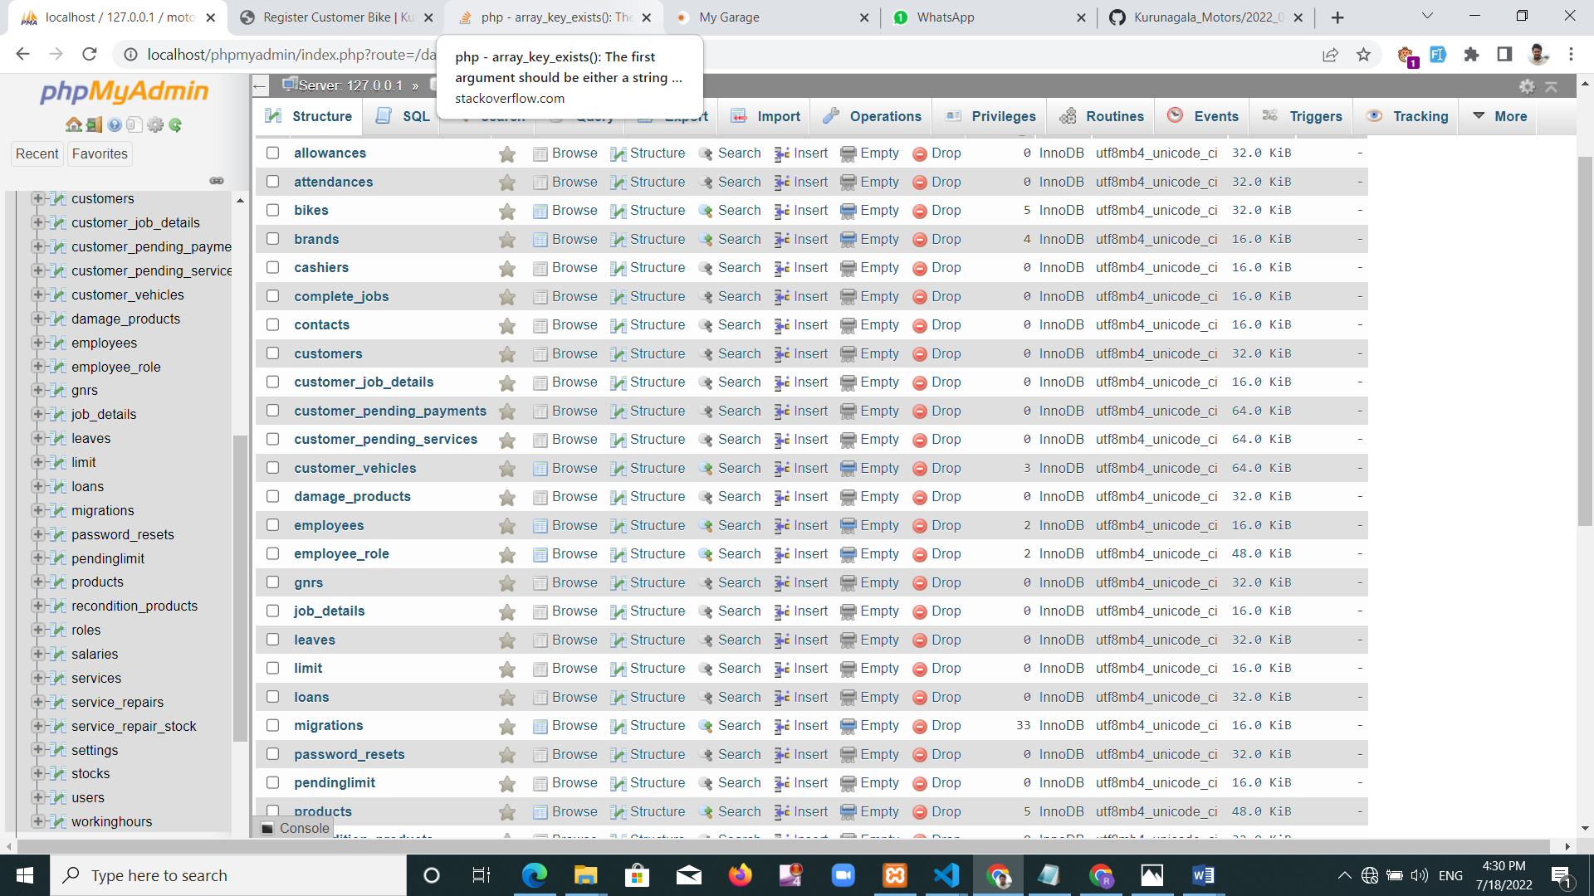

Figure 5: Database tables

4.3.3. New user registration

New user registration source code display in figure 6.

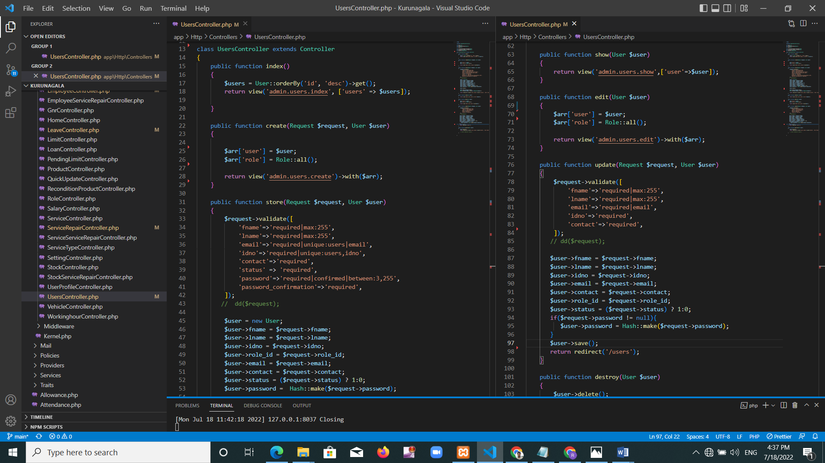

Figure 6: New User Registration source code

4.3.4. Give allowance source code

Give employee allowance source code display in figure 7.

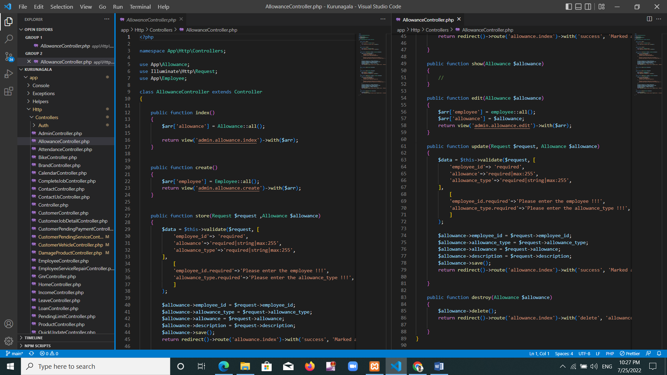

Figure 7: Give allowance source code

4.3.5. Mark employee attendance source code

Mark employee attendance source code display in figure 8.

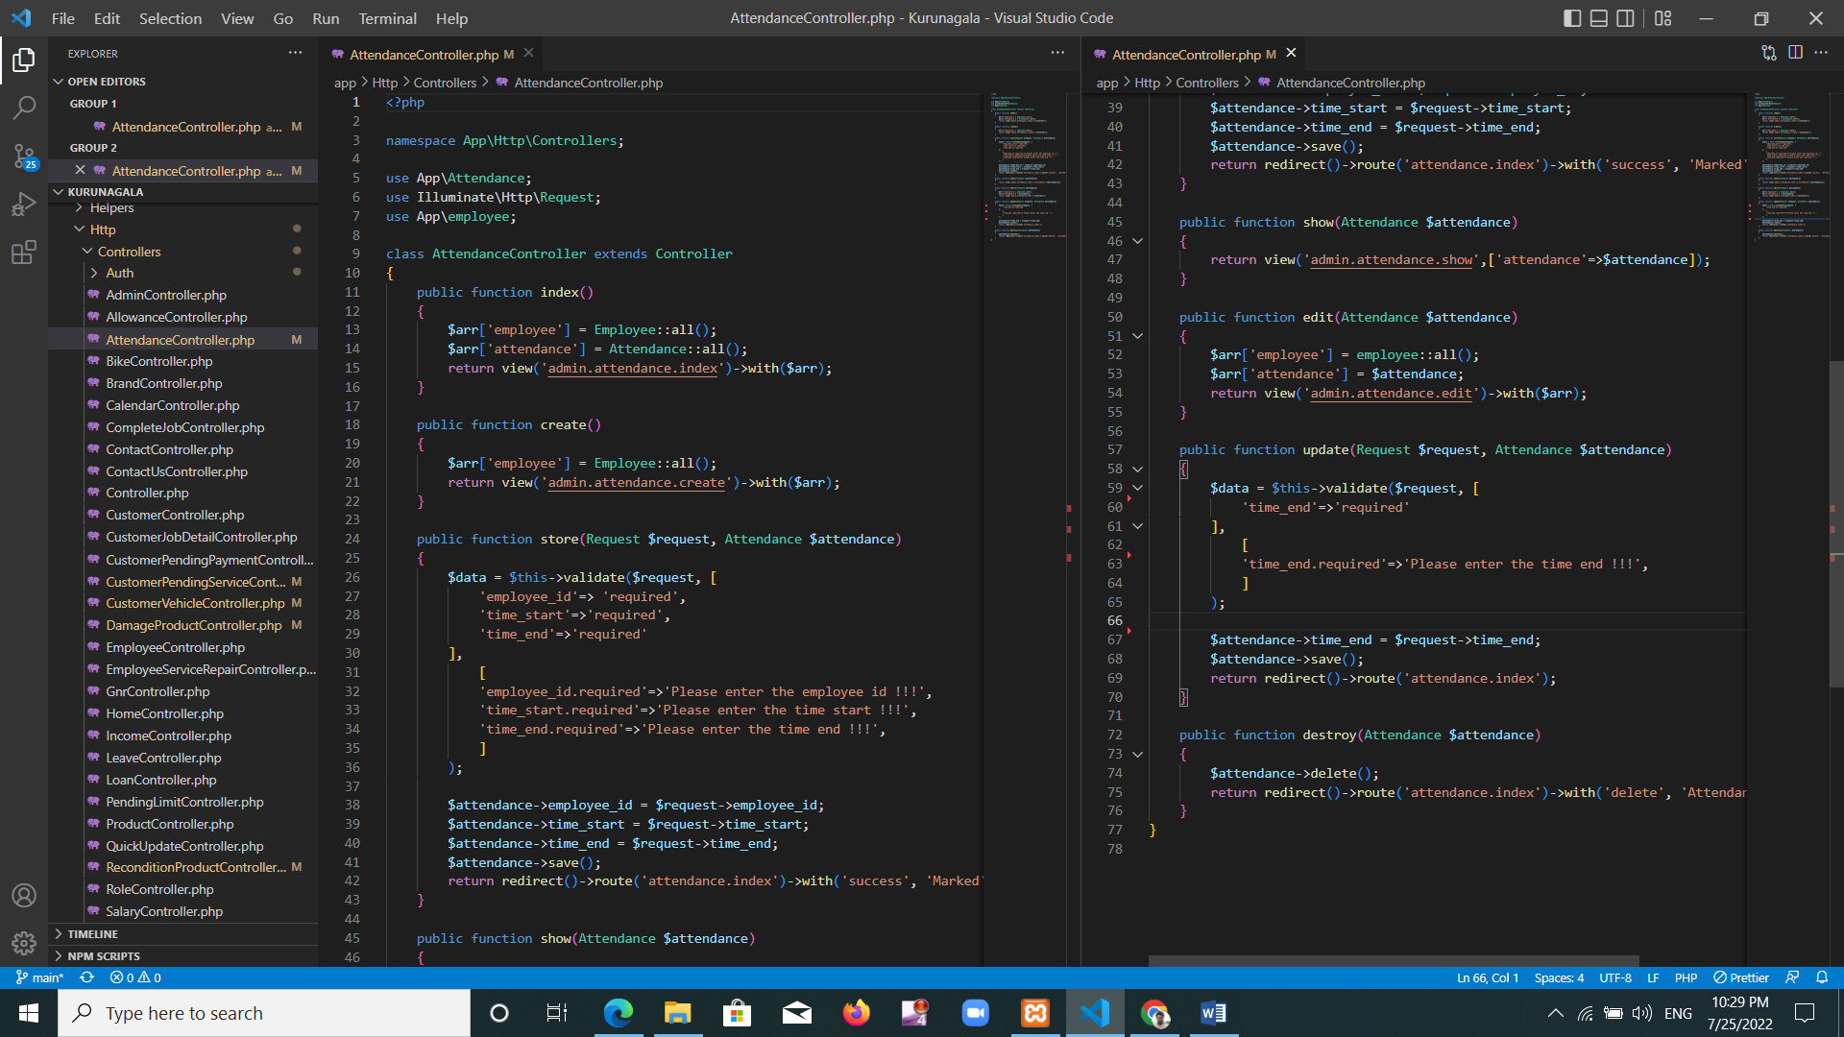

Figure 8: Mark attendance source code

4.3.6. Add brand

Add new brand source code display in figure 9.

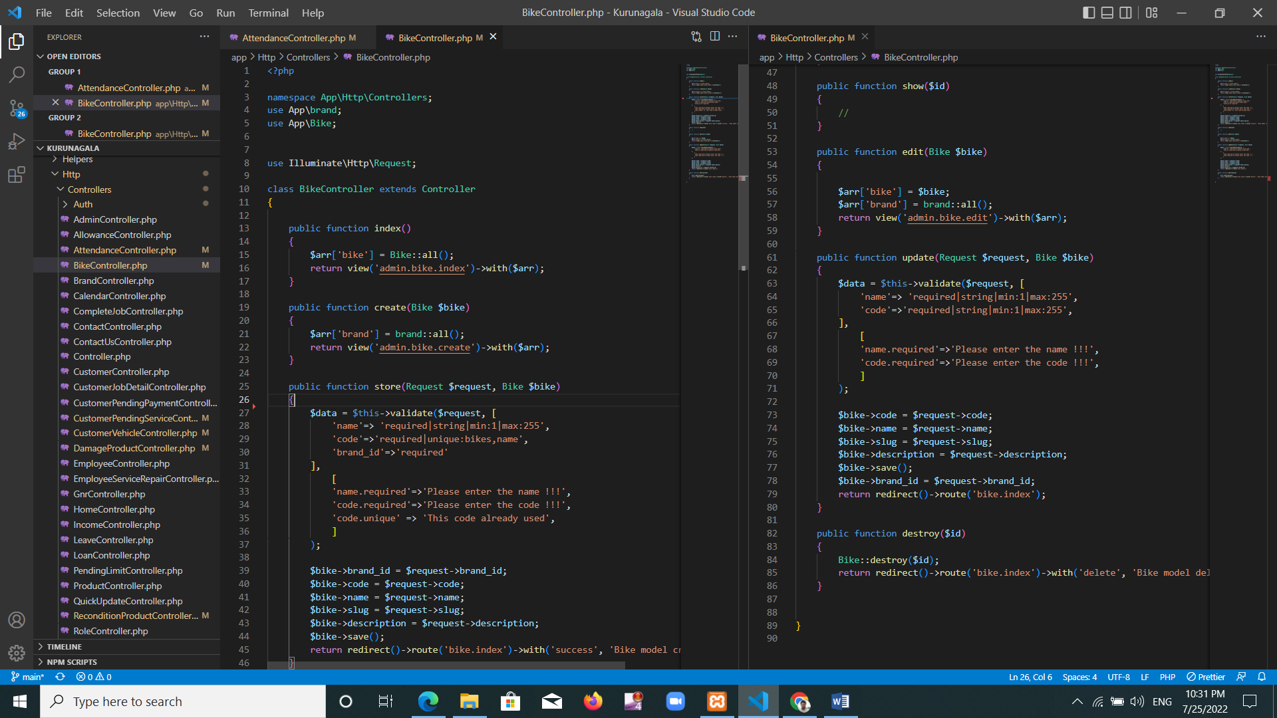

Figure 9: add brand source code

4.3.7. Contact us form

Contact us form source code display in figure 10.

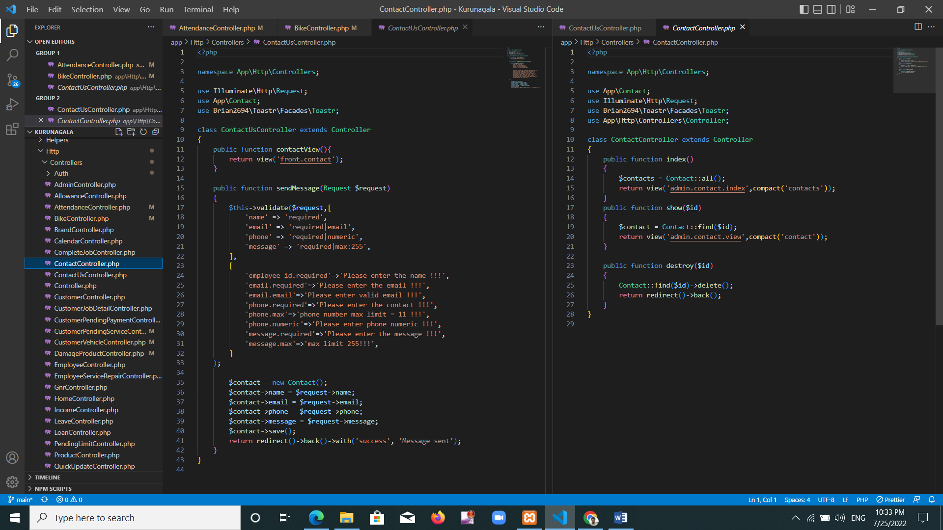

Figure 10: Contact form source code

4.3.8. Customer controller

Customer dashboard source code display in figure 11.

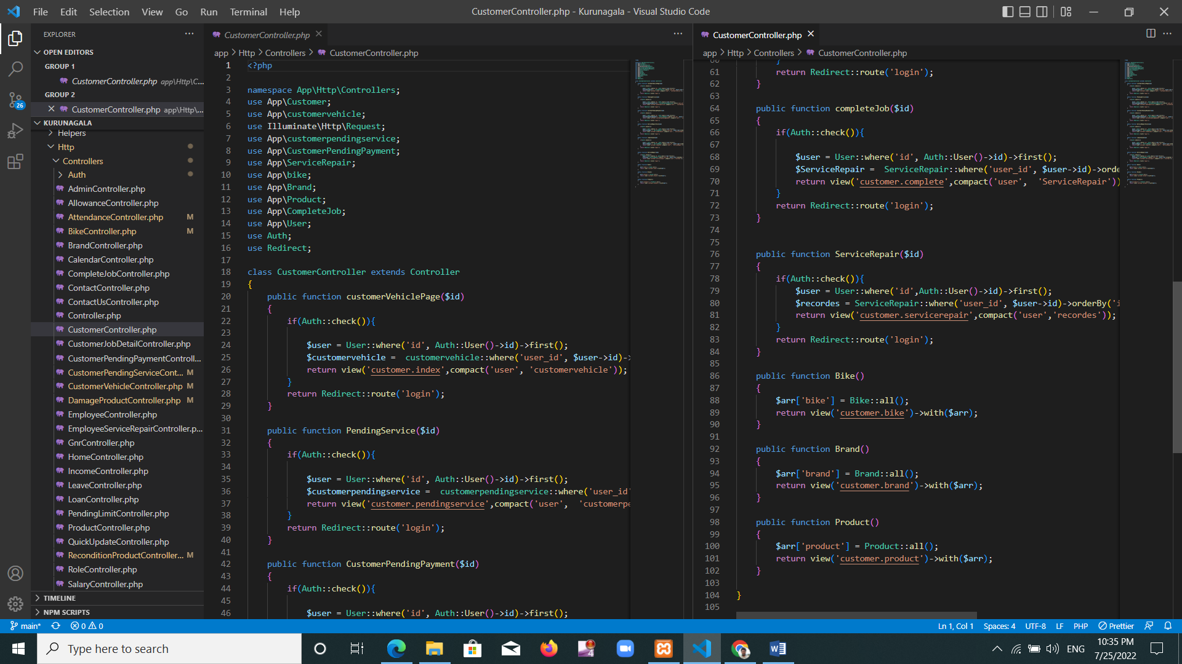

Figure 11: Customer source code

4.3.9. Customer vehicle Controller

New customer bike register source code display in figure 12.

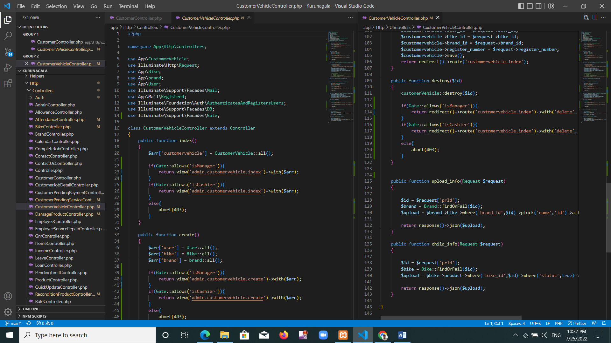

Figure 12: Customer Vehicle register source code

4.3.10. Employee Controller

Add new employee source code display in figure 13.

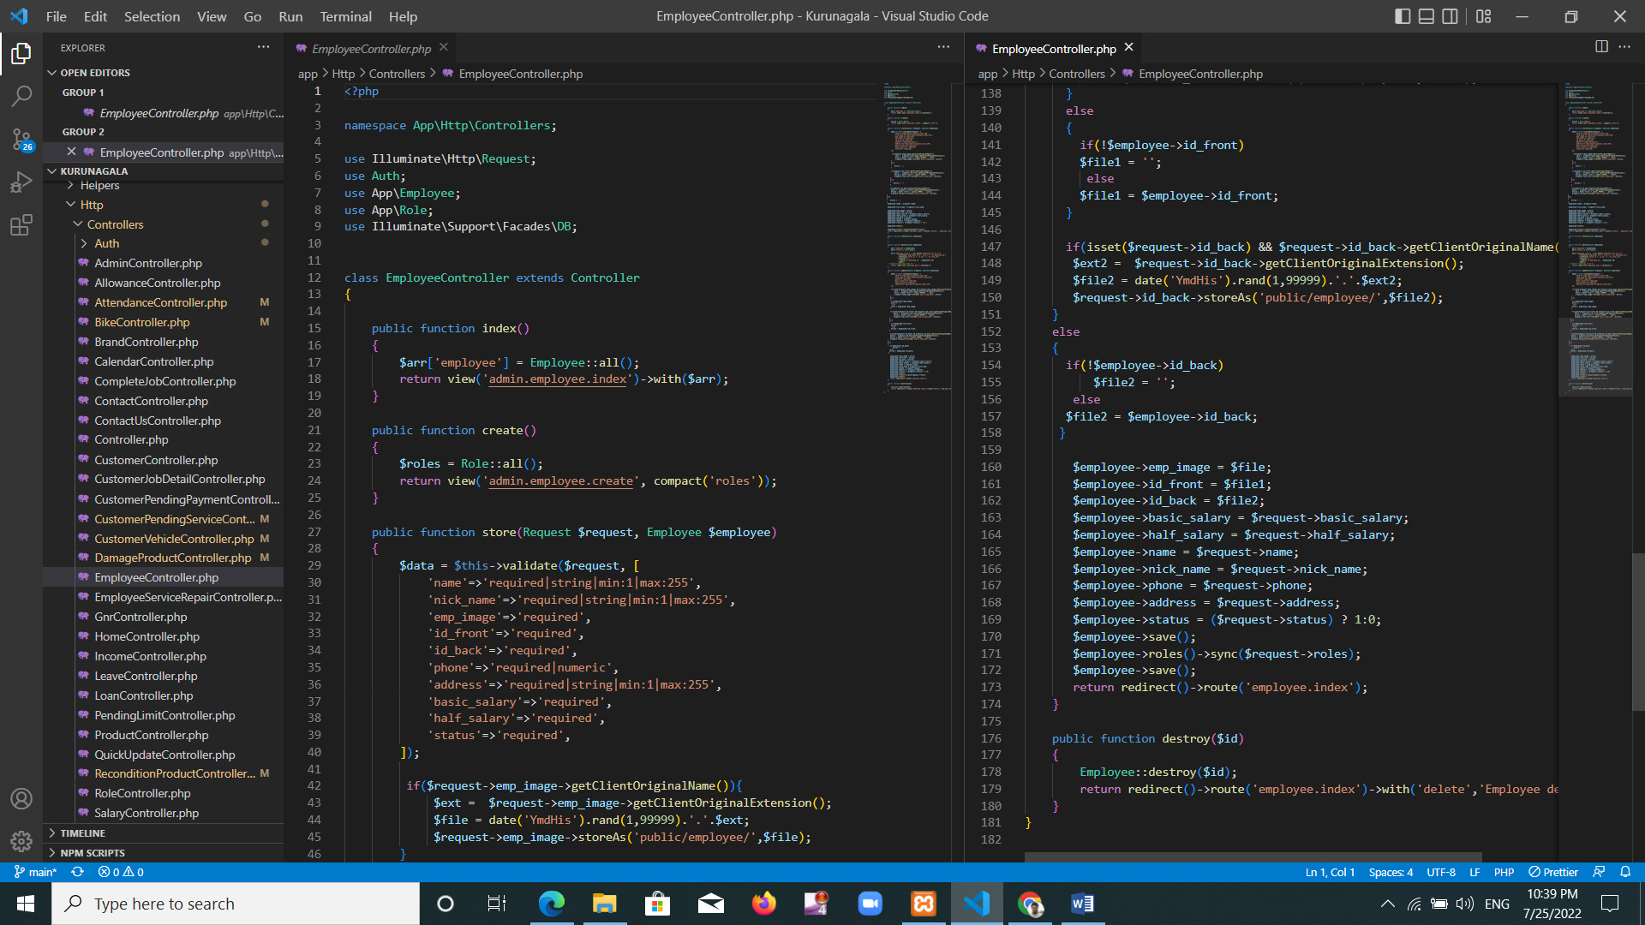

Figure 13: Add employee source code

4.3.11. Service repair Controller

Service repair source code display in figure 14

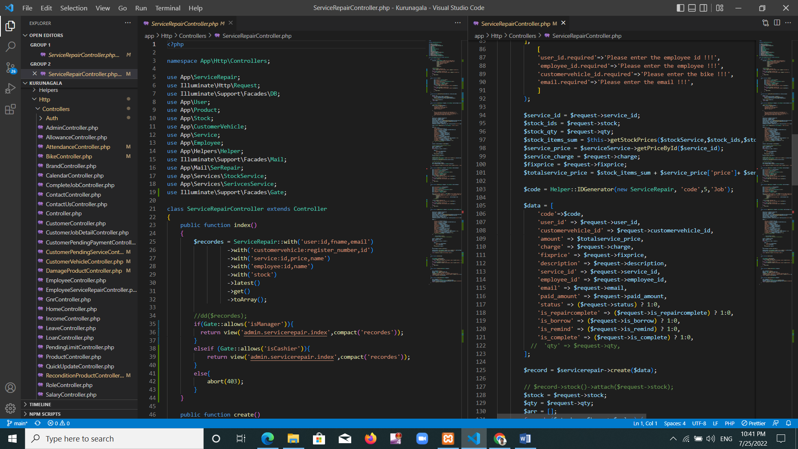

Figure 14: service repair source code

4.3.12. Good new received Controller

Goods new received source code display in figure 15

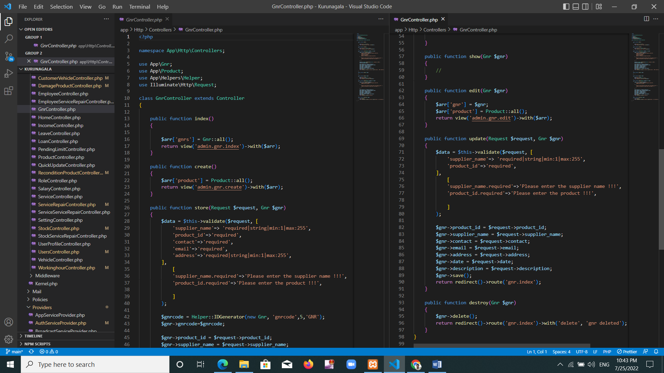

Figure 15: Good new received source code

4.3.13. Leave Controller

Employee leave source code display in figure 16.

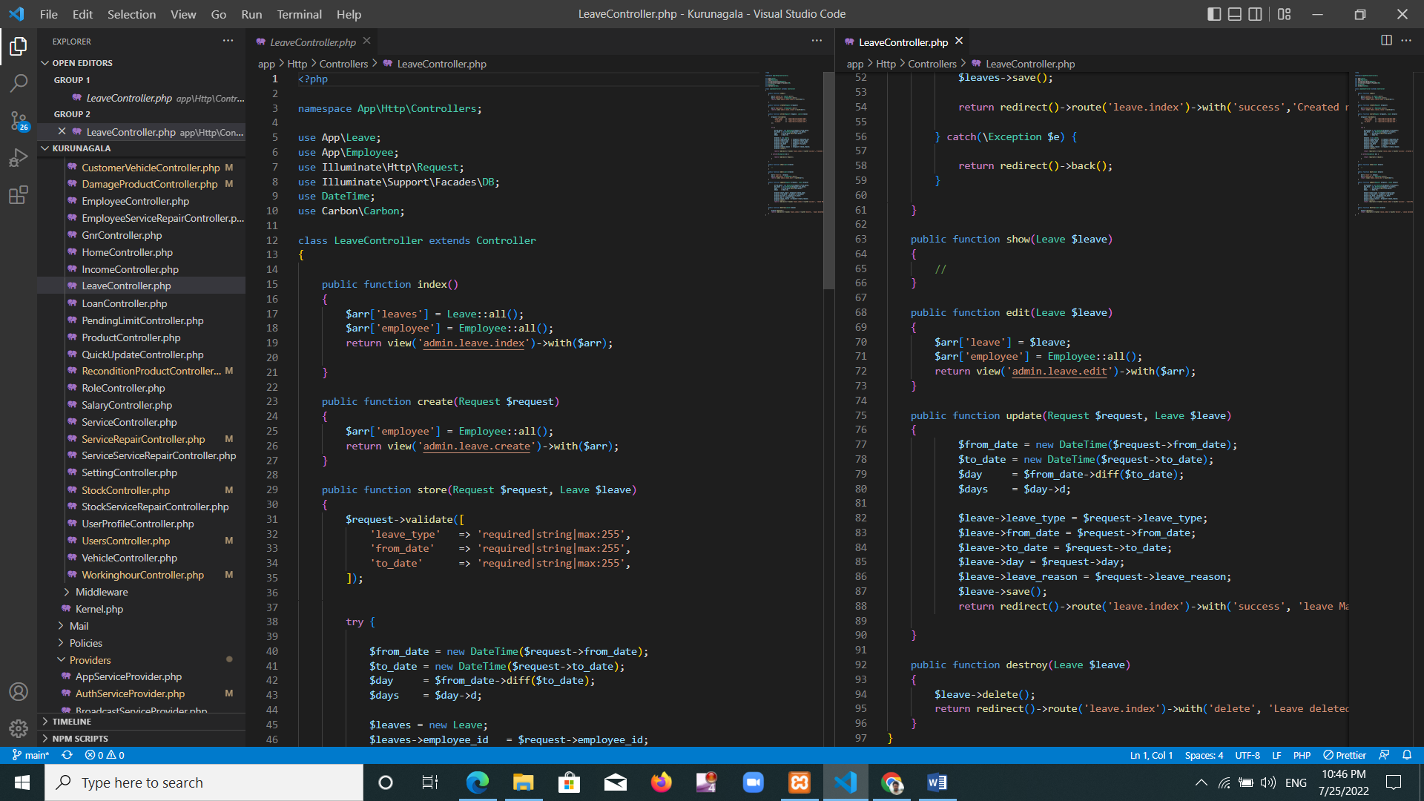

Figure 16: employee leave source code

## 4.4 Summery

This includes the steps to be followed when implementing the system. Includes what problems arise in system development. There were issues about software, scenery, data community.

What are the minimum requirements to operate the system without a problem and some of the source codes needed to implement the system.

# Chapter 5 - Results and Evaluation

## 5.1. Introduction

This chapter contains details of Kurunegala Motorcycle Service Site Management Information System Inspection and Evaluation phase. Testing methods can improve the quality of the system. The testing process contains basic points about supporting the quality and improving the software.

Considering how reliable the Kurunegala Motors system is and how the system works correctly. Suggestions are needed to be suggested which examiners are required to gain confidence and accuracy further further. This chapter includes ideas for improving and correcting some of those errors which can be learned from mistakes and difficulties.

## 5.2. Plan of Evaluation

Below are some testing methods used for evolution? For example, black box tests, unit tests, white box tests can be shown. Using these technologies, the system is user friendly enough to meet the needs and software engineering needs. These testing methods help the software system create high efficiency and effective as well as high precision.

## 5.3. Testing Methods

Investigation hopes to find errors that can be learned through mistakes or difficulties and rectify them and trust the system. Errors occur when there is a possibility or diverse between actual performance and outcome. Different testing methods can be used to conduct such condition testing. Could show some such testing methods.

* Black Box Test
* White box test

## 5.4. Black Box Testing

Used this method to assess the functionality of Kurunegala motors system. It is evaluated to deliver correct results as a result. For example, progressive tests can be shown, integration tests. Experiments, errors and methods were done here. The inspections will help to ensure that the requirements of the Kurunegala Motors Garage are met with the system. Performance requirement, security requirement, safety requirement checked as well as the accuracy of the system, flexibility also tested. Functional testing and non-functional testing are described in the above chapter 3.

## 5.5 White Box Testing

All aspects of Kurunegala Motors system were tested through this test system. White box testing can be used to test the internal strategy of Kurunegala Motors system.

## 5.6 Test plan and Test cases

A strategy used to ensure and ensure that the system works according to its plan specifications and other requirements. Using high-level test plans to conduct a successful testing process. Separates the whole system into smaller parts. This can reduce complexity. Problems can be investigated at minimum levels.

* System login module
* User registration module
* Create service repair module
* Create salary module
* Create allowance module
* Create loan module

### 5.6.1. System Login module

System log in test case display in table 45.

|  |  |  |  |
| --- | --- | --- | --- |
| Project name | Kurunagala motor management information system | Test designed by | Developer  (MGRP Yasasiri) |
| Release version | 1.0 | Test executed by | Developer  (MGRP Yasasiri) |
| Module name | System login |  |  |
| Pre-condition | -internet available  -use support browser |  |  |

|  |  |  |  |  |
| --- | --- | --- | --- | --- |
| Id | Test case description | Input | Expected output | Result |
| 01 | User login to system | Empty email and password | Display warning message ‘Please fill out this field’ | Pass |
|  |  | Incorrect email or password | Redirect to login page with alert “Sorry, These credentials do not match our records.” | pass |
|  |  | Incorrect email and password | Redirect to login page with alert “Sorry, These credentials do not match our records.” | pass |
|  |  | Correct email and password | User redirect to their dashboard | pass |

Table 45: User login module test case

### 5.6.2. New user register

Add new user test case display in table 46.

|  |  |  |  |
| --- | --- | --- | --- |
| Project name | Kurunagala motor management information system | Test designed by | Developer  (MGRP Yasasiri) |
| Release version | 1.0 | Test executed by | Developer  (MGRP Yasasiri) |
| Module name | New customer signin |  |  |
| Pre-condition | -internet available  -use support browser  -customer need knowledge to follow signin process |  |  |

|  |  |  |  |  |
| --- | --- | --- | --- | --- |
| Id | Test case description | Input | Expected output | result |
| 02 | New customer sign in | Form fill with missing required data | Display error message “please fill out this field” | pass |
|  |  | Form fill with invalid data. | Display error message “ please match the requested format” | pass |
|  |  | Form fill with existing data that need unique. Ex- email | Display error message “The email as already been taken” | pass |

Table 46: Sign up new user test case test case

### 5.6.3 Create new service-repair

Add new service-repair test case display in table 47.

|  |  |  |  |
| --- | --- | --- | --- |
| Project name | Kurunagala motor management information system | Test designed by | Developer  (MGRP Yasasiri) |
| Release version | 1.0 | Test executed by | Developer  (MGRP Yasasiri) |
| Module name | Create new service-repair |  |  |
| Pre-condition | -internet available  -use support browser  -login as manager or cashier |  |  |

|  |  |  |  |  |
| --- | --- | --- | --- | --- |
| Id | Test case description | Input | Expected output | Result |
| 03 | Create new service-repair | Form fill with missing required data. ex: email | Display error message “please enter the email” | pass |
|  |  | Form fill with invalid data. (email type without @) | Display error message “Please include a @ in the email. “ | pass |
|  |  | Form fill with  valid data | Display success message ‘service repair created successfully’ | pass |

Table 47: Create new service repair test case

### 5.6.4 Add new employee

Add new employee test case display in table 48.

|  |  |  |  |
| --- | --- | --- | --- |
| Project name | Kurunagala motor management information system | Test designed by | Developer  (MGRP Yasasiri) |
| Release version | 1.0 | Test executed by | Developer  (MGRP Yasasiri) |
| Module name | Add new employee |  |  |
| Pre-condition | -internet available  -use support browser  -login as manager |  |  |

|  |  |  |  |  |
| --- | --- | --- | --- | --- |
| Id | Test case description | Input | Expected output | Result |
| 04 | Add new employee | Form fill with missing required data. ex: name | Display error message “The name field is required.” | pass |
|  |  | Form fill with invalid data. Ex: contact | Display error message “Please match the requested format “ | Pass |
|  |  | Form fill with  valid data | Display success message ‘employee created successfully’ | Pass |

Table 48: Add new employee test case

### 5.6.5. Add role

Add role test case display in table 49.

|  |  |  |  |
| --- | --- | --- | --- |
| Project name | Kurunagala motor management information system | Test designed by | Developer  (MGRP Yasasiri) |
| Release version | 1.0 | Test executed by | Developer  (MGRP Yasasiri) |
| Module name | Add role |  |  |
| Pre-condition | -internet available  -use support browser  -login as manager |  |  |

|  |  |  |  |  |
| --- | --- | --- | --- | --- |
| Id | Test case description | Input | Expected output | Result |
| 05 | Add new role | Form fill with missing required data. | Display error message “please fill out this field” | pass |
|  |  | Form fill with  valid data | Display success message ‘create new role successfully’ | Pass |

Table 49: Add role test case

### 5.6.6. Add salary

Add employee salary test case display in table 50.

|  |  |  |  |
| --- | --- | --- | --- |
| Project name | Kurunagala motor management information system | Test designed by | Developer  (MGRP Yasasiri) |
| Release version | 1.0 | Test executed by | Developer  (MGRP Yasasiri) |
| Module name | Add Salary |  |  |
| Pre-condition | -internet available  -use support browser  -login as manager |  |  |

|  |  |  |  |  |
| --- | --- | --- | --- | --- |
| Id | Test case description | Input | Expected output | Result |
| 06 | Add new salary | Form fill with missing required data. ex: salary month | Display error message “The name field is required.” | Pass |
|  |  | Form fill with missing required data. ex: employee name | Display error message “workdays required. Please enter the employee name!!! “ | Pass |
|  |  | Form fill with  valid data | Display success message ‘Salary Marked’ | Pass |

Table 50: Add salary test case

### 5.6.7. Add leave

Add employee leave test case display in table 51.

|  |  |  |  |
| --- | --- | --- | --- |
| Project name | Kurunagala motor management information system | Test designed by | Developer  (MGRP Yasasiri) |
| Release version | 1.0 | Test executed by | Developer  (MGRP Yasasiri) |
| Module name | Add new leave |  |  |
| Pre-condition | -internet available  -use support browser  -login as manager |  |  |

|  |  |  |  |  |
| --- | --- | --- | --- | --- |
| Id | Test case description | Input | Expected output | Result |
| 07 | Add new leave | Form fill with missing required data. ex: to_date | Display error message “The to_date field is required.” | Pass |
|  |  | Form fill with  valid data | Display success message ‘Created new leave successfully’ | Pass |

Table 51: Add leave test case

### 5.6.8. Add loan

Add loan test case display in table 52.

|  |  |  |  |
| --- | --- | --- | --- |
| Project name | Kurunagala motor management information system | Test designed by | Developer  (MGRP Yasasiri) |
| Release version | 1.0 | Test executed by | Developer  (MGRP Yasasiri) |
| Module name | Add new loan |  |  |
| Pre-condition | -internet available  -use support browser  -login as manager |  |  |

|  |  |  |  |  |
| --- | --- | --- | --- | --- |
| Id | Test case description | Input | Expected output | Result |
| 08 | Add new loan | Form fill with missing required data. ex:loan_amount | Display error message “Please enter the loan amount!!!” | pass |
|  |  | Form fill with  valid data | Display success message ‘Marked loan ’ | Pass |

Table 52: Add loan test case

### 5.6.9. Add attendance

Add daily attendance test case display in table 53.

|  |  |  |  |
| --- | --- | --- | --- |
| Project name | Kurunagala motor management information system | Test designed by | Developer  (MGRP Yasasiri) |
| Release version | 1.0 | Test executed by | Developer  (MGRP Yasasiri) |
| Module name | Add new attendance |  |  |
| Pre-condition | -internet available  -use support browser  -login as manager |  |  |

|  |  |  |  |  |
| --- | --- | --- | --- | --- |
| Id | Test case description | Input | Expected output | Result |
| 09 | Add new attendance | Form fill with missing required data. ex: time_end | Display error message “Please enter the time end!!!” | pass |
|  |  | Form fill with  valid data | Display success message ‘Marked ’ | Pass |

Table 53: Add attendance test case

### 5.6.10. Add allowance

Add allowance to employee test case display in table 54.

|  |  |  |  |
| --- | --- | --- | --- |
| Project name | Kurunagala motor management information system | Test designed by | Developer  (MGRP Yasasiri) |
| Release version | 1.0 | Test executed by | Developer  (MGRP Yasasiri) |
| Module name | Add allowance |  |  |
| Pre-condition | -internet available  -use support browser  -login as manager |  |  |

|  |  |  |  |  |
| --- | --- | --- | --- | --- |
| Id | Test case description | Input | Expected output | Result |
| 10 | Add new allowance | Form fill with missing required data. ex: allowance | Display error message “The allowance field is required.” | pass |
|  |  | Form fill with  valid data | Display success message ‘Marked allowance’ | Pass |

Table 54: Add allowance test case

## 5.7. Some User Interface in System

**Login page**

Figure 17 login page interface. The user here must provide their email and password. Unregistered customers can access the sign in page.

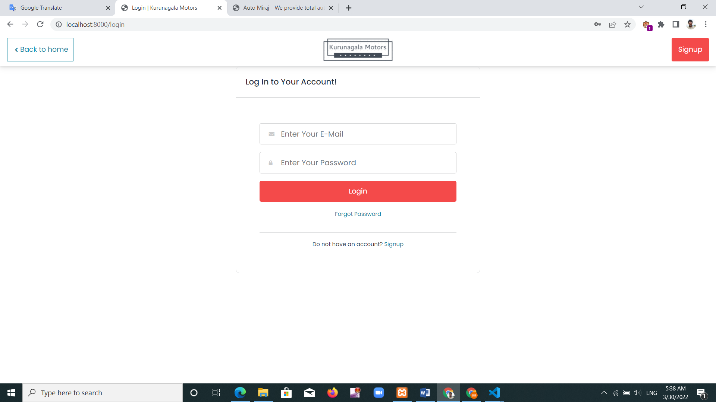

Figure 17: login page interface

**Register page**

Customers can use this page to register in the system Figure 18 has shown that interface. Users who already have an account can access the login page through this.

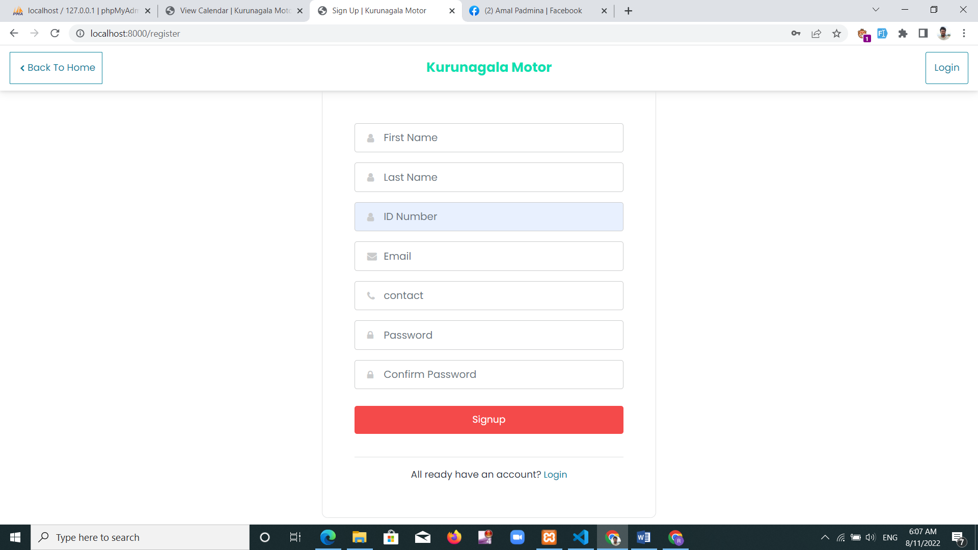

Figure 18: register page interface

**Cashier dashboard**

Cashier interface is shown under Figure 19. cashier can handle the system through his interface.

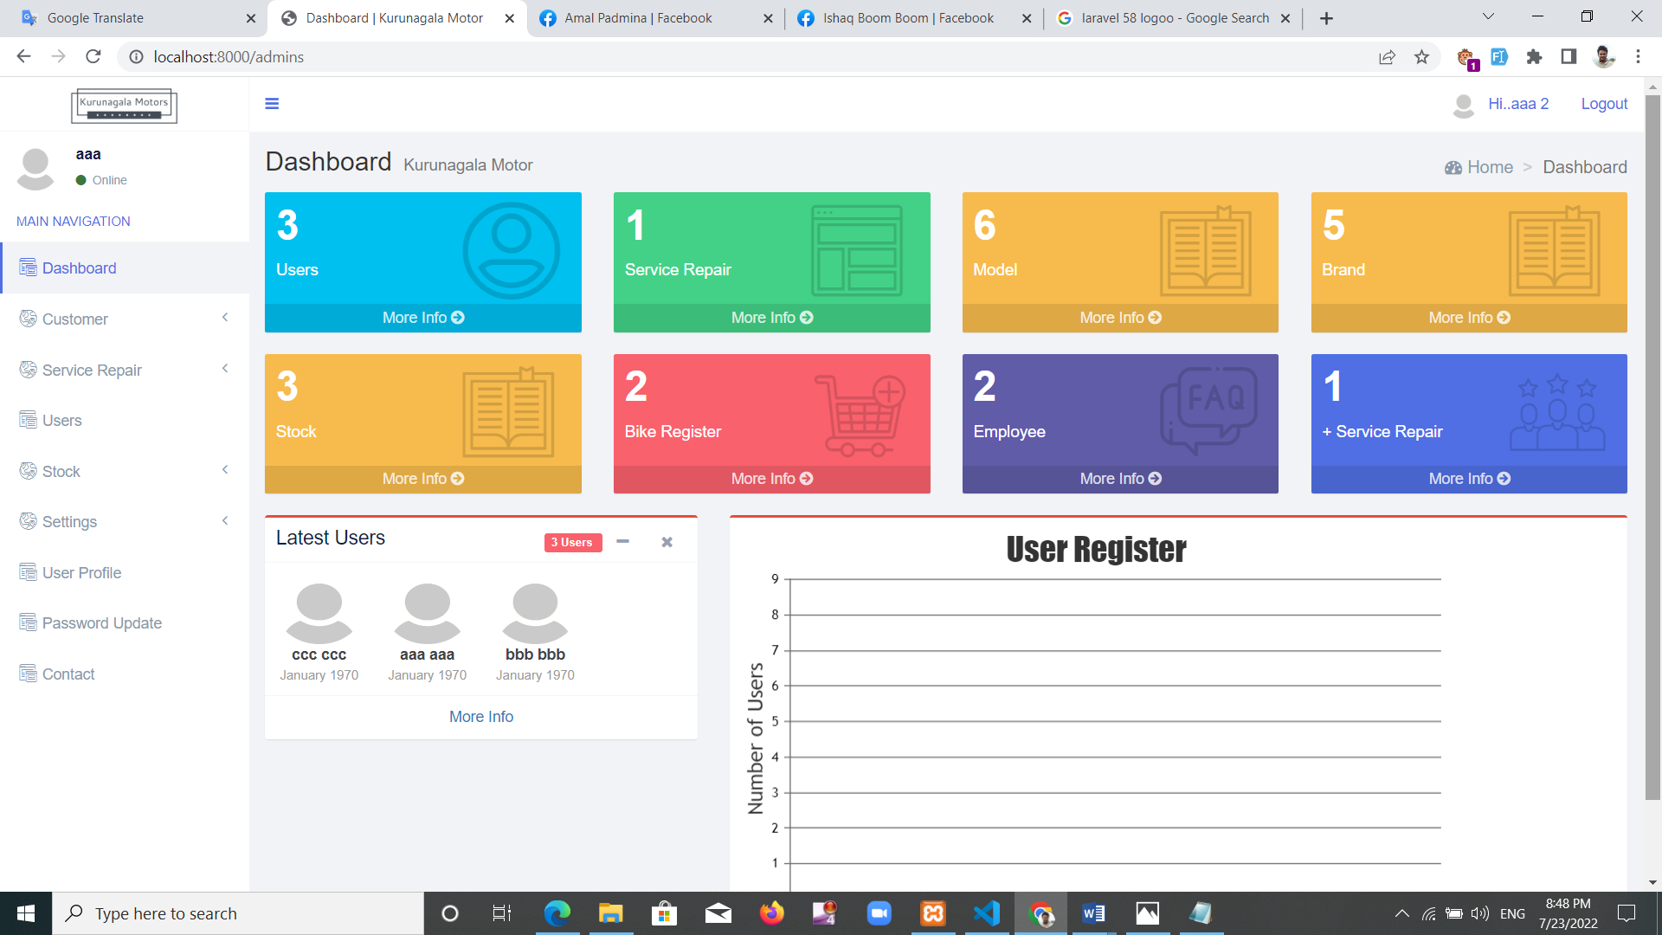

Figure 19: Cashier dashboard interface

**Manager dashboard**

Manager's interface is shown under Figure 20. Manager can handle the system through his interface.

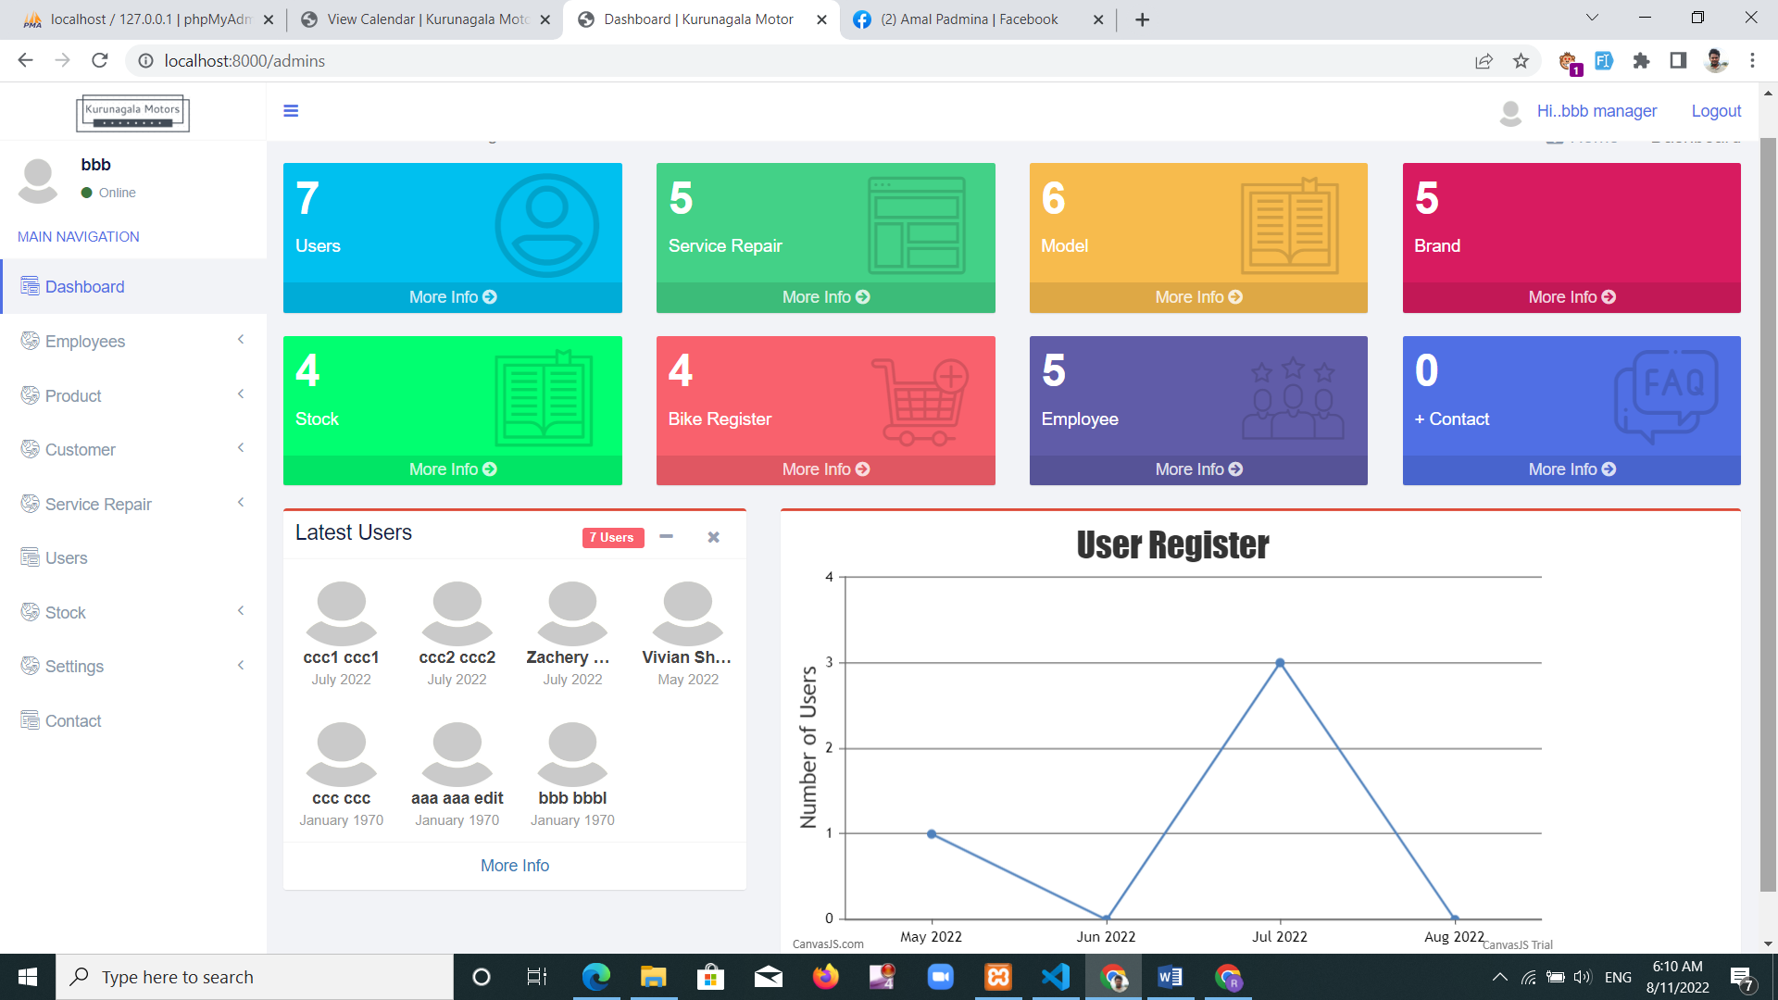

Figure 20: Manager Dashboard interface

**Home page**

Unregistered customer's interface is shown under figure 21. Here you can see customer service information about garage supply, spare parts.

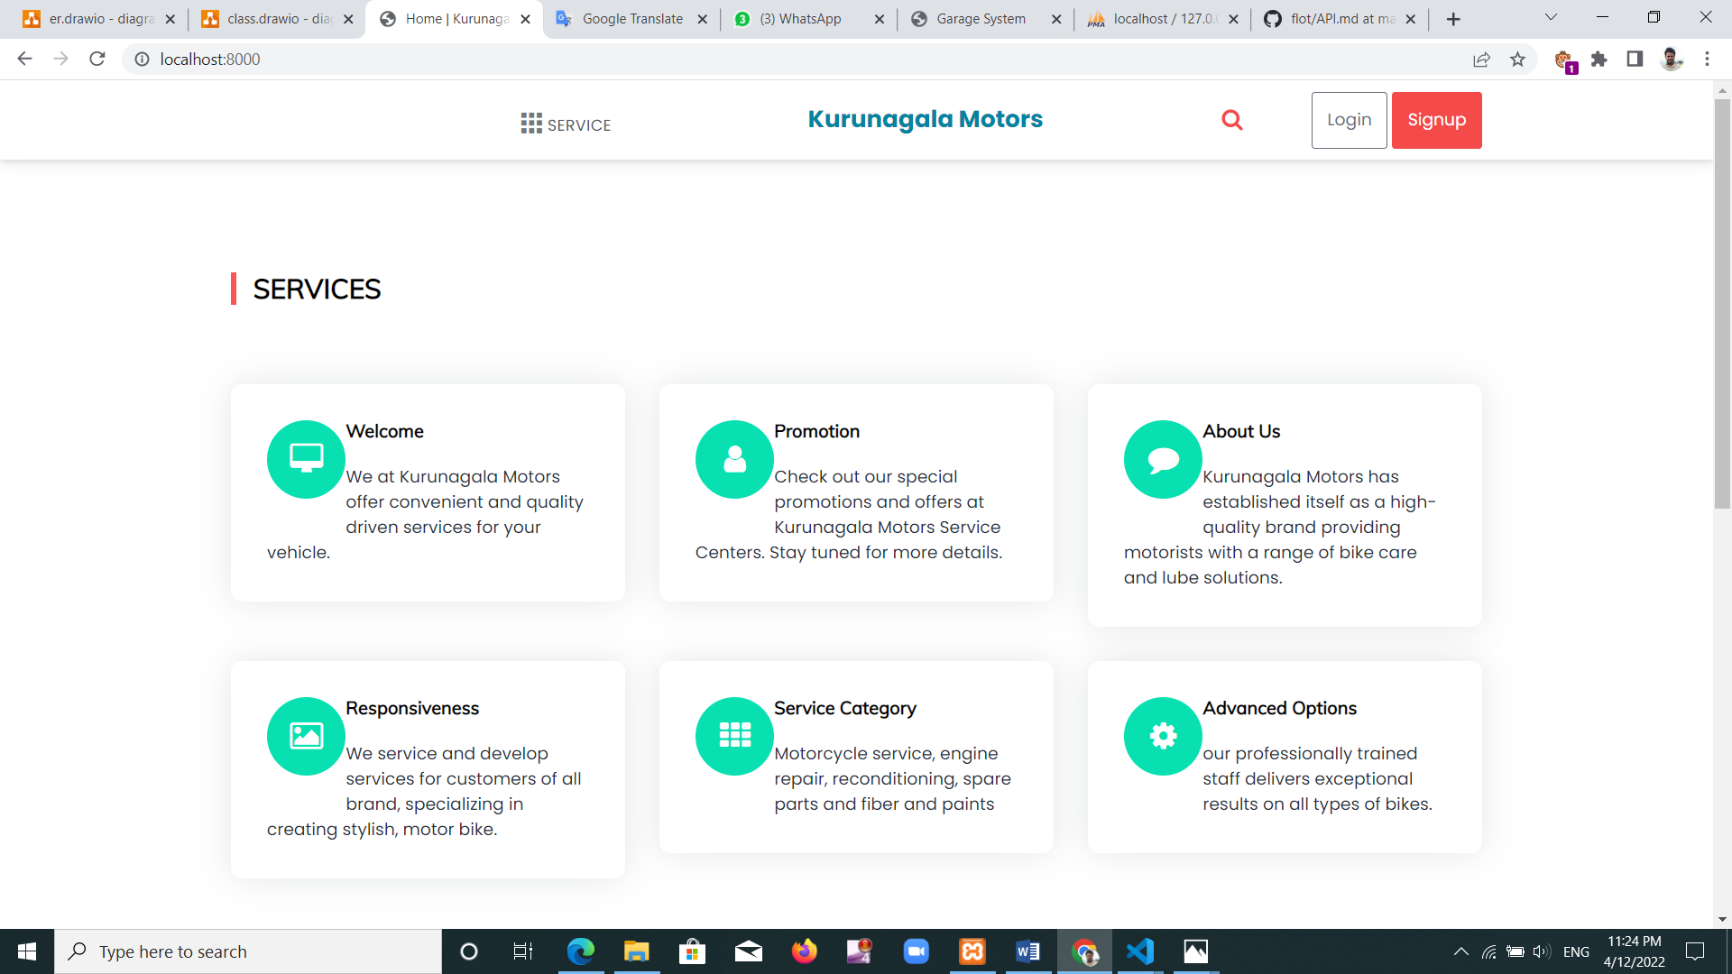

Figure 21: Home page

**Add user page**

New user registration is done by figure 22 interface. Manager can register cashier and customers, cashier can only register customers. Customers who register here will be an email message with information about it. This is where information is edit and delete.

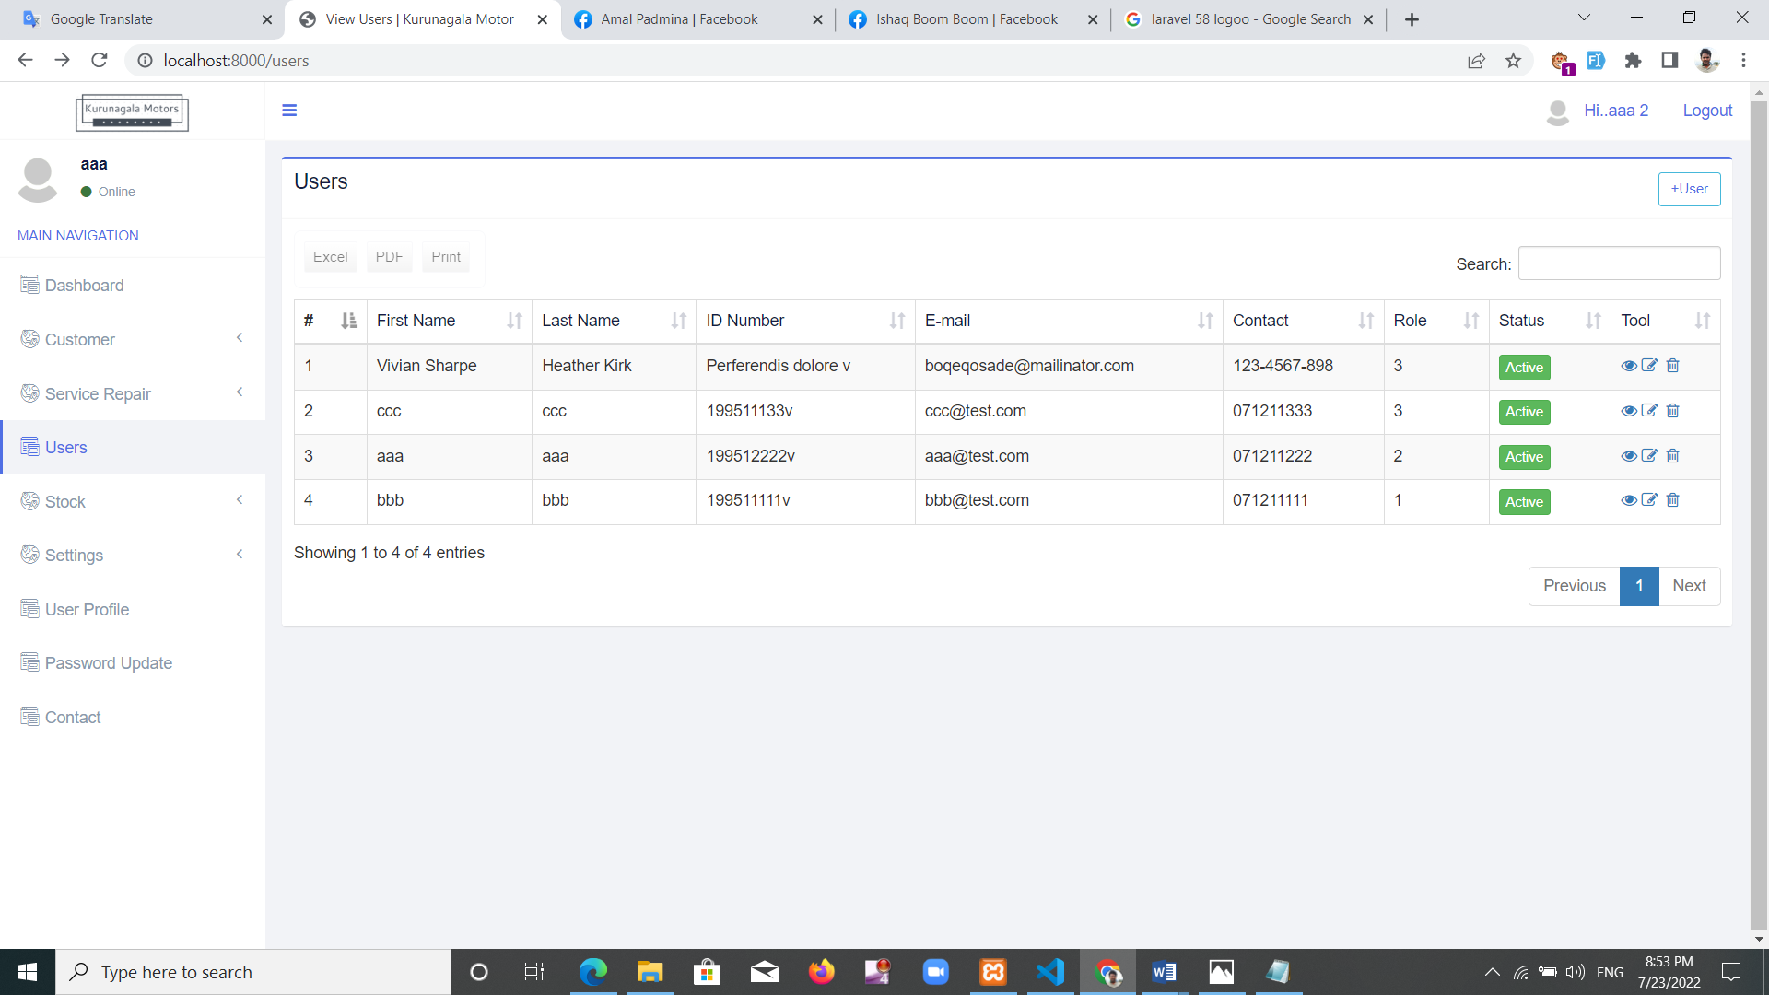

Figure 22: Add user page interface

**Customer bike register page**

Figure 23 shows the interface of registering the customer's motorcycle. Manager and cashier doing this registration. This is where information is edit and delete.

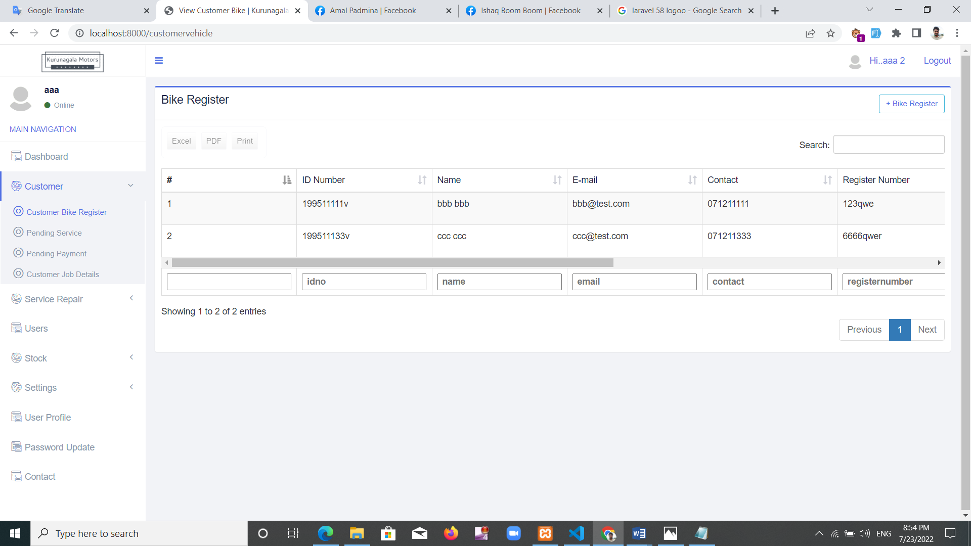

Figure 23: Customer bike register interface

**Customer pending service**

Customer can register for their next service if wanted. Customer received an email message with relevant remind on a date. That interface is shown by figure 24 it’s a new addition to the system. This can improve the quality of service provided to customers.

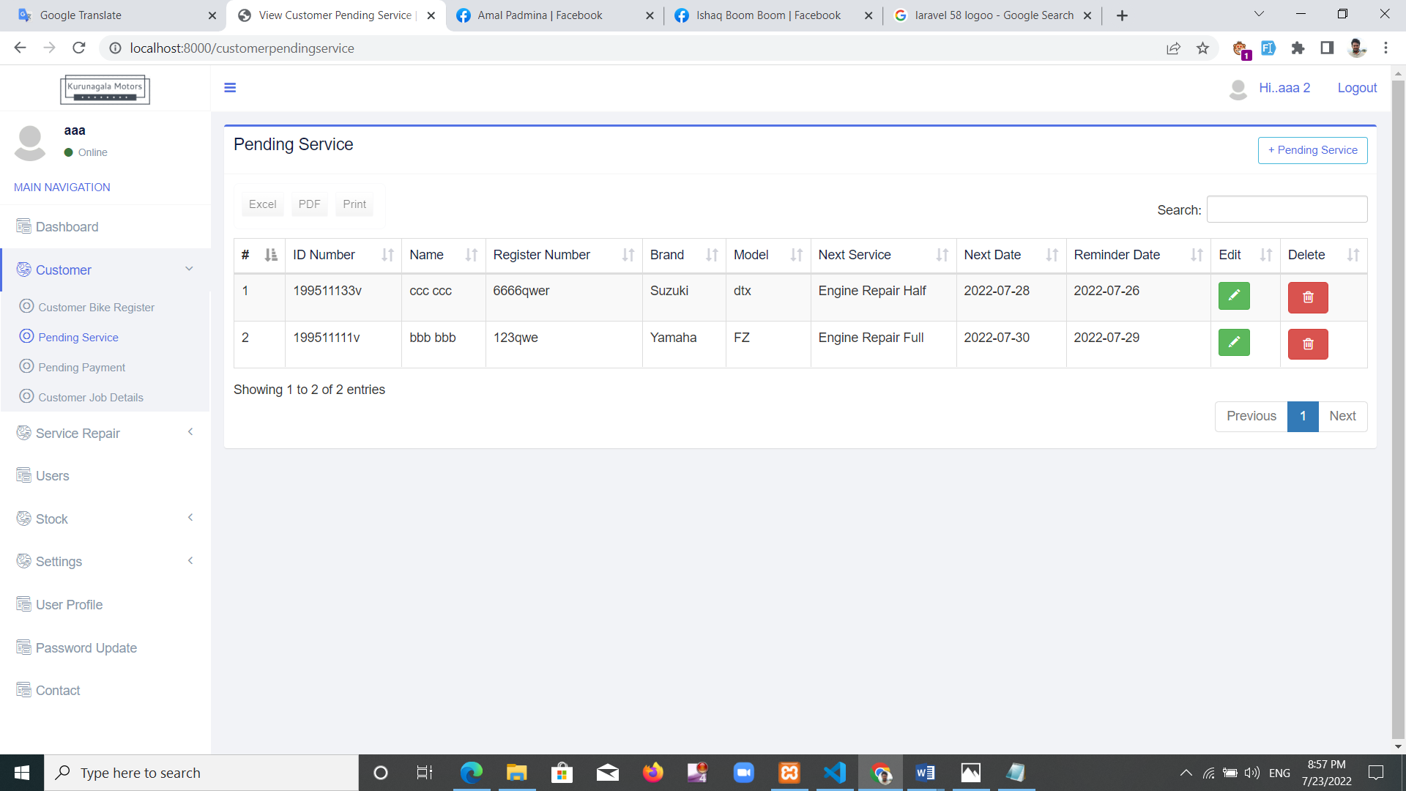

Figure 24: Customer pending service interface

**Customer pending payment**

This interface will show the customer if they have half payment of bill, once a service-repair is done. User can send an email to reconcile regarding borrowing payment. This can reduce the losses caused by avoiding charges. This is also a newly added event. Figure 25 shows that interface.

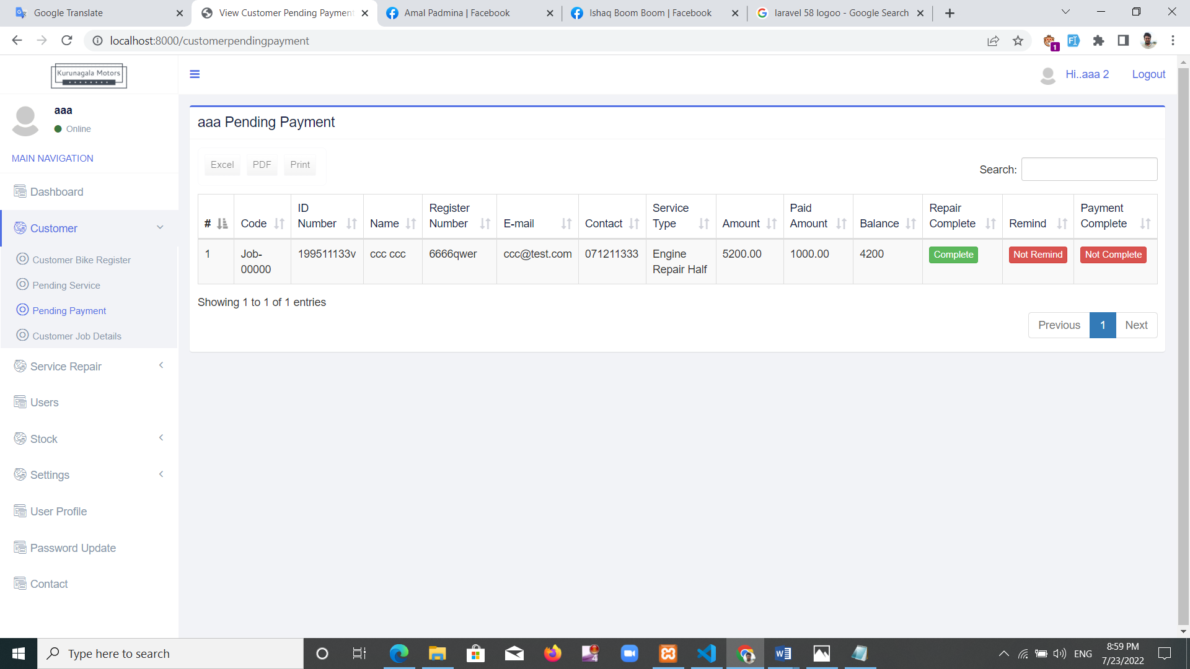

Figure 25: Customer pending payment interface

**Add service**

This can add new services to the system. Still used to the service code by employees. The price of the service should also be added here. A description to the service can be added. That information can be changed and removed. That interface is shown in figure 26.

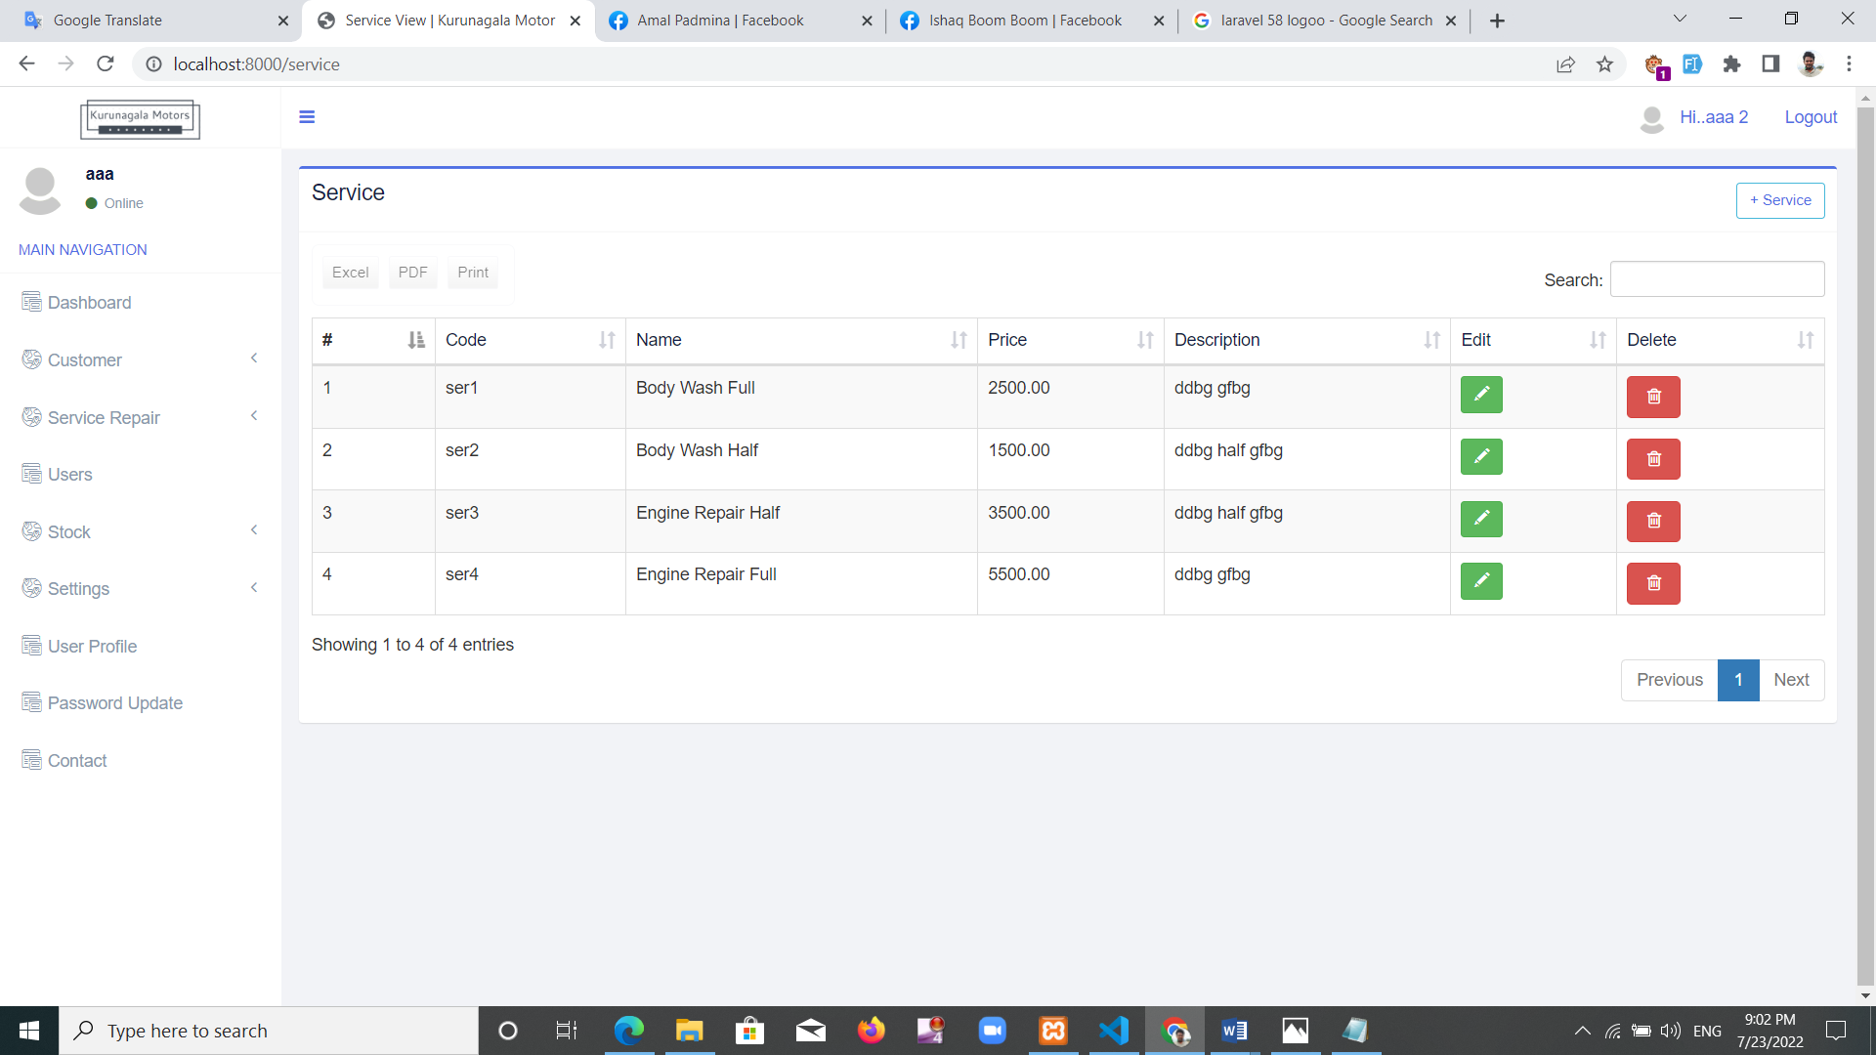

Figure 26: Add service interface

**Job services**

Here user can easily see the service provided during each repair. Service number, charge of service and start time can also be seen. This helps the manager gain an easy understanding of the day-to-day services. Figure 27 shows that interface. Records can be available as pdf, excel, and print.

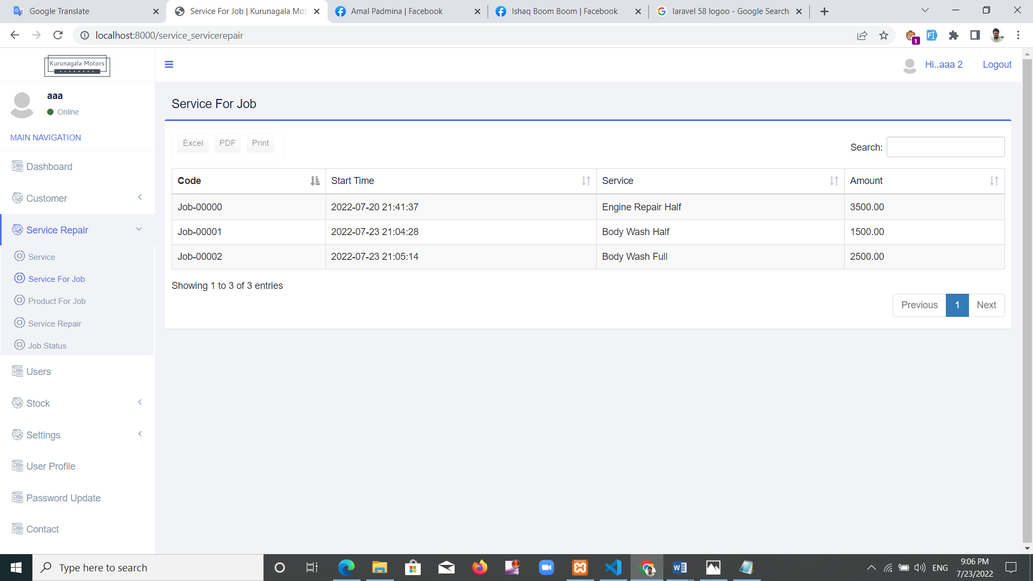

Figure 27: Job - service interface

**Used products for job**

Spare parts used for each service and its price separately can be seen here. This is why user can easily identify the spares used for each repair. Records can be available as pdf, excel, and print. This helps avoid the difficulty of identifying spares that were used for one repair today. The interface is shown here in figure 28. The manager and cashier can use this interface.

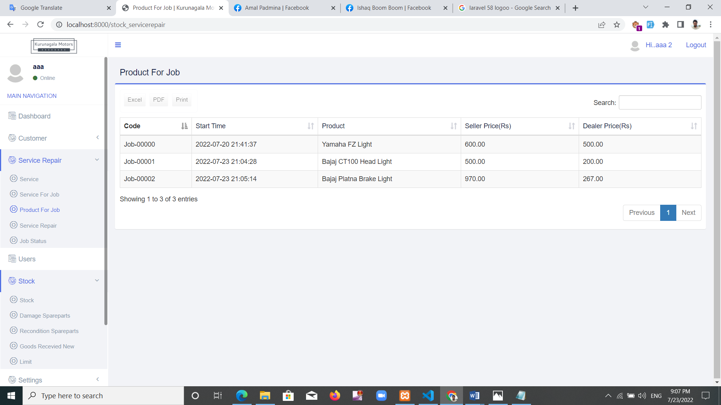

Figure 28: Used products for job interface

**Service-repair page**

This is one of the key components of the system. There will be motorcycle services registration. Customer name, motorcycle must pick up. Must choose the service to provide later, choose an employee and register a repair. There are codes for repair being created. Needed spare parts should be noted. If it is an extra charge when issuing the bills, you can collect it too. Customer can pay the whole amount or share. Email message about payment of credit can be done here. Also an email message when you register a repair and an email message will be sent once the repair is completed. This interface is shown in figure 29.

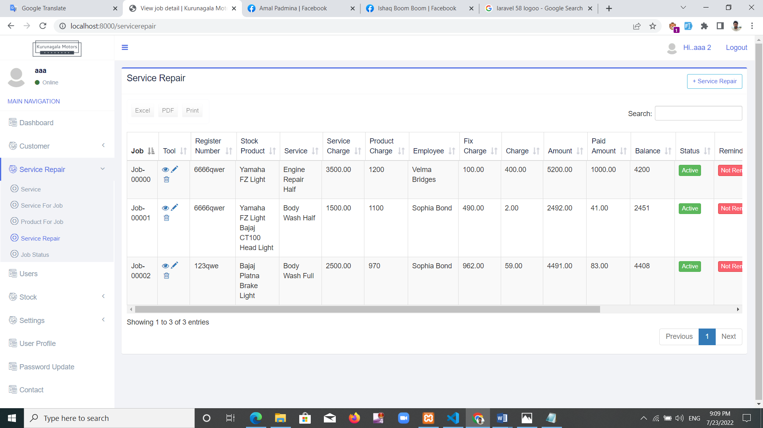

Figure 29: Service-repair page interface

**Complete job page**

This interface shows the repairs that completed the repairs and also finished the payment. Those repairs may show as a fully finished repairs. Information about the completely final repairs can be found through this interface. That interface is shown in figure 30.

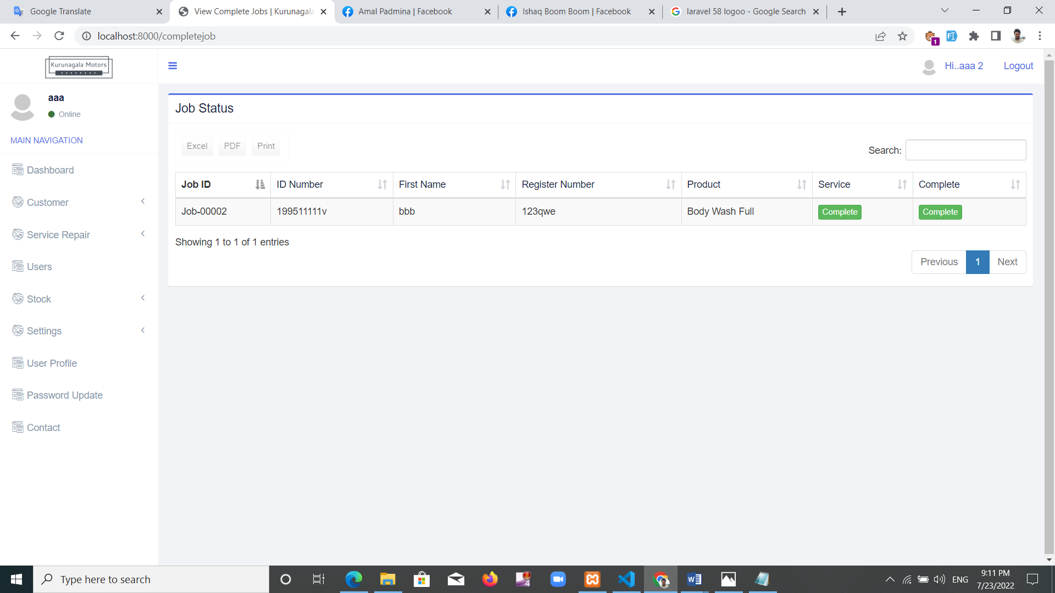

Figure 30: Complete job page interface

Add roles

Roles added to the system here. Currently enrolled as manager, cashier, customer, technician, and trainee. That interface is shown in figure 31.

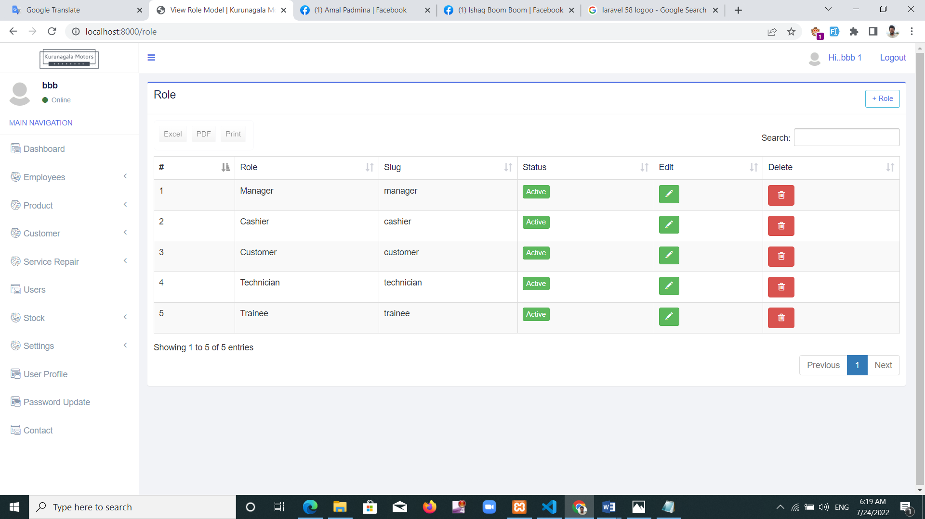

Figure 31: Add role interface

Employee page

Employees register here. Employee photo, basic pay levels, personal information must be entered here. Only the manager can use that interface. It was shown in figure 32.

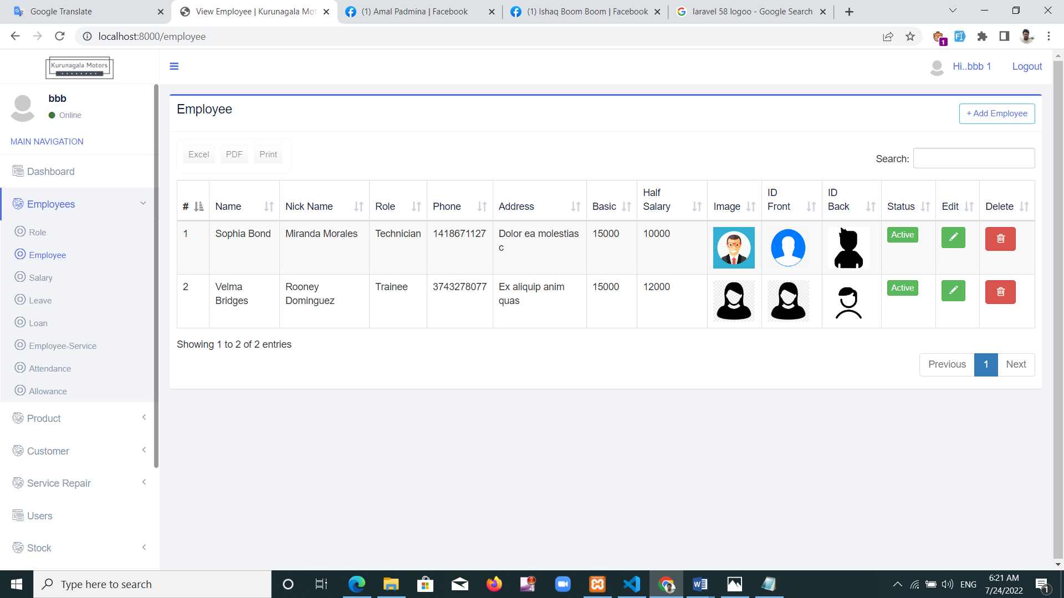

Figure 32: Employee page interface

**Employee salary**

Employee salary pay details are given here. The salary is based on employee's obtained leave, service-repair, allowance and loan payments. There's an interface shown in figure 33.

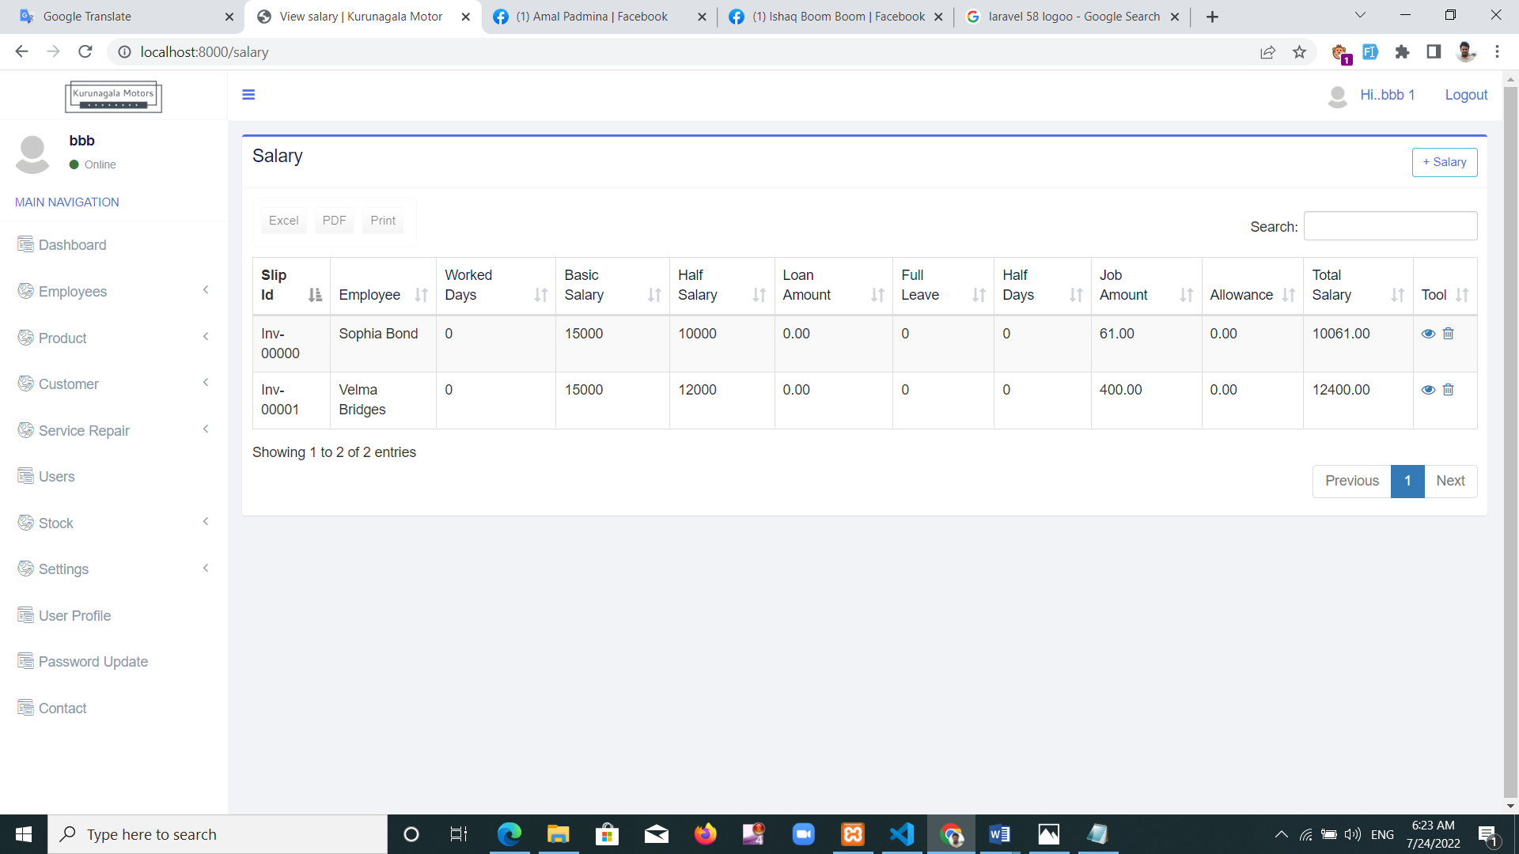

Figure 33: Employee salary interface

**Employee leave**

This interface can include employee's leave. Employees can take full day leave or half day leave. Figure 34 shows that interface.

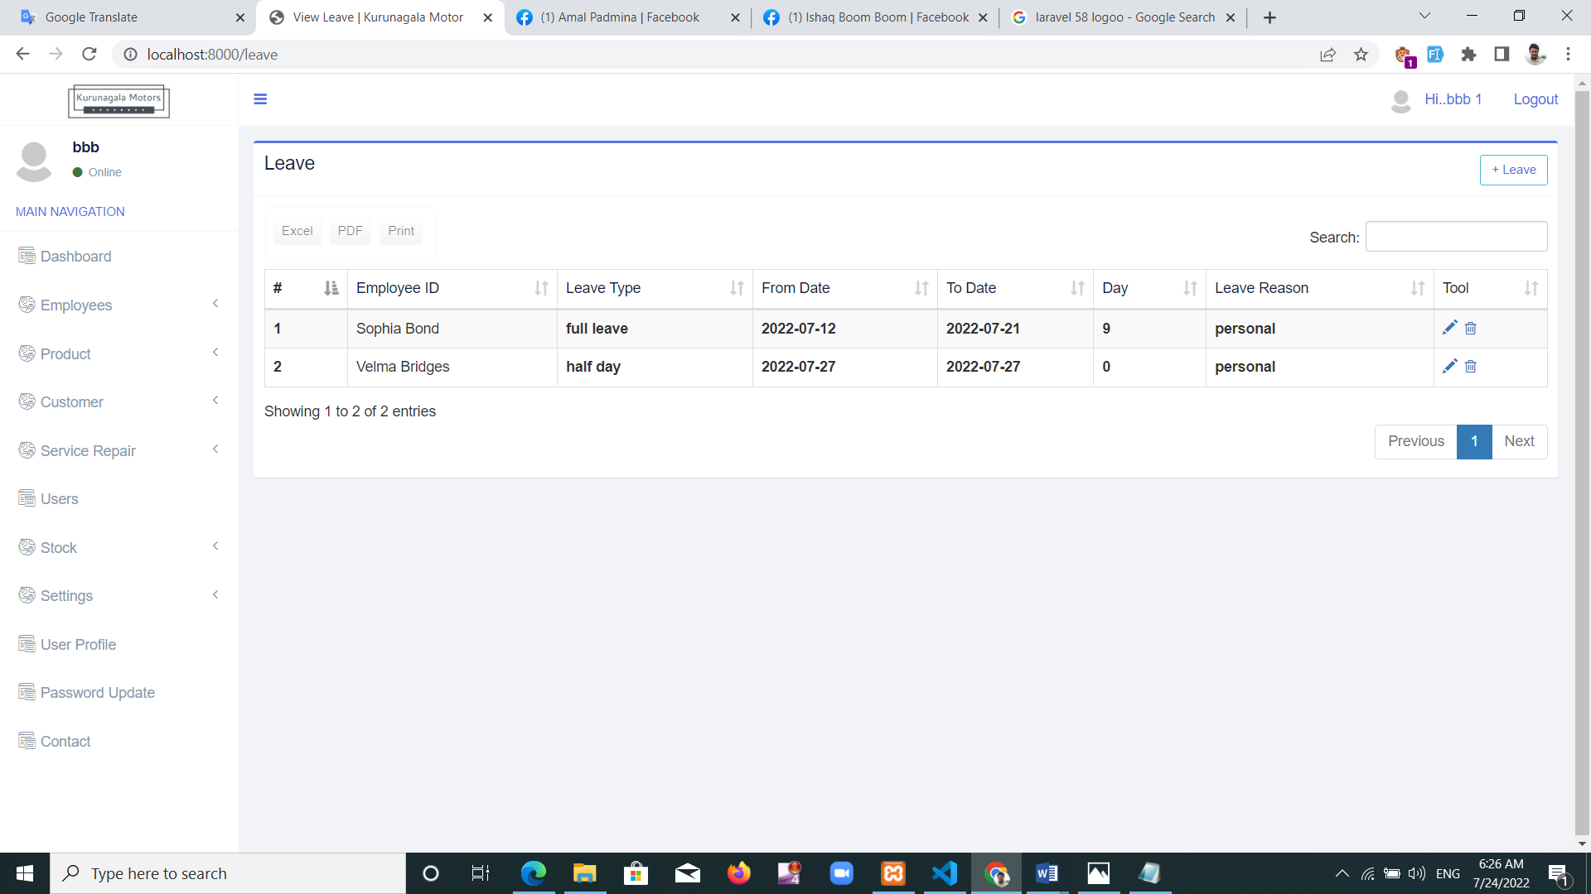

Figure 34: Employee leave interface

**Employee loan**

Employees can get loans on a month's salary and reduce that loan amount in payments. An existing problem is that the company is facing losses due to avoiding re-closing employee loans. These problems arising due to the use of account books can be avoided through the new system. . Figure 35 shows that interface.

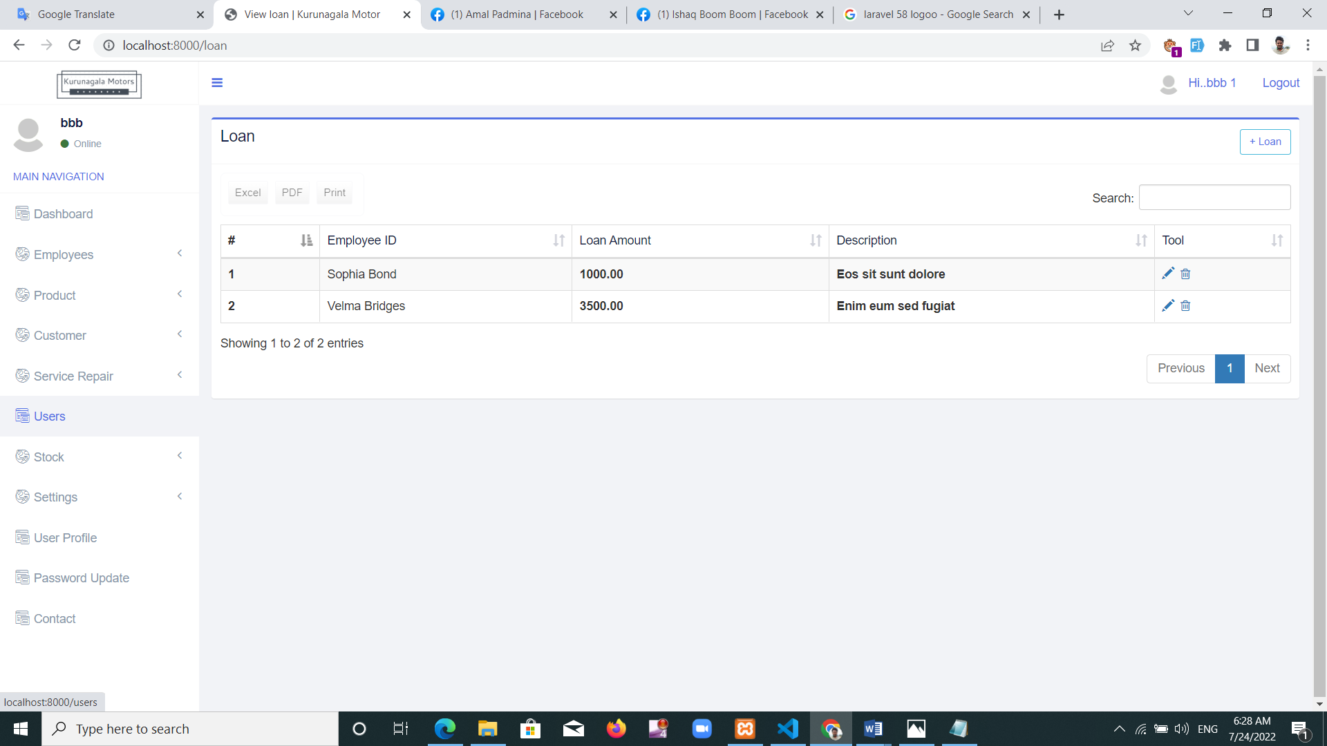

Figure 35: Employee loan interface

**Employee performance**

This interface helps to monitor the service-repairs done by each employee. The spare parts used by the employee can also be seen separately. Nowadays it is difficult to get information through paper works after a customer makes a complaint. But that information is easily obtained through the new system. There's an interface shown in figure 36.

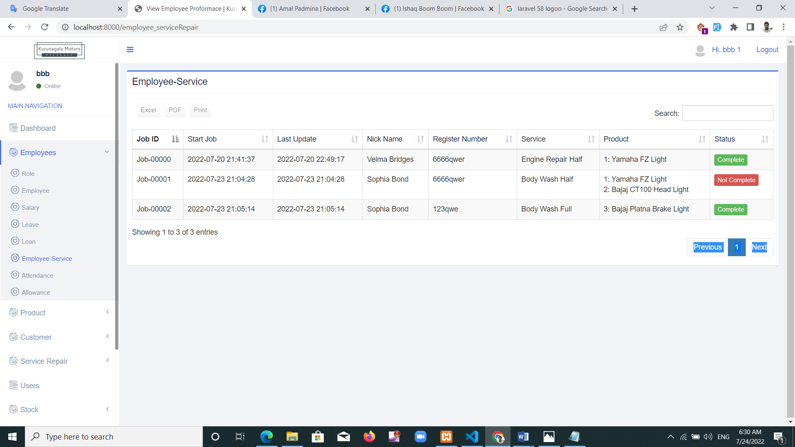

Figure 36: Employee performance interface

**Attendance**

The attendance of employees has been seen in this interface. its interface is shown in figure 37

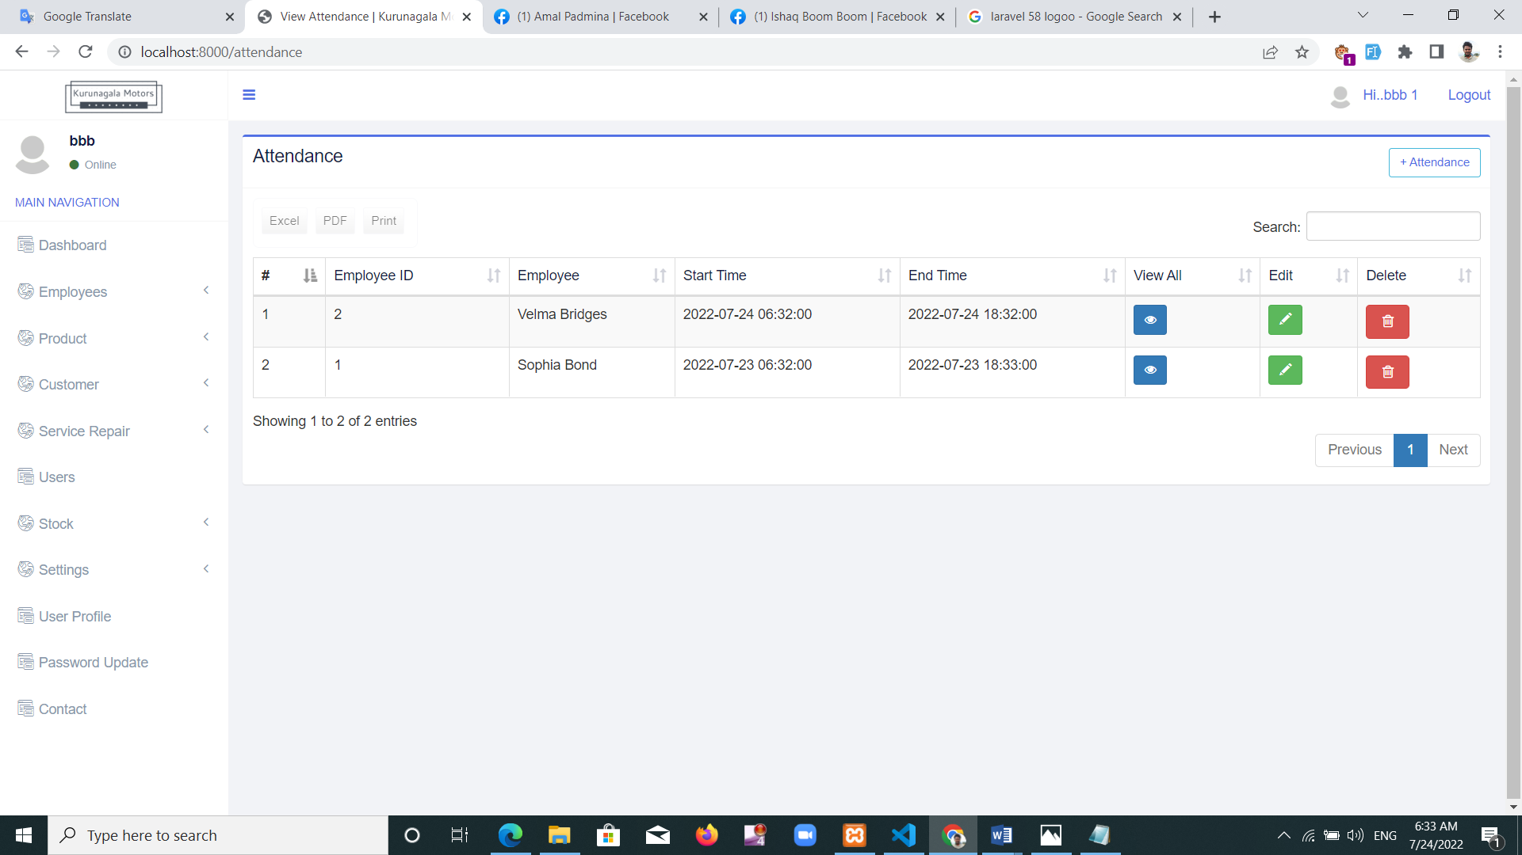

Figure 37: Attendance interface

**Allowance**

Kurunegala Motors Garage is doing allowance to employees and those allowance can be collected in this section. Those offers add to the salary there’s an interface shown in figure 38.

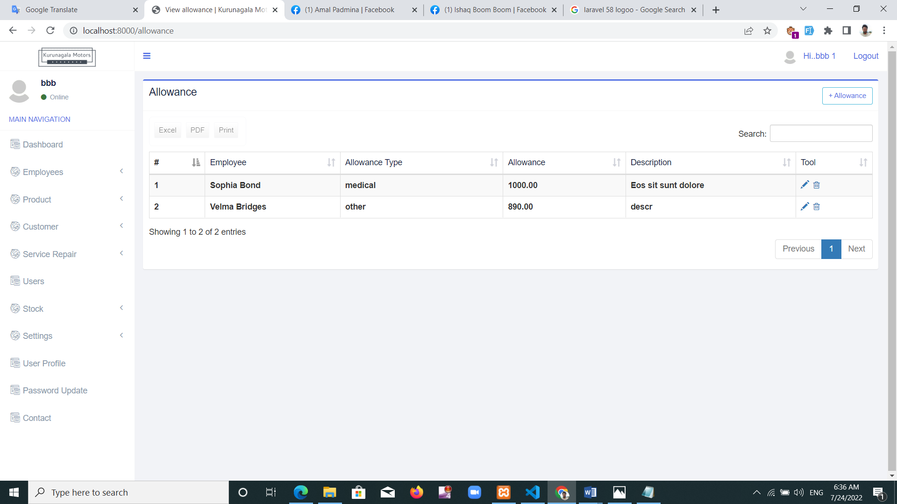

Figure 38: Allowance interface

**Product**

Naming motorcycle spare parts is done at this stage. Motorcycle model and brand and spare part name should be included. There's an interface shown in figure 39.

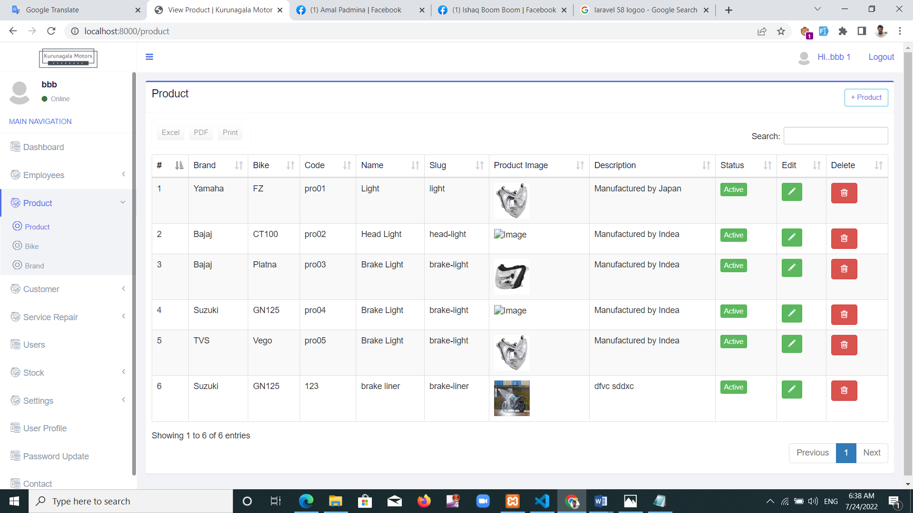

Figure 39: Product interface

**Bike model**

This interface is used to include motorcycle models. All the motorcycle models provided by Kurunegala Motors Company is included here. There's an interface shown in figure 40.

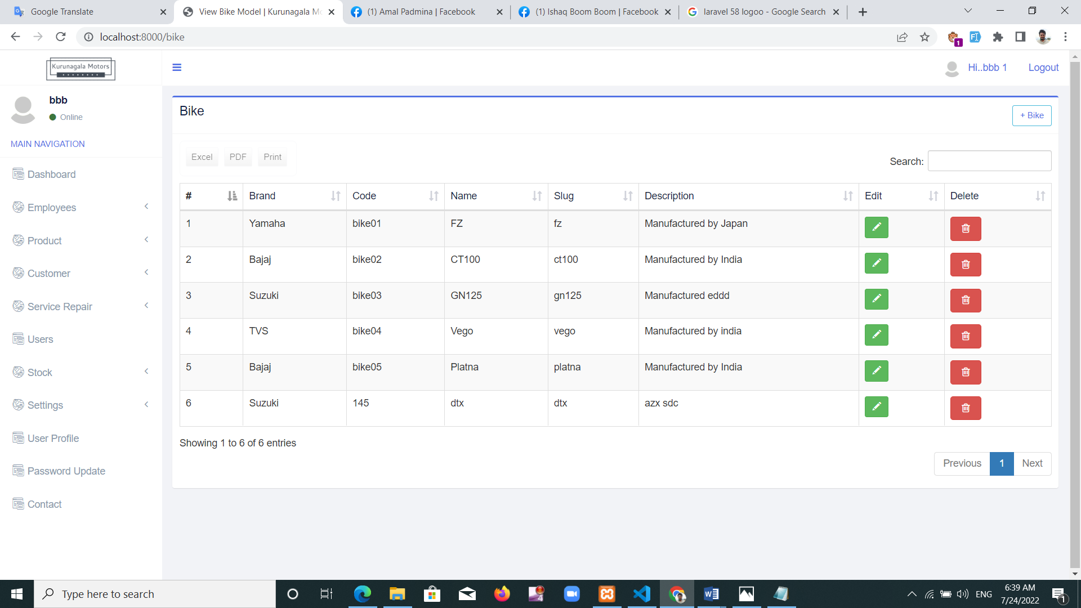

Figure 40: Bike model interface

**Brand**

Motorcycle brand registration is done here. There's an interface shown in figure 41. All the motorcycle brands provided by Kurunegala Motors Company services are included here

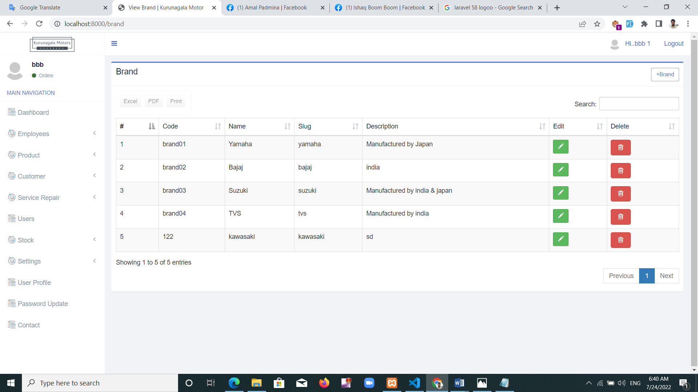

Figure 41: Brand

**Stock**

Addition of spares to the store is happening at this stage. Info of spare part name, share size, market price, color etc. are related to it. It can give minimum limit for spares and when it comes to minimum limit it shows red. This event will help re-order spares. There's an interface shown in figure 42.

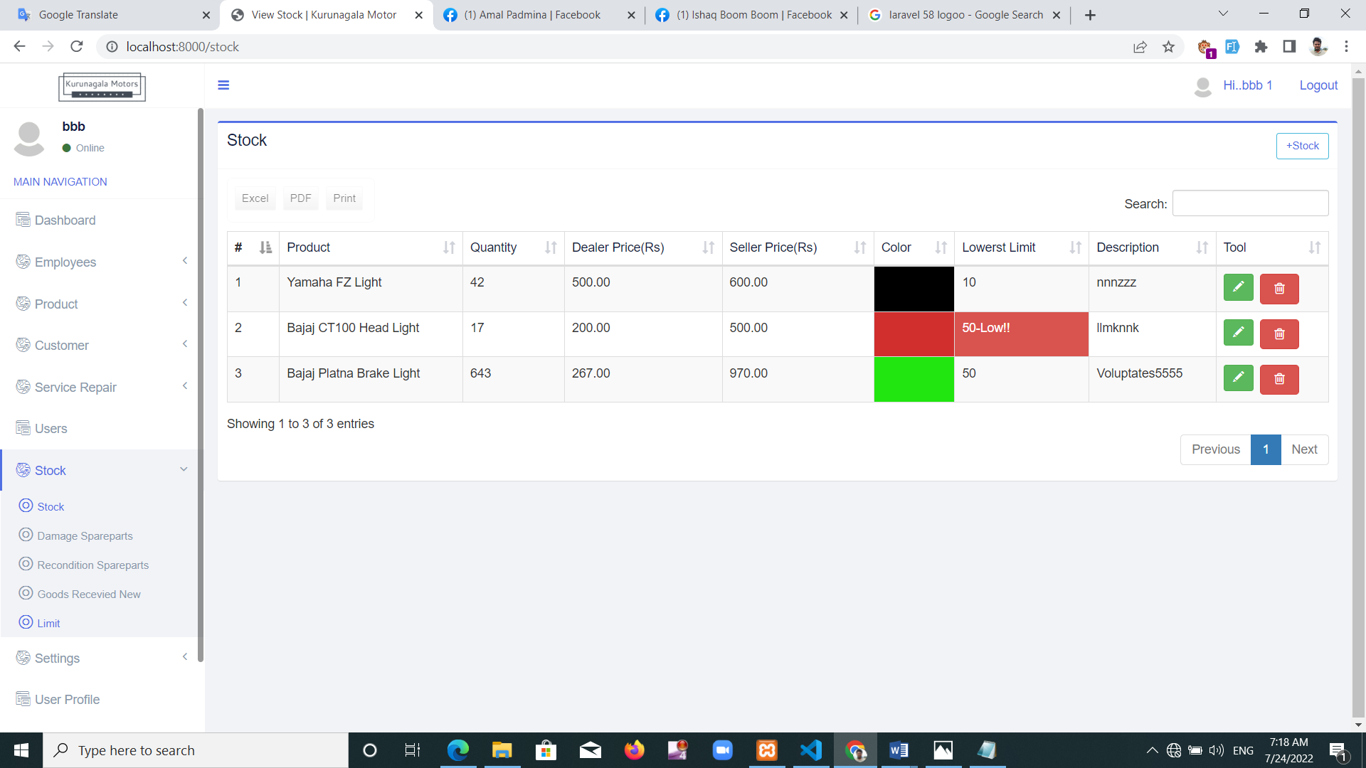

Figure 42: Stock

**Damage spare part**

This interface contains information about damaged spare parts. There's an interface shown in figure 43.

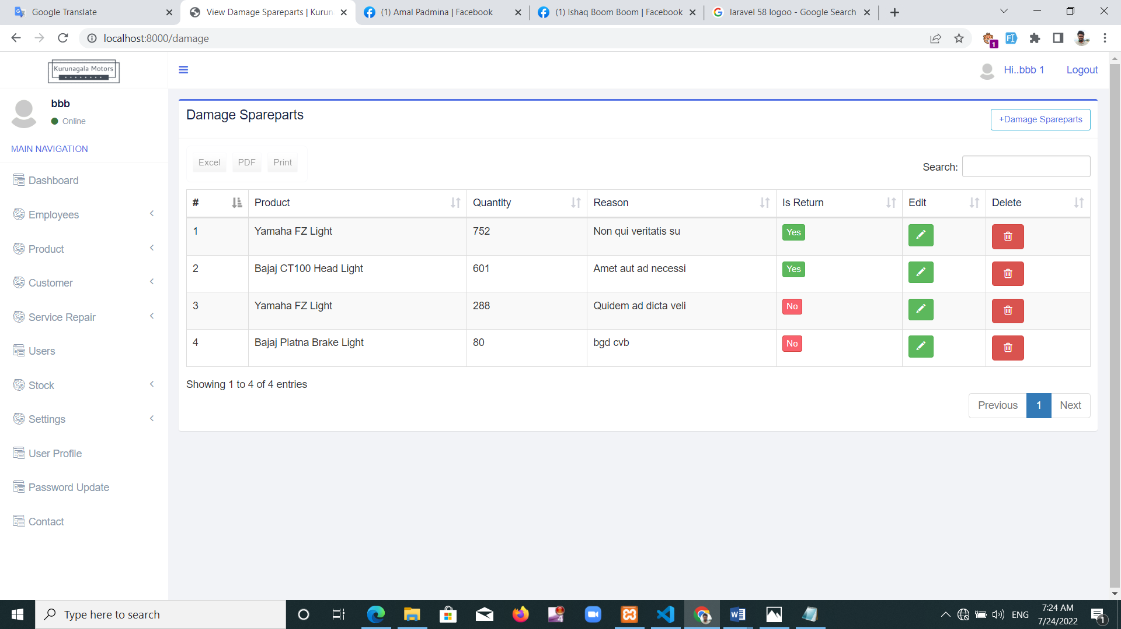

Figure 43: Damage spare part interface

**Recondition spare parts**

Used this interface when parting motorcycle. Here adds to the reusable stock system. There's an interface shown in figure 44.

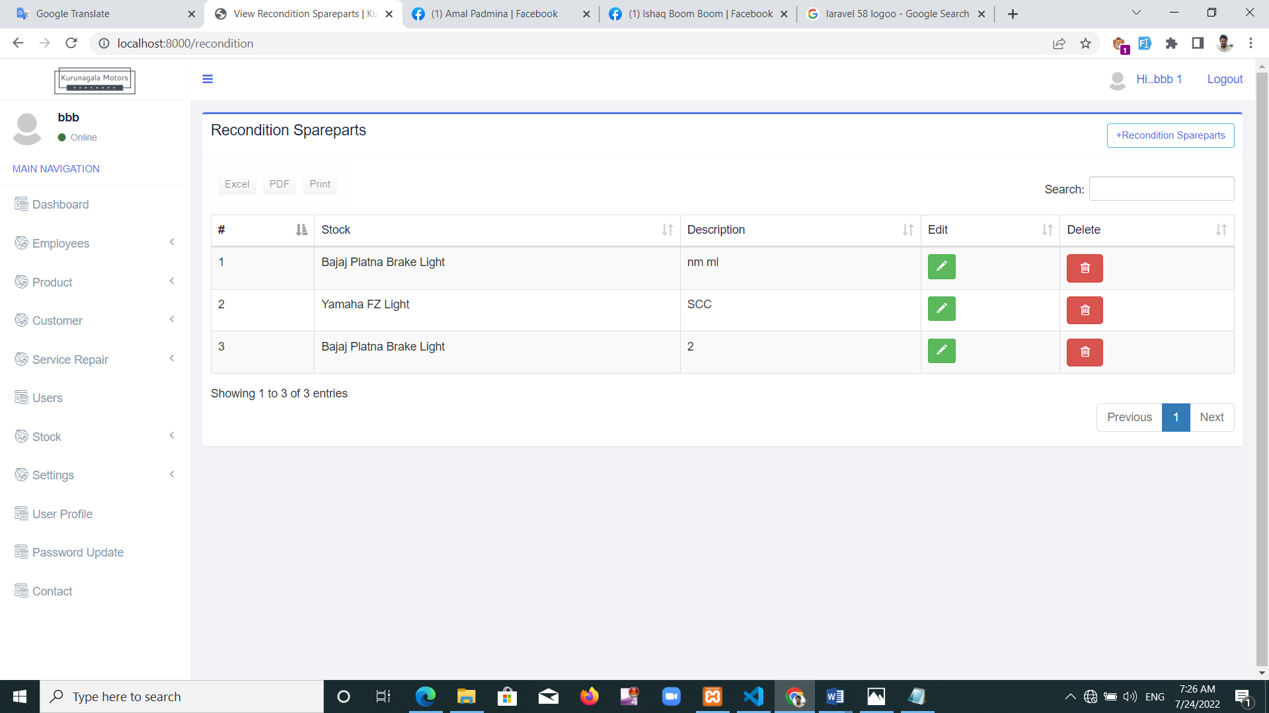

Figure 44: Recondition spare parts interface

**Goods received new**

New spares stock is added here once it is received. There's an interface shown in figure 45.

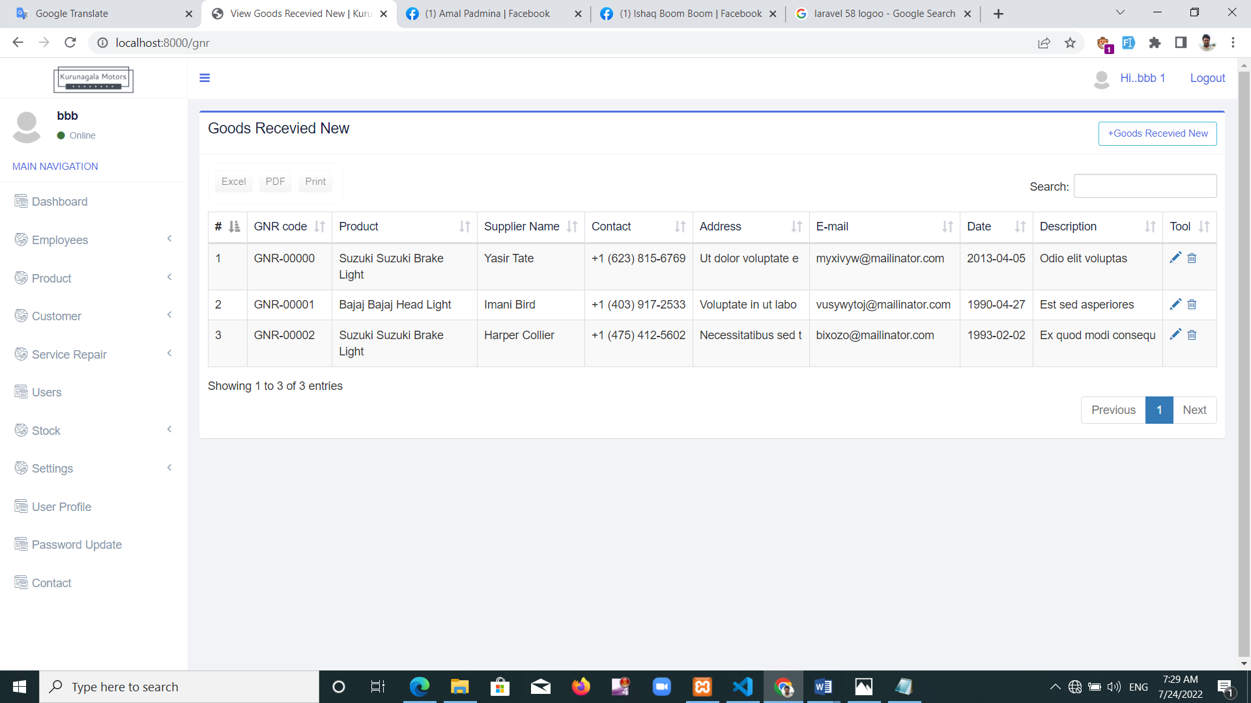

Figure 45: Goods received new interface

**Working hours**

Manager can upload up to date information regarding company running times. Web users can view it online. There's an interface shown in figure 46.

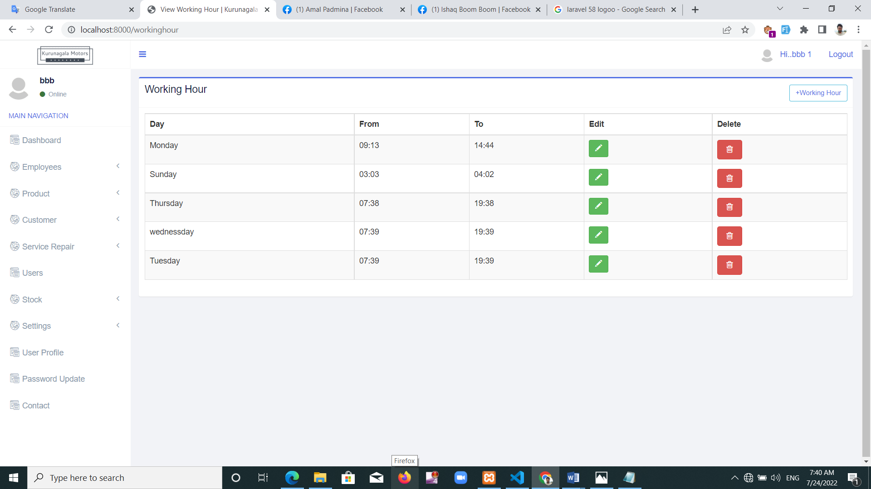

Figure 46: Working days interface

**Calendar**

Service-repairs registered each day, month will help to monitor through this calendar. There's an interface shown in figure 47.

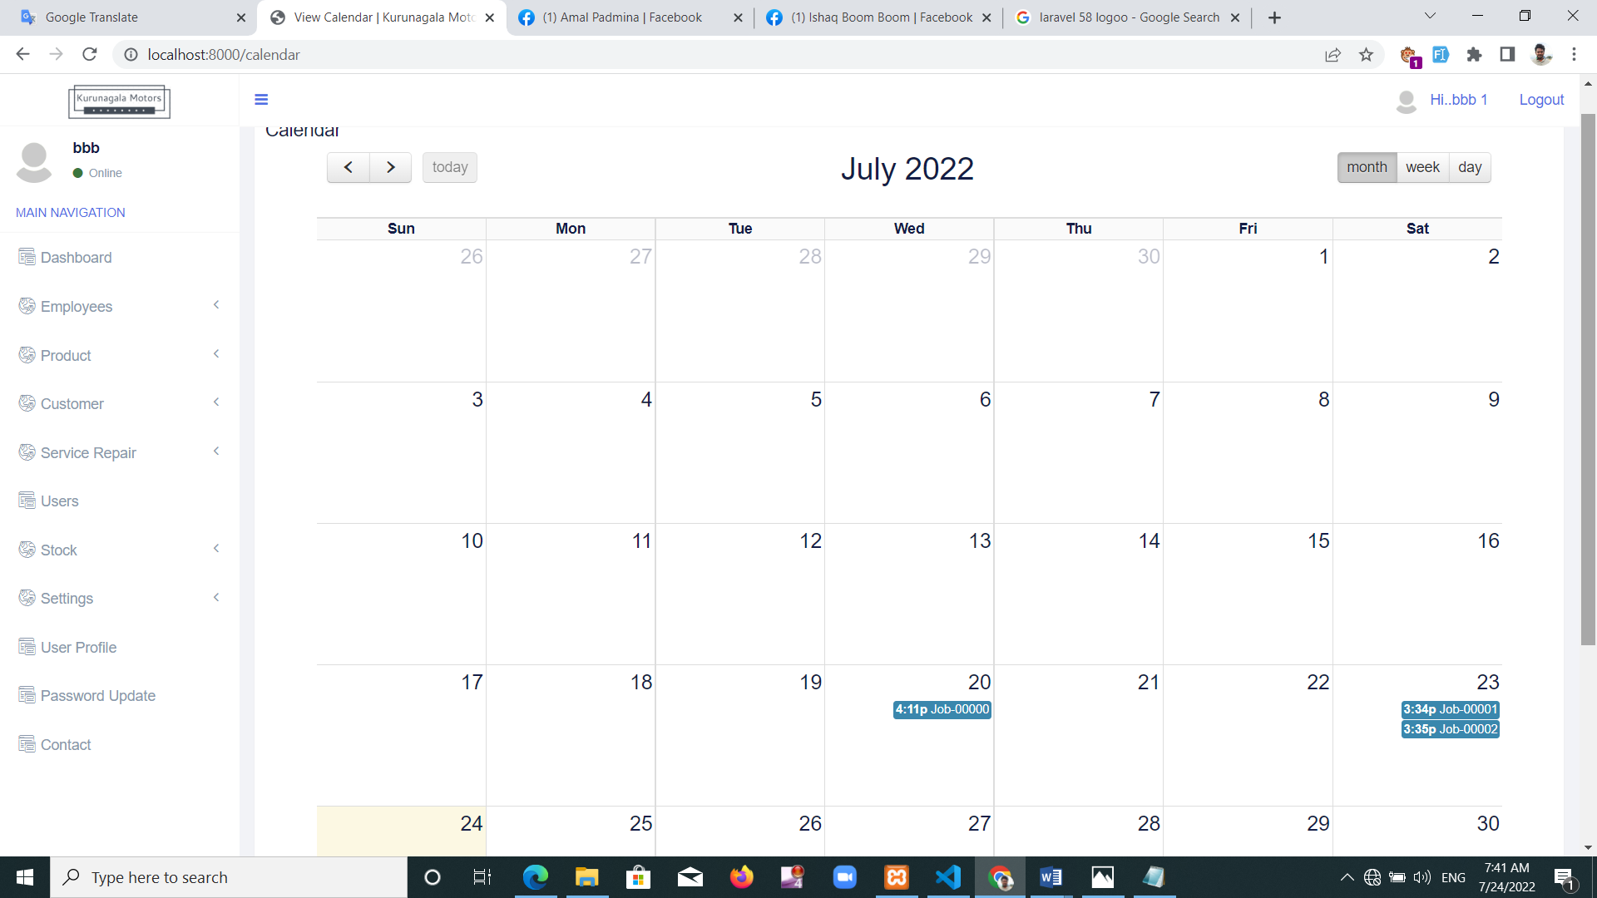

Figure 47: Calendar interface

**User profile**

This interface will help all registered users view and change their account information. Figure 48 shows that interface.

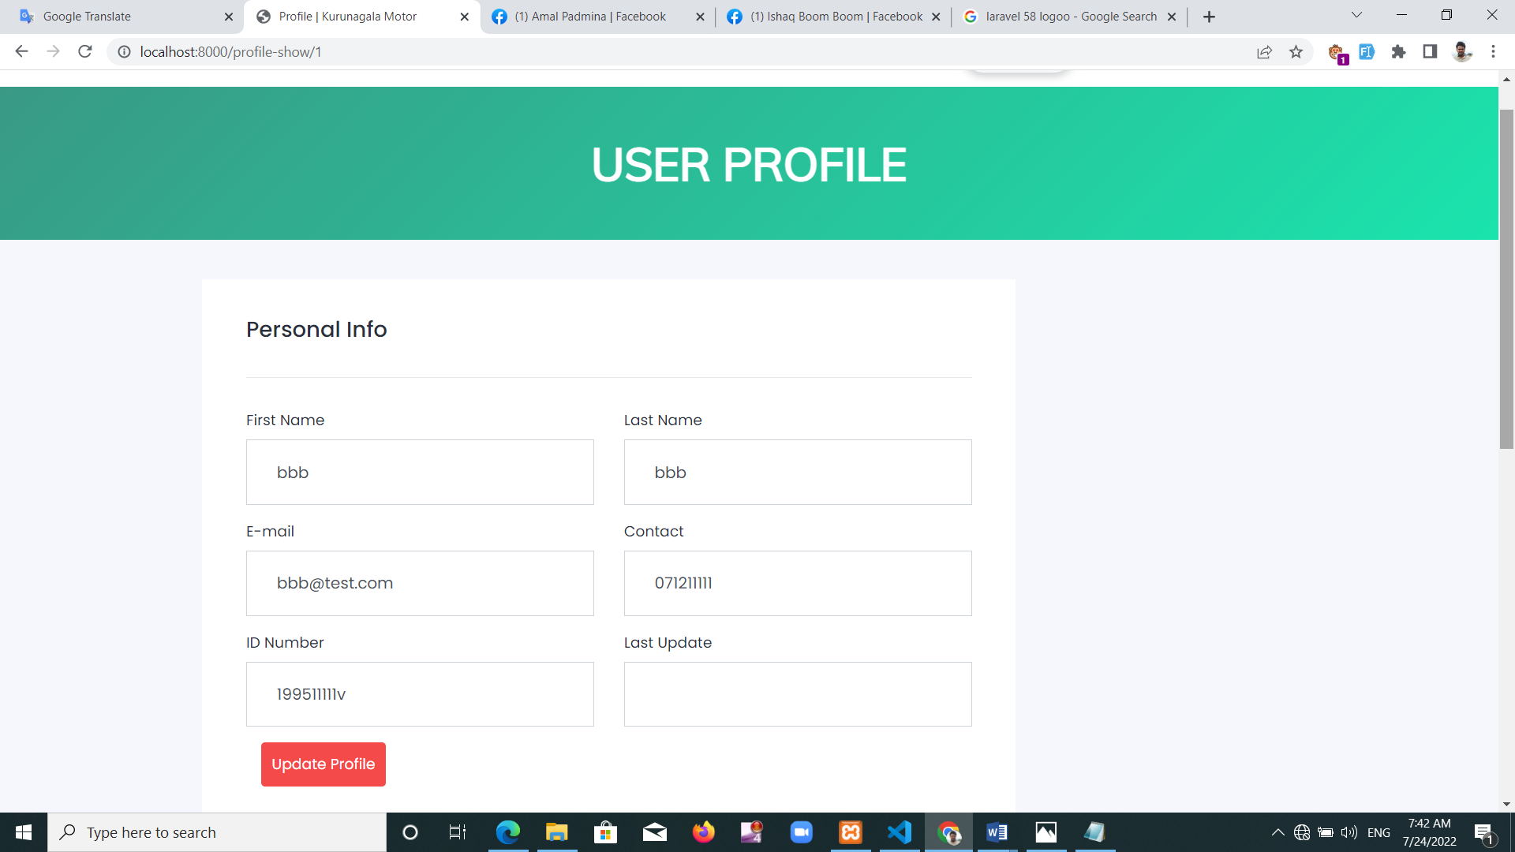

Figure 48: User profile

**Password update**

Users can use this interface if they want to change their password. Figure 49 shows that interface.

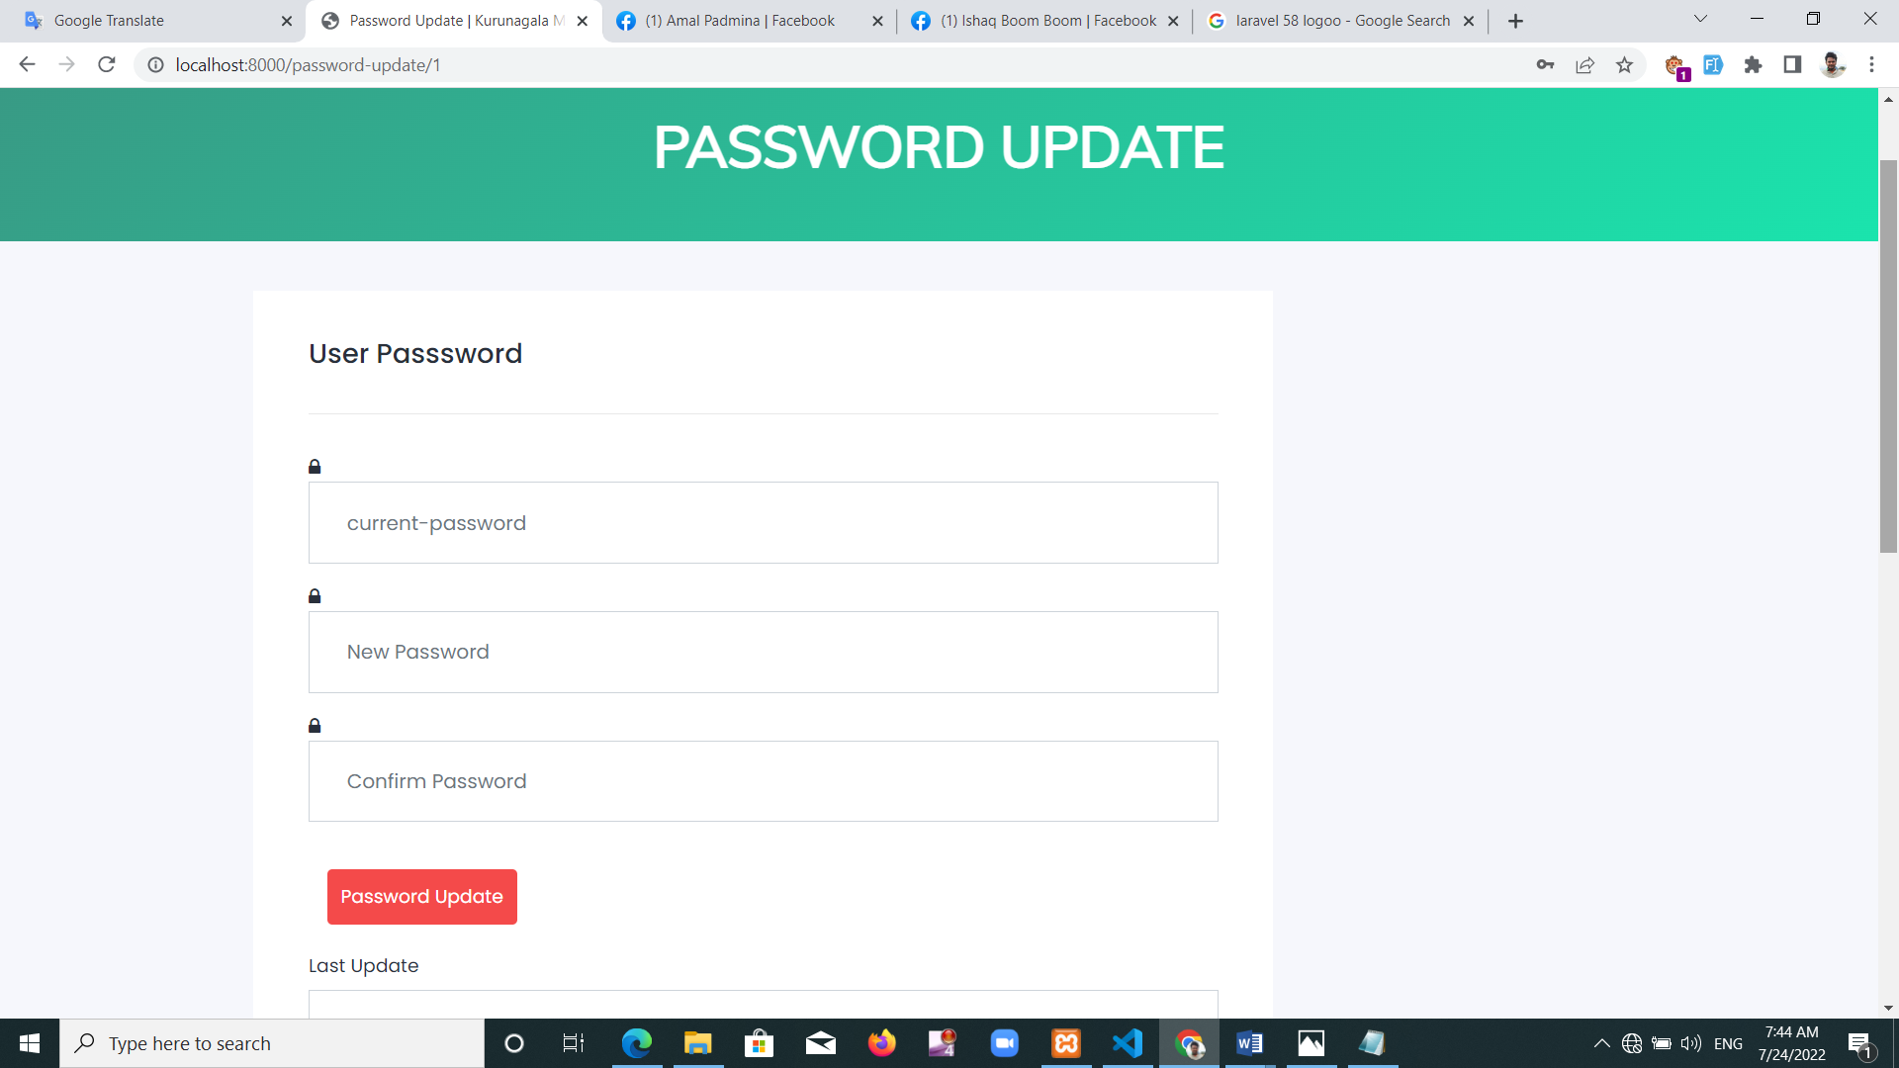

Figure 49: Password update interface

**Contact us form**

This interface shows the messages sent by any user who registered and unregistered. Those messages can be viewed and deleted. There's an interface shown in figure 50.

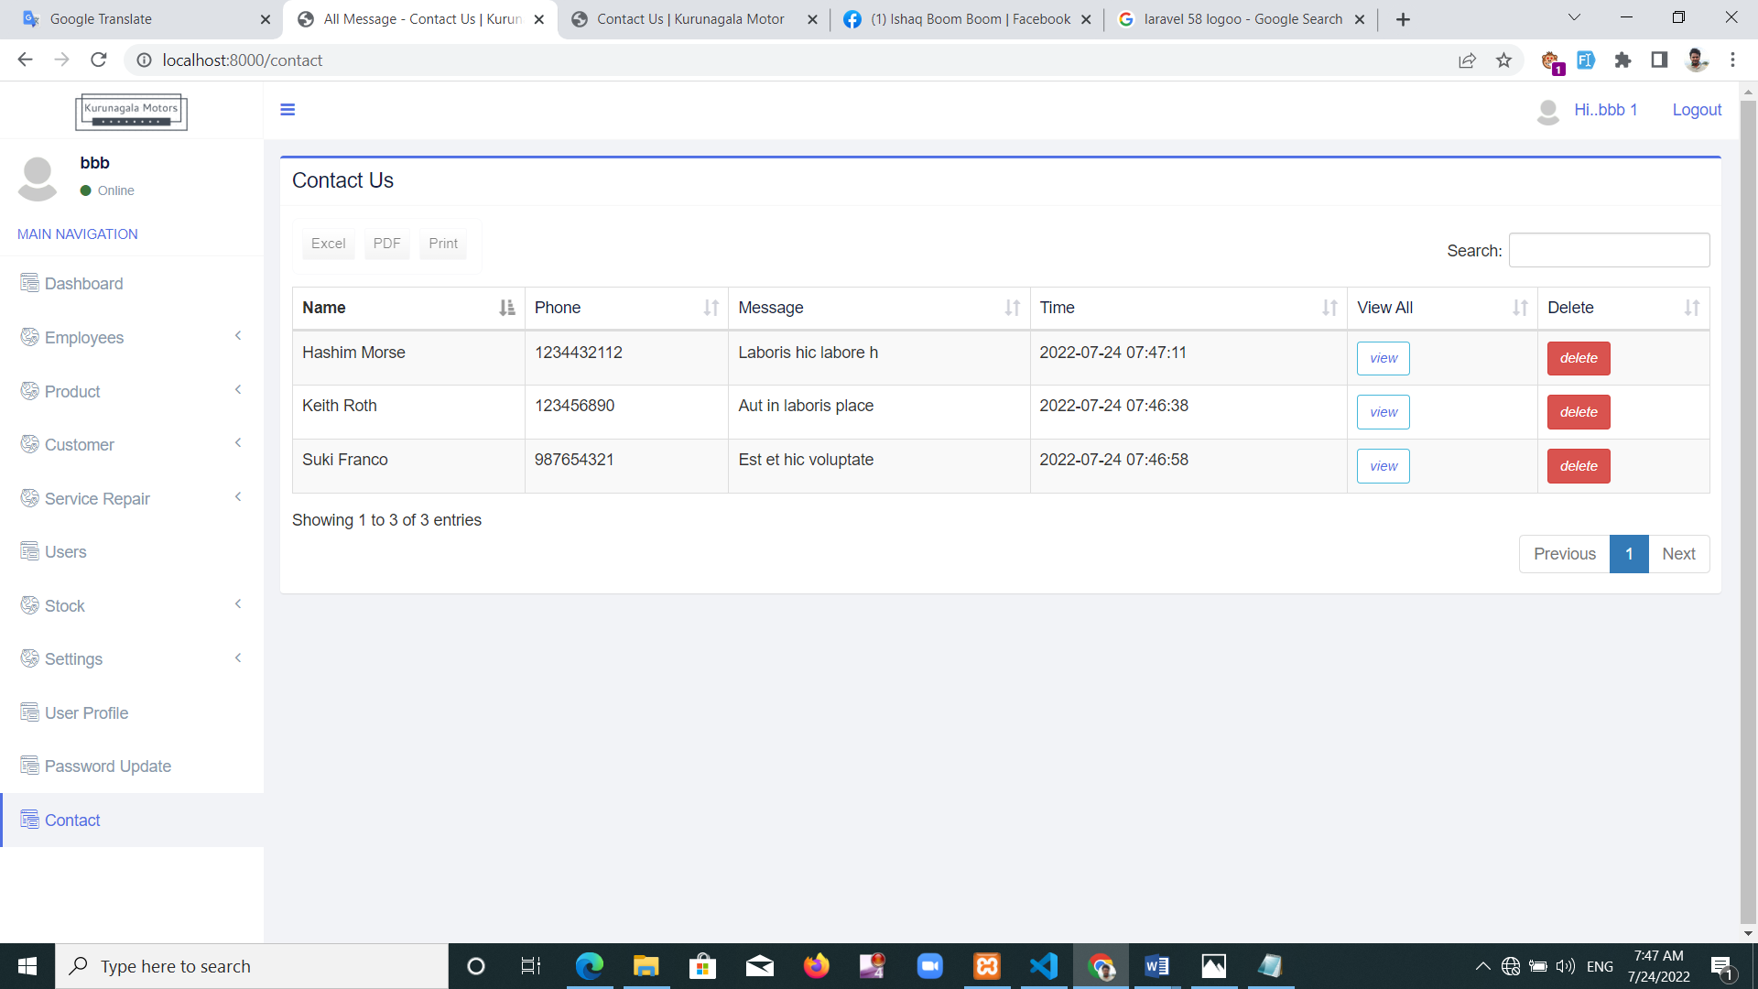

Figure 50: Contact-us form manager interface

**Customer home page**

This interface will help customers see information about their services, up to date data on spares, debt payments, and registered motorcycle information. There's an interface shown in figure 51.

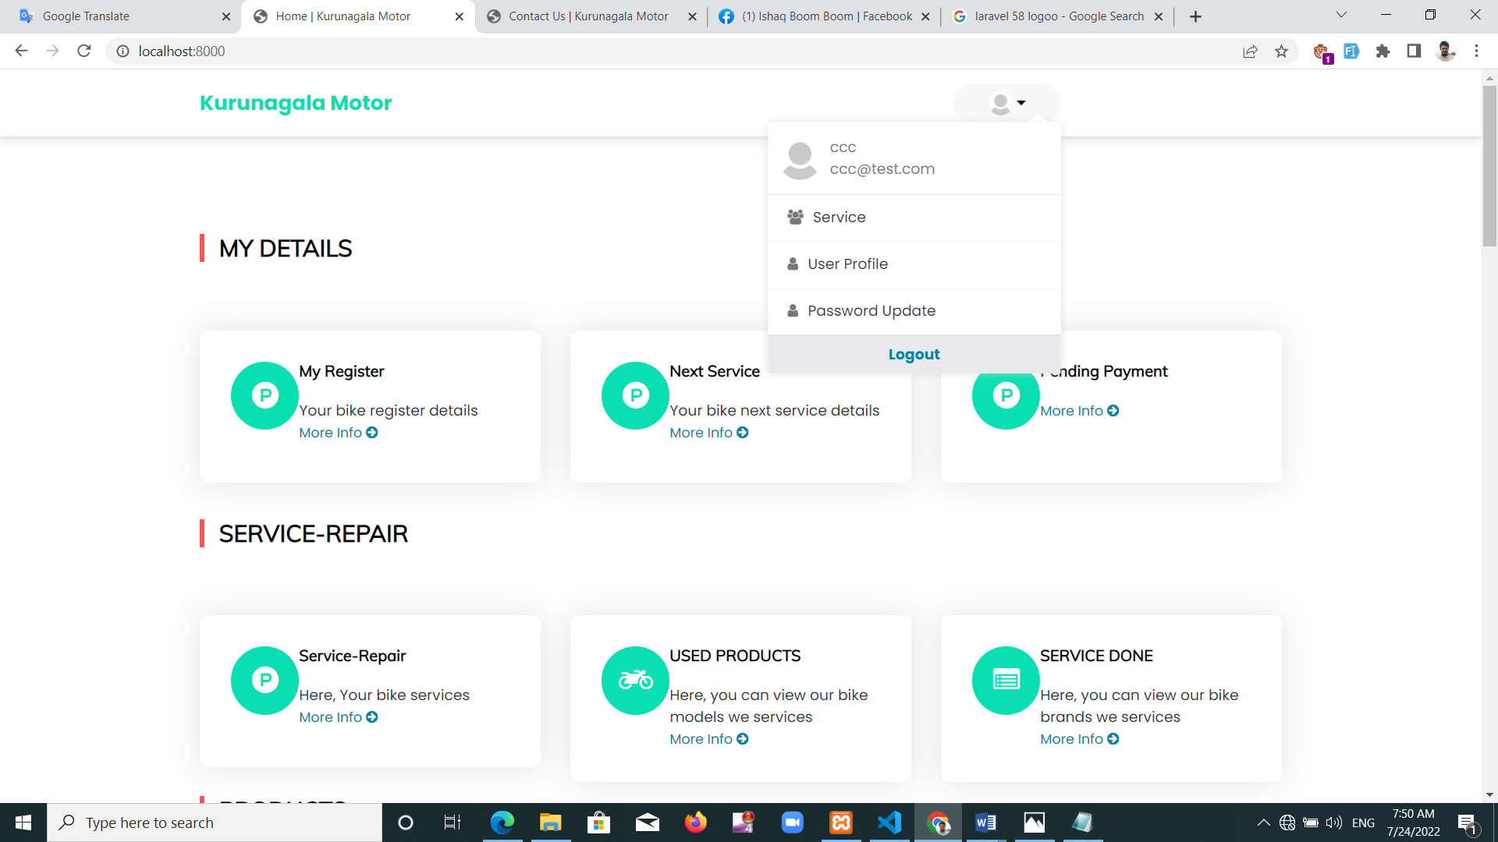

Figure 51: Customer home page interface

**Customer service repair details page**

This interface will help the customer see their repair history. This includes the information about the moter cycle registration number, the service done, the spares used. Figure 52 shows that interface.

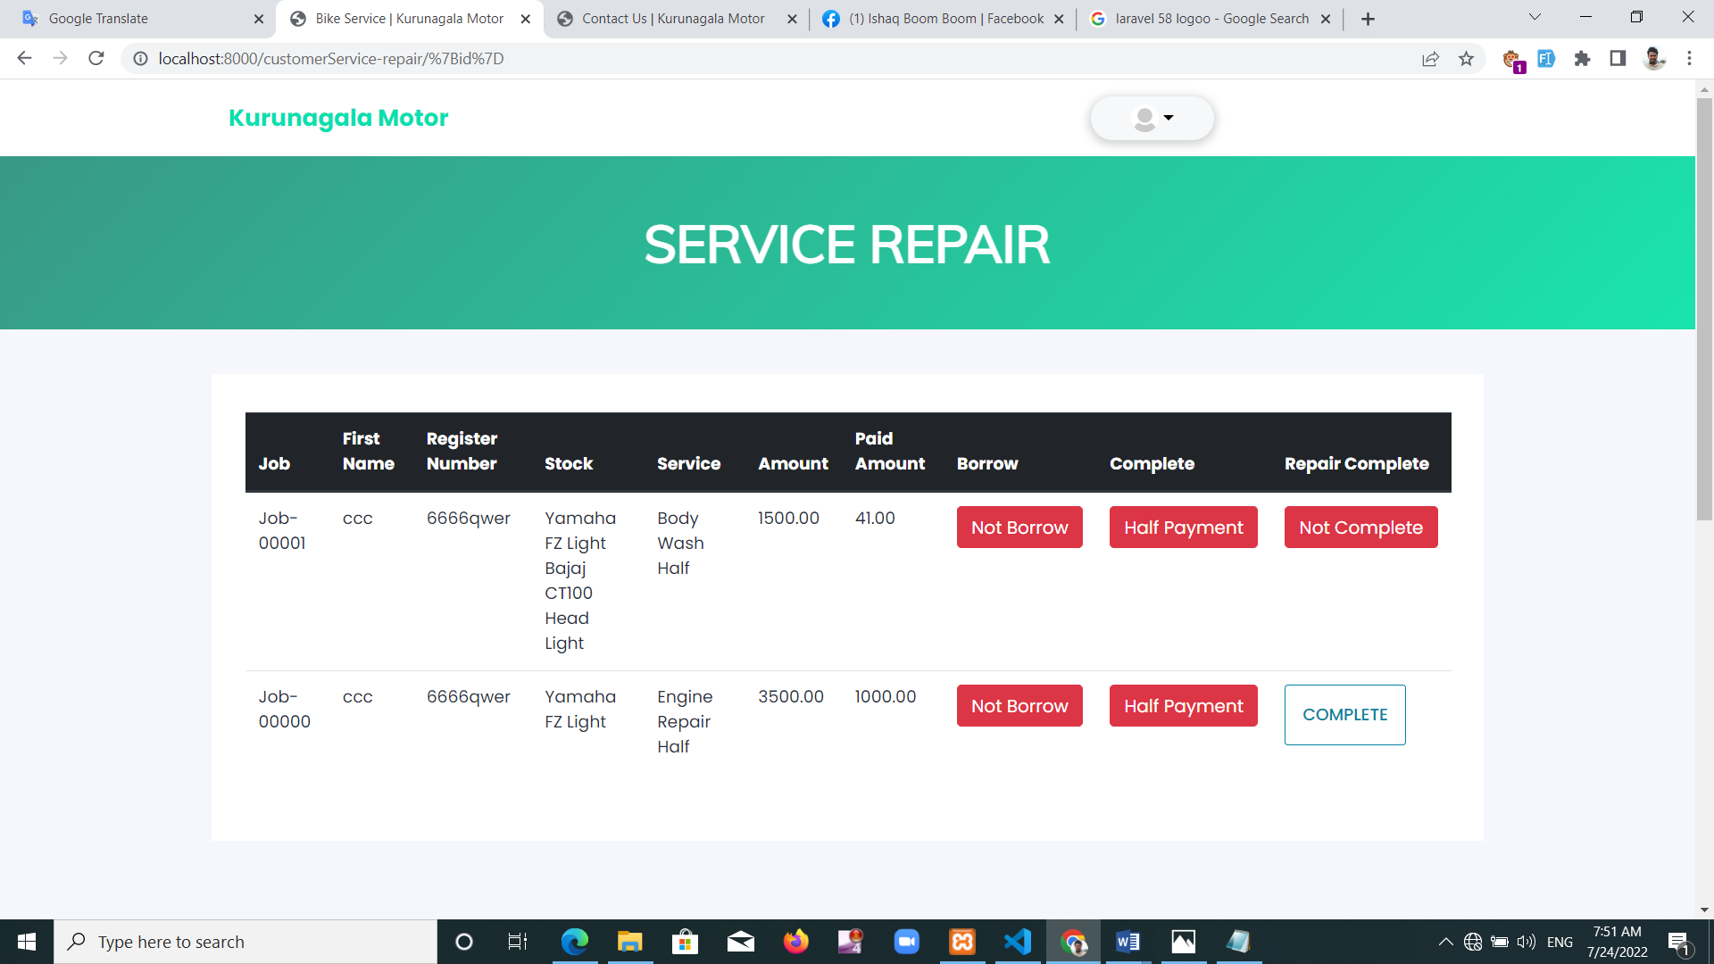

Figure 52: Customer service repair details page

**Customer bike register page**

Motorcycle details registered under each customer are included here. Customers can find the keys registered in their name here. There's an interface shown in figure 53.

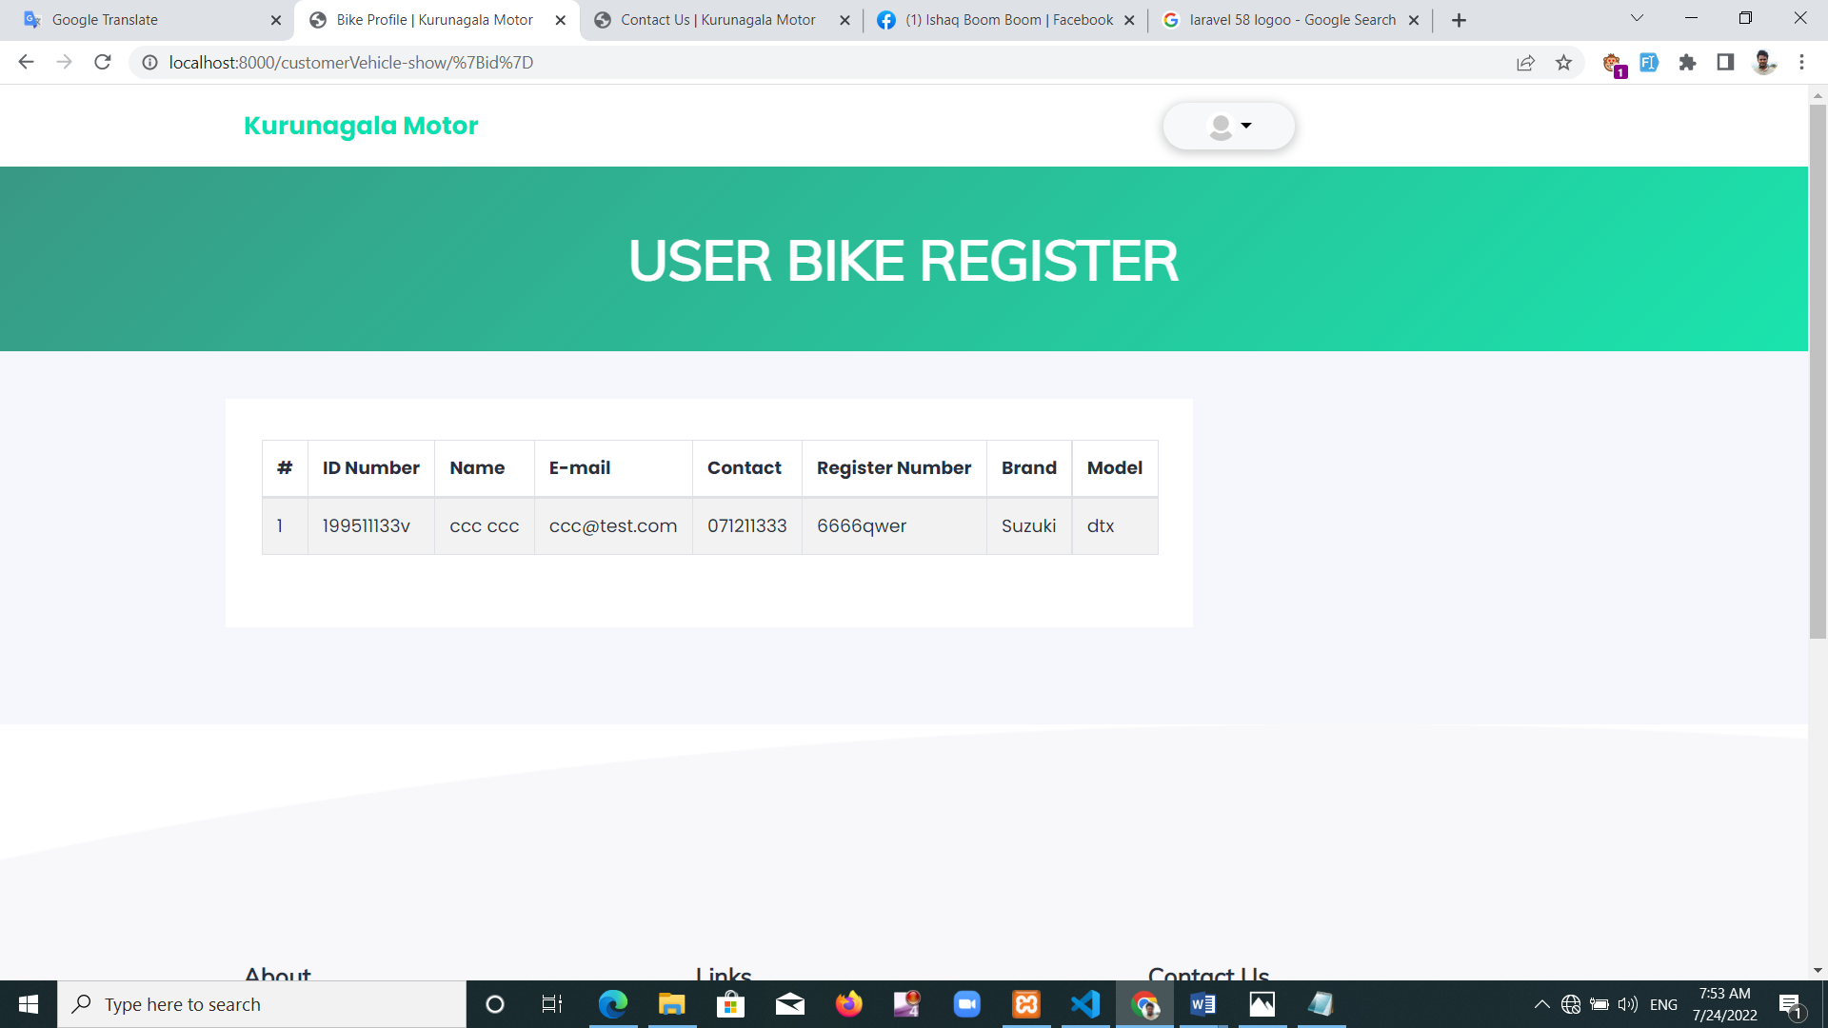

Figure 53: Customer bike register page

Customer pending service

The system gives the customer an opportunity to register their next service if necessary. Customer will receive an email message that needs repairs within the deadline of motorcycles. There's an interface shown in figure 54.

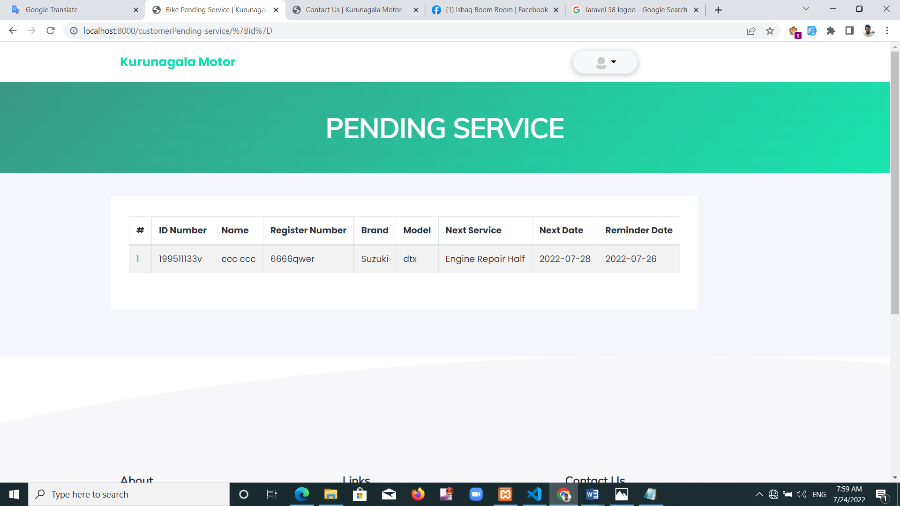

Figure 54: Customer pending service page interface

**Customer view product**

This allows customer to view spares online. Unregistered customers are also allowed to monitor spare parts here. Figure 55 shows that interface.

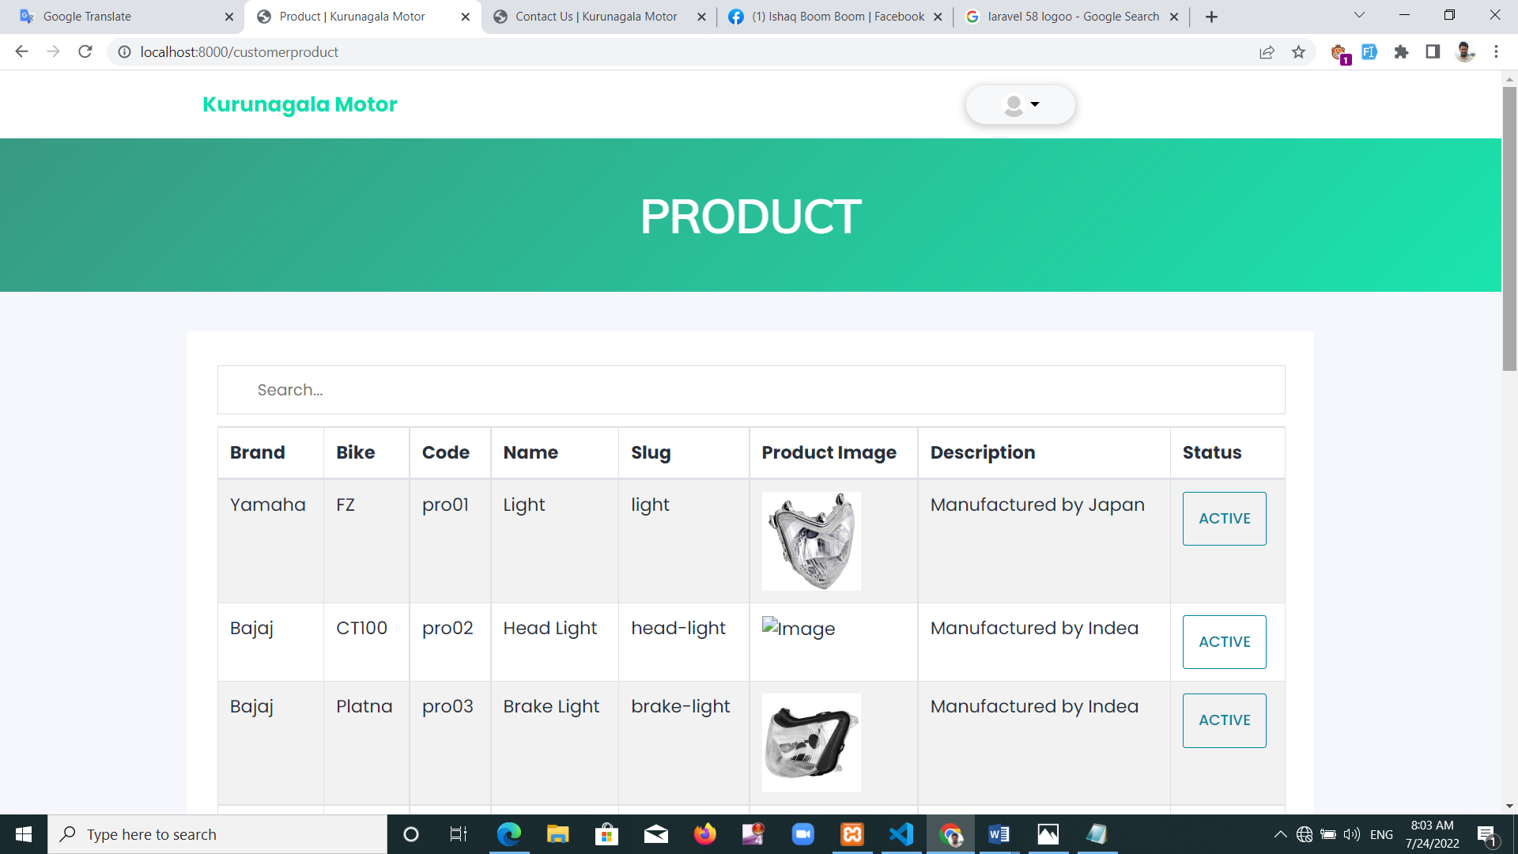

Figure 55: Customer product view interface

**Contact us form**

Customer can use this section to post their views. There's an interface shown in figure 56.

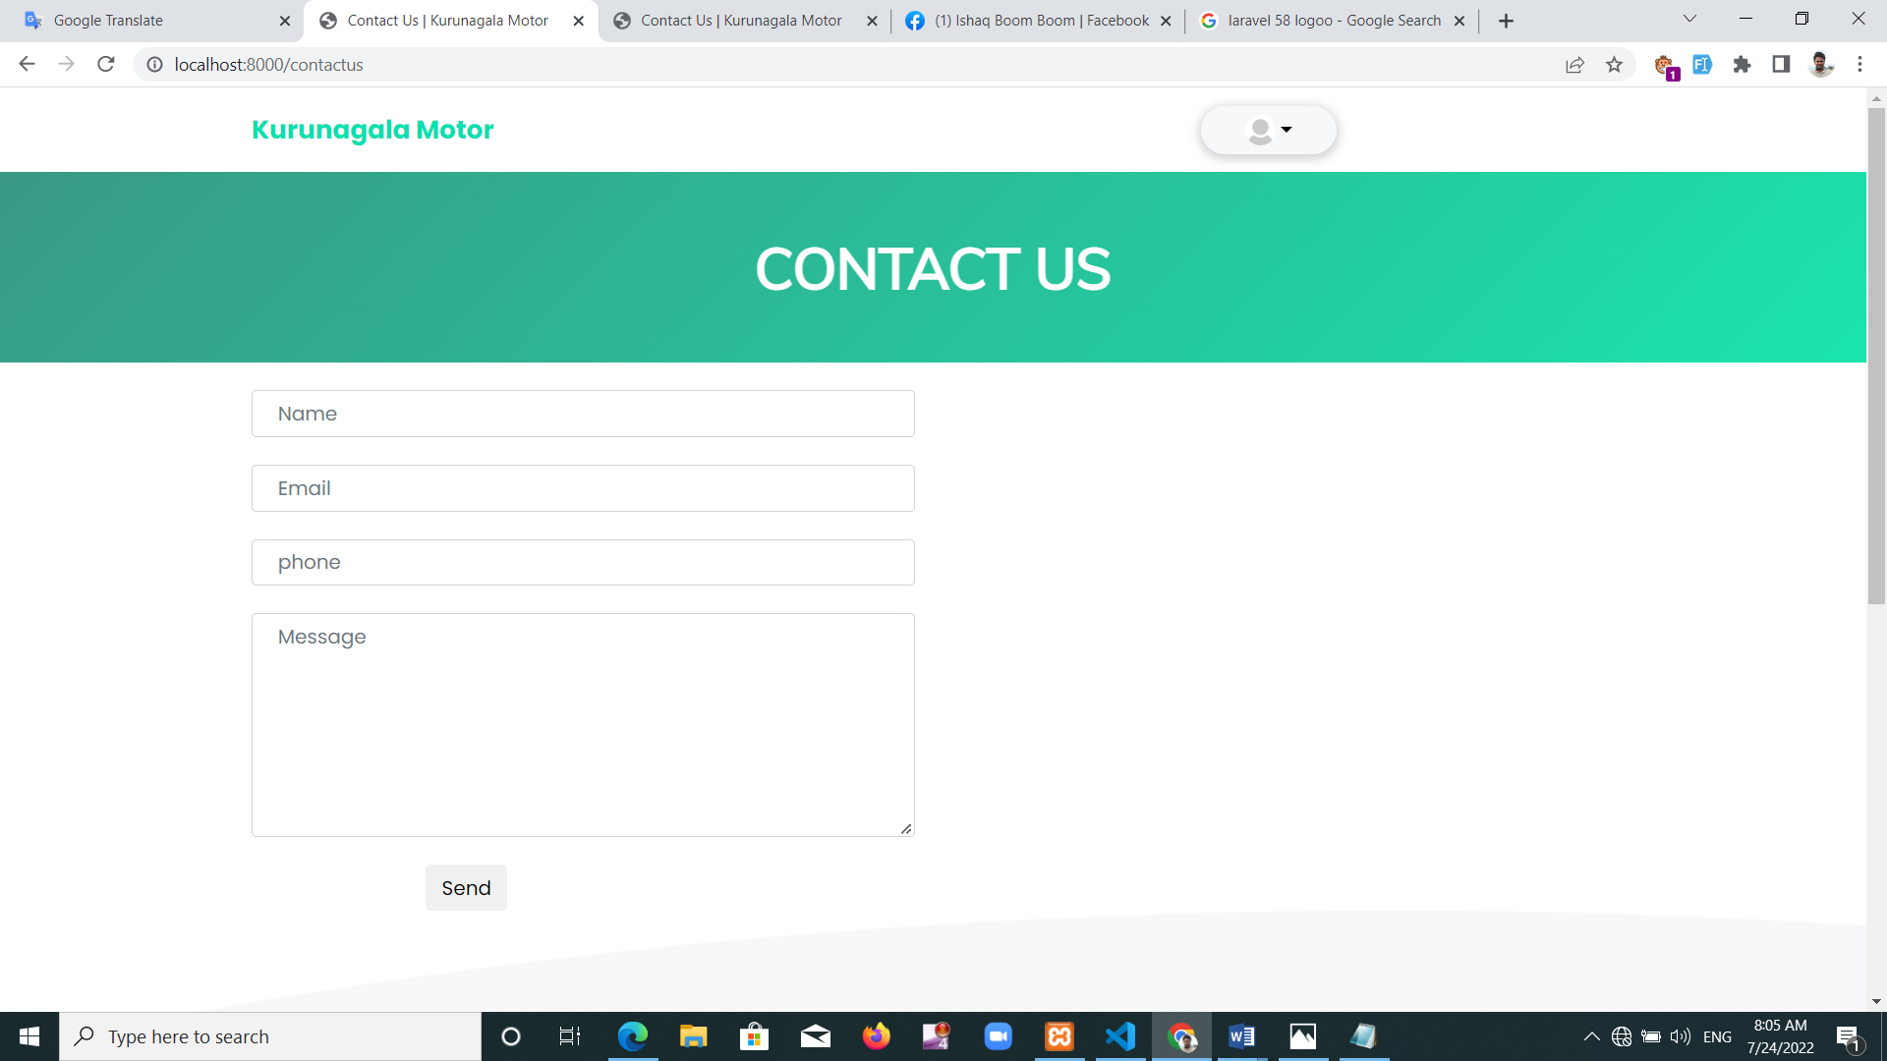

Figure 56: Contact us form

## 5.8. Summery

In this chapter, Kurunegala explained the evaluations of Motors Management System. There describes testing methods and how tests are conducted in the development of software. White box tests and black box tests explained. Some investigation needs explained here. Explained how employees examined the functionality of registration, employee salary payments, allowance payments, loans etc. It is expected that the accuracy of the system improved through these testing. Here added user interface of final system add a description about the interface details.

# Chapter 6 - Conclusions

## 6.1 Introduction

In this chapter there should be a summary of the project's objectives and a re-statement of its results. It contains what is learned from the project and what it acquired. This piece marks the end of the project.

## 6.2 Conclusion

It is very difficult to manage motorcycle service places using bookshelf these days. Garage manager is facing a number of problems because of this. Provide high quality service to protect employee jobs and retain customers due to current problems in the country. But under the current system, Kurunegala Motors Corporation is facing some problems.

* It is difficult to get correct information about the amount of work done by the employees. That information will help pay salaries and see the progress of the employees.
* Consumers may miss out on charging for motorcycles that are not paid in full. This is why the company is at losses.
* Lack of update information on spare parts store. Missing out on re-ordering until spares last.
* It is difficult to find information about services provided later. This is why it's hard to get information about the service when customers return.

The system will help you carry out more efficient and quality services through a motorcycle garage while managing existing resources. This is how you can explain the achievements of employee management. Employee receives his personal information at registration. The repairs done by the employee can be inspected separately. Due to the reduction of the employee's loan, the monthly salary, the loan charges are stopped.

Service payments are added to the basic salary depending on the repairs done by the employee. Problems arise during pay are avoided as the vacations taken by the employee are properly recorded. If you want to pay extra offers, this is allowed. The spare stock system received by the employee is noted. That's why spare parts are limited to being replaced. Manager can reduce conflicts with employees due to forgetfulness and avoidance during account book usage.

Let's consider the achievements in consumer management. Being able to monitor services and spare parts online is a success. The customer doesn't have to stay in the garage because they can learn about their motorcycle repairs online. Receiving an email at the start and end of the service so the motorcycle can be carried after the repair is completed. If the customer registers for the next service, it will also allow you to view information online. Since each service gets separate numbers, there is no chance for later repairs to be messed up. Customer can see their repair history. Consumers have paid a share of their money and carried motorcycles before the system was used. But the residue charges are avoided due to the lack of proper maintenance of account books. But it's easy to charge the rest because the information in the new system shows in a separate interface. Customer can remind payments by email message if required. This is why the garage benefits are bigger.

Let's consider the achievements through repair management. Some motorcycle repairs may be missed due to busyness. But the complete or not complete jobs view through the system such avoidance is minimized because it can be observed separately. All the information system deployed by the employee, repair information, repair spares, basic payment, service charges etc. Every repair will get a different number. This is why the information related to the repair can be seen separately. Separate buttons used to show the repair is complete, payment is complete, and motorcycle is accepted by customer. This is why observation makes easy. This information can be downloaded as records.

There are also some achievements in store management. An existing problem was the inability to realize those spares are minimal until stocks run out. The new system can provide a minimum level for spares. Red shows that part when it comes to the lowest. This is why spare parts make it easier to re-order. Store shows the remainder when spares are issued for repairs. You can see differently which employee got the spares and which repair. Used spares and damaged spares can be added to a separate system.

Trying to create faces in a friendly way to user. This cool most attractive web page has been created. Helps users know the information they need clearly. It's easy to comprehend because information is shown through the state. The system will help you carry out more efficient and quality services through a motorcycle garage while managing existing resources.

## 6.3. Future Works

The system has been developed to create a convenient environment for those who work with garage issues. If their needs increase in the future, the system must be improved and implemented. This could happen at least in many years to come. Construction needs to be done in such a situation. An understanding of existing system and user requirements is required. Necessary commentary lines, meaningful diversities and method naming can be maintained by following code standards. So looking forward to establishing further following upgrades on this project. Transferring chat with customers can be more effective if there is a way of discuss. Enhancing the computer knowledge of employees and facilitating them to get services through the system.

## The government has restricted the delivery of spare parts as of now. It is difficult to keep importing spare parts because of the lack of spare parts in the nation. So that they can return to the store for repairs, used spare parts might be upgraded. Discussed how to make it easier for cashiers to handle their information. Currently, cashiers receive merely the support necessary to keep the system working on a predetermined income. There is potential to increase customer access to online services. However, it was delayed because to a stock scarcity and difficulties with employee hiring.

## 6.4 Reflection

By successfully managing time while dealing with the continuing Corona crisis and other moment problems in the country, the project was able to be completed on time. The project made it feasible to reduce discrimination by using the same codes as the special codes that the company's personnel already use to produce spares. On this endeavor, my lack of understanding regarding garage services and spare components was a concern. However, I am fully aware of how the project's services are being delivered. Talked about the garage manager and internet consumption, and resolved numerous problems. This helped me comprehend motorcycles better.

## 6.5. Summary

Almost all objectives of the project were met according to the user expectations. The requirements of the system were thoroughly analyzed. It was successfully transformed into a design model and then implemented into an implementable source. Tested in a few stages later. Identified flaws corrected. The achievements achieved through this system are described. Benefits of consumer management, explained with problems faced in the past. Avoiding charges was observed as a major issue. The statues applied to it were explained. Benefits of repair management explained with problems faced in the past. The benefits of employee management are explained with problems faced in the past. The inability to monitor the progress of the employees became a problem and indicated that a separate interface was separated through the system. Benefits of Store Management, explained with problems faced in the past. One problem indicated that there was a delay in re-ordering spares. Also discussed the plans to be done ahead of this project. Some plans had to be postponed due to existing problems in the country. Problems of using technology will also be reduced in the future.

# Reference

1. 20t, 20l2 20l3. (2009). New registration of motor vehicles. Retrieved August 5, 2021, from Gov.lk website: https://dmt.gov.lk/images/PDF/statistics/pop2015.pdf
2. Dl.ucsc.cmb.ac.lk. 2022. [online] Available at: <https://dl.ucsc.cmb.ac.lk/jspui/bitstream/123456789/4328/1/2013MIT027.pdf> [Accessed 14 March 2022].
3. R. Addo-Tenkorang and P. Helo, “Enterprise Resource Planning (ERP): A review literature report,” Iaeng.org. [Online]. Available: http://iaeng.org/publication/WCECS2011/WCECS2011_pp1126-1134.pdf. [Accessed: 18-Mar-2022].
4. M. D. Watson and S. B. Johnson, “A theory of vehicle management systems,” in 2007 IEEE Aerospace Conference, 2007.
5. Adler, Jane. "Between the lines: profitable garage management." Journal of Property Management, vol. 63, no. 3, May-June 1998, pp. 58+. Gale Academic OneFile, link.gale.com/apps/doc/A21061049/AONE?u=anon~a90fcf51&sid=googleScholar&xid=f28d6d35. Accessed 18 Mar. 2022.
6. “Service Station Management Software | CSoft Lanka,” CSoft Lanka, Jan. 25, 2016. https://csoftlanka.com/project/service-station-management-software/ (accessed Mar. 20, 2022).
7. “Auto Miraj - We provide total auto solutions | Over 25 years of service,” Auto Miraj. http://www.automiraj.lk/index.html# (accessed Mar. 16, 2022)
8. “VIRSU.LK | Key Business Solutions,” virus.lk. https://virus.lk/garage-management-system.php (accessed Mar. 20, 2022).

# Appendix A – Activity diagram

Add new employee activity diagram

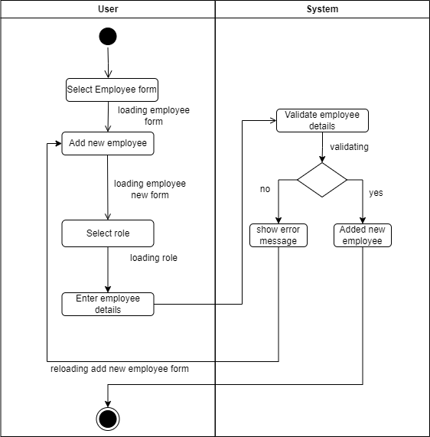

Figure 57: Add new employee activity diagram

Add pending service details

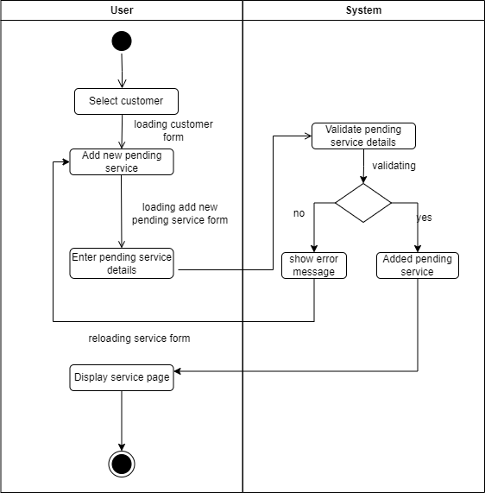

Figure 58: Add pending service details

Add new product activity diagram

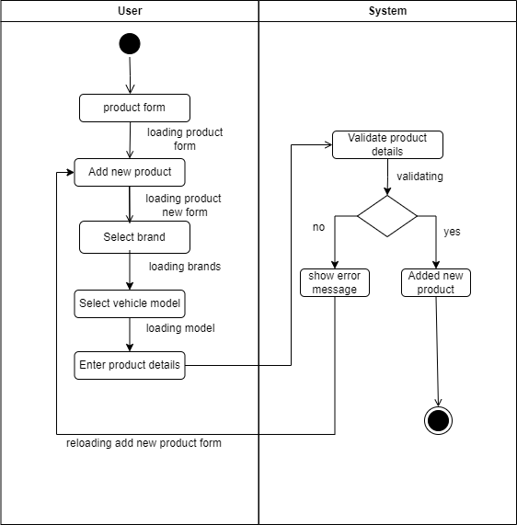

Figure 59: Add new product activity diagram

Add role activity diagram

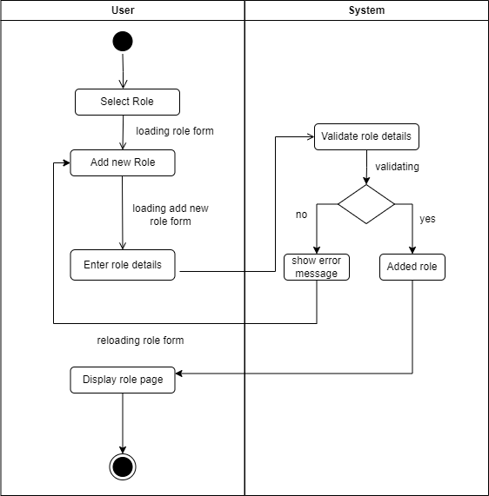

Figure 60: Add role activity diagram

Add service activity diagram

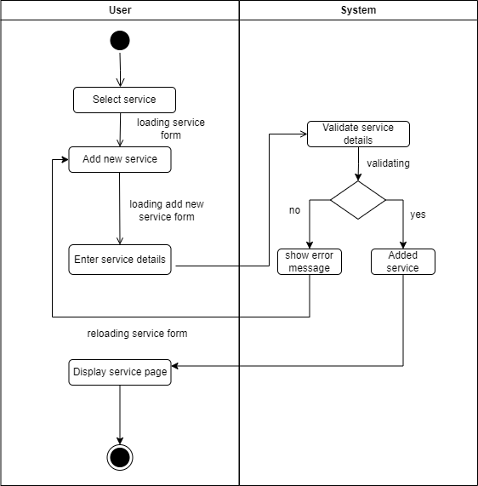

Figure 61: Add service activity diagram

Calculate salary activity diagram

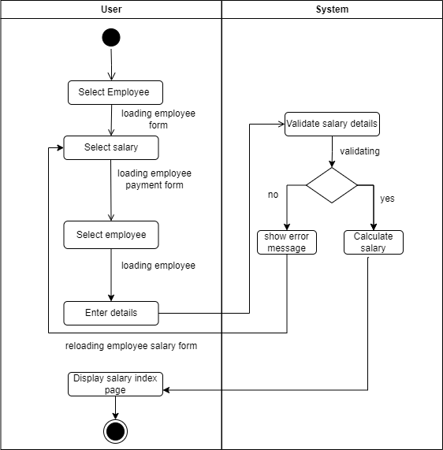

Figure 62: Calculate salary activity diagram

Add new user activity diagram

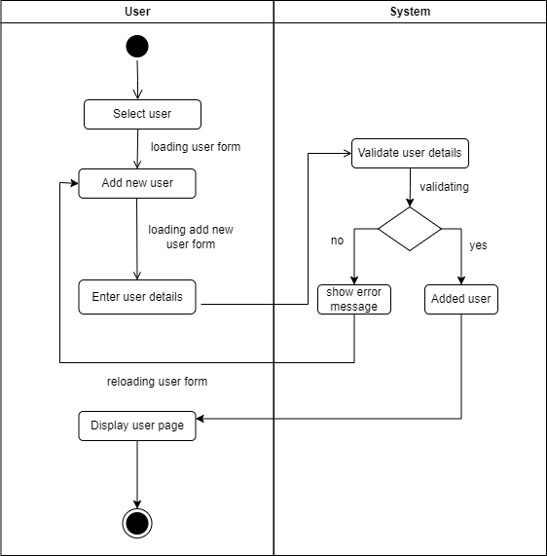

Figure 63: Add new user activity diagram

Add service repair activity diagram

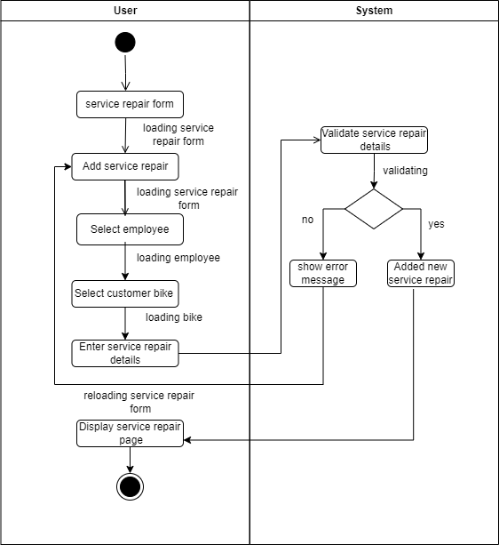

Figure 64: add service repair activity diagram

Add customer vehicle activity diagram

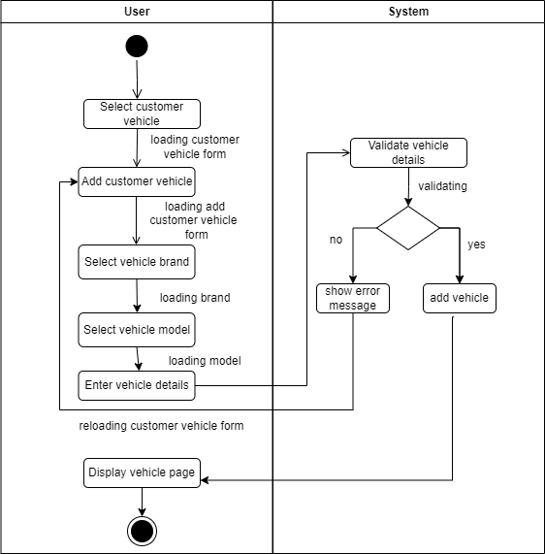

Figure 65: Add customer vehicle activity diagram

# Appendix B – DFD diagram

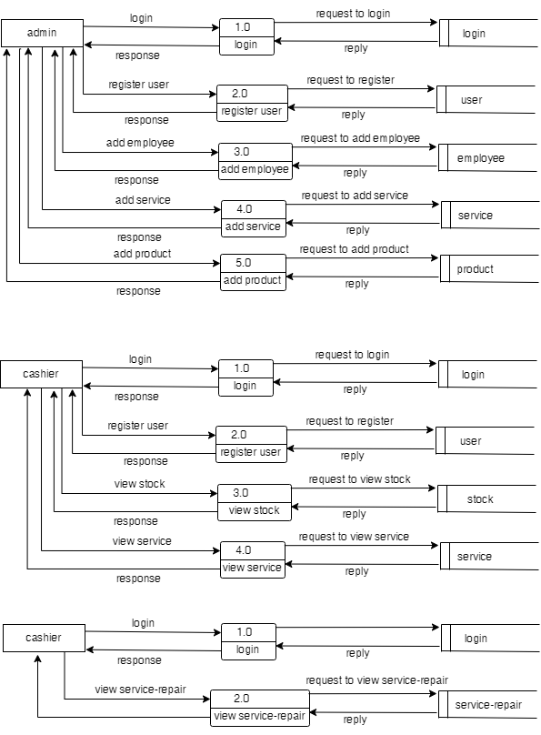

Figure 66: DFD diagram

# Appendix C – SRS

**Software Requirements Specification**

**For**

**Kurunagala Motors Management Information System**

**Version 1.0**

**Prepaired by: E1947056 – M.G.R.P.Yasasiri**

**Bachelor of Information Technology (External Degree)**

**Faculty of Information Technology**

**University of Moratuwa**

**Date of Submission – 16th of April 2022**

**Table of Contents**

**List of Figure** 22

**List of Tables** .**Error! Bookmark not defined.**

**Revision History** 22

**1.** **Introduction** 23

**1.1.** **Purpose** 23

**1.2.** **Document Conversions** 23

**1.3.** **Intended Audience and Reading Suggestions** 23

**1.4.** **Project scope** 23

**1.5.** **Reference** 24

**2.** **Overall Description** 24

**2.1.** **Product Perspective** 24

**2.2.** **Product Features** 26

**2.3.** **User Classes and Characteristics** 28

**2.4.** **Operating Environment** 28

**2.5.** **Design and implementation** 28

**2.6.** **Assumptions and Dependencies** 28

**3.** **System features** 28

**3.1.** **New Employee Registration** 28

**3.1.1.** **Description and Priority** 28

**3.1.2.** **Stimulus/ Response Sequences** 29

**3.1.3.** **Functional Requirements** 29

**3.2.** **New Customer Registration** 29

**3.2.1.** **Description and Priority** 29

**3.2.2.** **Stimulus/ Response Sequences** 29

**3.2.3.** **Functional Requirements** 30

**3.3.** **create new Role** 30

**3.3.1.** **Description and Priority** 30

**3.3.2.** **Stimulus/ Response Sequences** 30

**3.3.3.** **Functional Requirements** 30

**3.4.** **Log in to the system** 30

**3.4.1.** **Description and Priority** 30

**3.4.2.** **Stimulus/ Response Sequences** 31

**3.4.3.** **Functional Requirements** 31

**3.5.** **Logout in the system** 31

**3.5.1.** **Description and Priority** 31

**3.5.2.** **Stimulus/ Response Sequences** 31

**3.5.3.** **Functional Requirements** 31

**3.6 View spare parts and services** 31

**3.6.1. Description and Priority** 32

**3.6.2. Stimulus/Response Sequences** 32

**3.6.3. Functional Requirements** 32

**3.7 Add new employee** 32

**3.7.1. Description and Priority** 32

**3.7.2. Stimulus/Response Sequences** 32

**3.7.3. Functional Requirements** 33

**3.8 Add Model** 33

**3.8.1. Description and Priority** 33

**3.8.2. Stimulus/Response Sequences** 33

**3.8.3. Functional Requirements** 33

**3.9 Add Brand** 33

**3.9.1. Description and Priority** 33

**3.9.2. Stimulus/Response Sequences** 34

**3.9.3. Functional Requirements** 34

**3.10 Add Product** 34

**3.10.1. Description and Priority** 34

**3.10.2. Stimulus/Response Sequences** 34

**3.10.3. Functional Requirements** 35

**3.11 Register Customer** 35

**3.11.1. Description and Priority** 35

**3.11.2. Stimulus/Response Sequences** 35

**3.11.3. Functional Requirements** 35

**3.12 Sign in Customer** 35

**3.12.1. Description and Priority** 36

**3.12.2. Stimulus/Response Sequences** 36

**3.12.3. Functional Requirements** 36

**4.** **External Interface Requirements** 36

**4.1.** **Mock Screen** 36

**4.2.** **Hardware Interface** 38

**4.3.** **Software interface** 39

**4.4.** **Communication interface** 39

**5.** **Other Nonfunctional Requirement** 39

**5.1.** **Performance Requirement** 39

**5.2.** **Safety Requirement** 39

**5.3.** **Security Requirement** 39

**5.4.** **Software Quality Attributes** 40

**6.** **Other Requirements** 40

**Appendix A: Glossary of terms** 40

**Appendix B: Analysis models** 40

**List of Figure**

Figure 1: Class diagram 27

Figure 2: Login page for proposed system 37

Figure 3: Register page for proposed system 37

Figure 4: Admin dashboard for proposed system 37

Figure 5: Cashier dashboard for proposed system 38

Figure 6: Customer dashboard for proposed system 38

Figure 7: Use case diagram 41

**List of Tables**

Table 1: Document Convention.................................................................................................... 23

Table 2: Glossary of abbreviation................................................................................................. 41

Table 3: Login use case description.............................................................................................. 43

Table 4: Create profile user case description................................................................................ 43

Table 5: Logout use case description............................................................................................ 4

Revision History

|  |  |  |  |
| --- | --- | --- | --- |
| Name | Date | Reason For Change | Version |
|  |  |  |  |
|  |  |  |  |

1. **Introduction**

**1.1 purpose**

The document's goal is to compile and evaluate all of the various suggestions that have been made for defining the system and its consumer-related requirements. In order to better understand the project, we will also define concepts that may be developed later and record ideas that are being explored but may be abandoned as the product develops. Additionally, we will forecast and organize how we expect this product will be used.

This SRS document's primary objective is to provide readers a thorough overview of our software product, including all of its features and objectives. This paper defines the project's user interface, hardware, and software requirements as well as the audience. It describes how our customers, our team, and the target audience view the product and its capabilities. But, participating in the software development lifecycle (SDLC) processes is useful for any developer or designer.

1.2. **Document Conversions**

|  |  |
| --- | --- |
| Category | Description |
| Font | Times New Roman |
| Size | 12 |
| Line & paragraph spacing | 1.5 |
| Style | Normal |
| Color | Black |

Table 41: Document conversion

* 1. **Intended Audience and Reading Suggestions**

SRS documentation created as getting intended audience which consists of developers of the system, stakeholders of project, the garage staff and consumer motorcyclists of kurunagala motors and any other parties in the Kurunagala Motors Management Information System.

* 1. **Project scope**

The goal of this system is to give users a productive workspace where they can produce more work. This system's user-friendly interface makes it possible to understand all of the system's usability aspects. This system aids in viewing data so that historical records may be checked through them and judgments can be based on them. The task is finished by this system in a remarkably short amount of time, resulting in a low time consumption and high level of efficiency.

**1.4 Reference**

1. Pdfs.semanticscholar.org. 2021. [online] Available at: <https://pdfs.semanticscholar.org/3ab6/0c9ff860fafdc369a44b700bba22ba2da1d1.pdf> [Accessed 11 December 2021].
2. “My TECHWR-L | articles | community | about TECHWR-L articles -employment | articles -getting started | articles -planning | articles -technology | articles -writing | tags,” Psu.edu. [Online]. Available: https://citeseerx.ist.psu.edu/viewdoc/download?doi=10.1.1.470.9878&rep=rep1&type=pdf. [Accessed: 25-Mar-2022].
3. S. W. Ali, Q. A. Ahmed and I. Shafi, "Process to enhance the quality of software requirement specification document," 2018 International Conference on Engineering and Emerging Technologies (ICEET), 2018, pp. 1-7, doi: 10.1109/ICEET1.2018.8338619.
4. **Overall Description**

**2.1 Product Perspective**

Through the Kurunagala Motors Management system, it is hope to make the Kurunagala Motors garage fully operational and efficient and to make the motorcycle garage a fully system. Kurunagala Motors Management system is hoped that the current financial, reporting and stock manage will be done through a computerized system.

* **Cashier description**

It includes Customer and motor cycle registration and service details, bill details, spare parts details and take reports, check stock and give discount for customers.

* **Customer description**

It includes customer account details, view spare parts and check pending services. View pending payments and service history. Customer received an email after the service.

* **Manager description**

It includes employee details roles, the given bonuses on merit to employees. Employees’ salaries, loan and allowance added. Add spare part, model, and brand. Check limits, service history and customer later payment.

Ability to obtain reports.

* Customer pending payments.
* The amount of work done by employee work separately.
* Used spare parts.
* Bike service report.
* Employee earn money for the garage separately.

Include a notification system.

* Make a notification when start and end of service repair.
* Notification about customer pending payments
* Pending services.

Display information related to charts. user, jobs and more. It facilitates comparison with past details.

Search details

* Stock now
* Goods received new
* products in the stock
* Stock limits
* Customer job details
* Customer pending service
* Employee daily work
* Complete job
* Employee used spare parts
* Employee payment
* Job spare parts
* Pending job
* Brand (honda, bajaj)
* Customer details
* Service repaired details
* Employee details
* Customer pending payments
  1. **Product Features**

The major features of kurunagala motors management system as shown in below Class Diagram.



Figure 67: Dfd diagram

* 1. **User Classes and Characteristics**

The system will support three types of user privileges manager, cashier and motor bike customers.

* 1. **Operating Environment**

Operating environment for the kurunagala motors management information system is as listed below.

* Database : MySql
* server : xampp
* font end : HTML, CSS , JavaScript, bootstrap
* back end : PHP (Laravel framework)
* Operating system: Windows, mac, linux
  1. **Design and implementation**

The system shall be developed using PHP (Laravel framework), HTML, and MySQL server, Bootstrap and JavaScript.

For the proposed system need internet connection.

**User Documentation**

With the instruction following, any person hopefully can understand steps of how to operate the system; a user manual will be created with all information about handling the system.

* 1. **Assumptions and Dependencies**

The OS used for System is windows, mac or linux.

The server used for System is XAMPP 3.3.0.

The database used for System is MySQL.

It is presumed that the software's final users have a rudimentary understanding of computers.

1. **System features**

**3.1. New Employee Registration**

**Description and Priority**

Provide new employee to register Kurunagala Motors Management information web base system.

Priority = 9

**Stimulus/ Response Sequences**

Stimulus: Manager Click Add Employee button

Response: Employee details page display

Stimulus: Enter the employee details

Response: Display employee details in the page

Stimulus: Click Save button

Response: Display Employee details page

**Functional Requirements**

REQ-1: The Manager shall be able to view and click on Add employee

REQ-2: The Manager shall be able to view add employee form

REQ-3: The Manager shall be able to enter the employee details

REQ-4: The Manager shall be able to store data in database

* 1. **New Customer Registration**

**Description and Priority**

Provide new user to register Kurunagala Motors Management web base system.

Priority = 9

**Stimulus/ Response Sequences**

Stimulus: User Click register button

Response: Register page display

Stimulus: Enter the user details

Response: Register user details display in register page

Stimulus: Click register button

Response: Display home page

**Functional Requirements**

REQ-1: The User shall be able to view and click on register

REQ-2: The User shall be able to view register form

REQ-3: The User shall be able to enter the user details

REQ-4: The User shall be able to store data in database

* 1. **new Role**

**Description and Priority**

Provide new role .

Priority = 9

**Stimulus/ Response Sequences**

Stimulus: manager click on Roles

Response: Roles page displayed

Stimulus: manager click on Create New Roles

Response: Create New Roles page displayed

**Functional Requirements**

REQ-1: The User (manager) shall be able to view and click on login

REQ-2: The manager shall be able to enter the username and password

REQ-3: The system shall be able to view all roles.

* 1. **Log in to the system**

**Description and Priority**

Provide user login to the users for use the system.

Priority = 9

**Stimulus/ Response Sequences**

Stimulus: user click login button

Response: login page displayed

Stimulus: user enter email and password

Response: email and password are validate from MySQL database

Stimulus: User click on login button

Response: Home page displayed. If email or password incorrect then display error message

**Functional Requirements**

REQ-1: The user must be able to see and choose the Login button.

REQ-2: The user shall be able to enter the email and password

REQ-3: The database shall be able to validate email and password

* 1. **Logout in the system**

**Description and Priority**

Users who log to the system shall be able to logout

Priority = 9

**Stimulus/ Response Sequences**

Stimulus: User clicks on logout

Response: user is logged out and home page displayed

**Functional Requirements**

REQ-1: The user must be given the option to leave the system.

**3.6 View spare parts and services**

**3.6.1. Description and Priority**

Customers shall be able to view spare parts and services

Priority=9

**3.6.2. Stimulus/Response Sequences**

Stimulus: Customer click “view spare part” button.

Response: Display all spare parts available

Stimulus: Customer click spare part.

Response: Display spare part details.

**3.6.3. Functional Requirements**

REQ-1: The customer shall be able to view and click “view” button

Req-2: The system shall be able to view spare parts.

**3.7 Add new employee**

**3.7.1. Description and Priority**

Manager shall be able to add new employees.

Priority=9

**3.7.2. Stimulus/Response Sequences**

Stimulus: Manager click “employee” button.

Response: Display all employees details

Stimulus: Manager Click “Add new employee” button.

Response: Display Add employee form.

Stimulus: Manager Click “Submit “button.

Response: Display new employee details.

**3.7.3. Functional Requirements**

REQ-1: The Manager shall be able to view and click “Add new employee” button

REQ-2: The Manager shall be able to view employee details.

REQ-3: The manager shall be able to enter details.

**3.8 Add Model**

**3.8.1. Description and Priority**

Manager shall be able to add model (CT100, Platna).

Priority=9

**3.8.2. Stimulus/Response Sequences**

Stimulus: Manager click “Add New bike” button.

Response: Display add bike model form.

Stimulus: Manager add bike model.

Response: Display spare part model details.

Stimulus: Manager click “Save” button.

Response: Display saved spare part model details.

**3.8.3. Functional Requirements**

REQ-1: The manager shall be able to click “Add New bike” button

REQ-2: The system shall be able to view spare parts bike.

REQ-3: The manager shall be able to click “Save” button

**3.9 Add Brand**

**3.9.1. Description and Priority**

Manager shall be able to add brand (Bajaj, Discoery).

Priority=9

**3.9.2. Stimulus/Response Sequences**

Stimulus: Manager click “Add New Brand” button.

Response: Display add brand form.

Stimulus: Manager add brand.

Response: Display brand details.

Stimulus: Manager click “Save” button.

Response: Display saved brand details.

**3.9.3. Functional Requirements**

REQ-1: The manager shall be able to click “Add New brand” button

REQ-2: The system shall be able to view brand.

REQ-3: The manager shall be able to click “Save” button

**3.10 Add Product**

**3.10.1. Description and Priority**

Manager shall be able to add product.

Priority=9

**3.10.2. Stimulus/Response Sequences**

Stimulus: Manager click “Add New Product” button.

Response: Display add product form.

Stimulus: Manager add product.

Response: Display spare part product details.

Stimulus: Manager click “Save” button.

Response: Display saved spare part product details.

**3.10.3. Functional Requirements**

REQ-1: The manager shall be able to click “Add New Product” button

REQ-2: The system shall be able to view spare parts product.

REQ-3: The manager shall be able to click “Save” button

**3.11 Register Customer**

**3.11.1. Description and Priority**

Manager, cashier shall be able to register customer.

Priority=9

**3.11.2. Stimulus/Response Sequences**

Stimulus: User click “Add New User” button.

Response: Display add user form.

Stimulus: User add user details.

Response: Display user details.

Stimulus: User click “Save” button.

Response: Display registered user details.

**3.11.3. Functional Requirements**

REQ-1: The user shall be able to click “Add New user” button

REQ-2: The system shall be able to view user details.

REQ-3: The user shall be able to click “Save” button

**3.12 Sign in Customer**

**3.12.1. Description and Priority**

Also customer shall be able to sign in.

Priority=9

**3.12.2. Stimulus/Response Sequences**

Stimulus: Customer click “Sign in” button.

Response: Display register form.

Stimulus: Customer add own details.

Response: Display customer details.

Stimulus: Customer click “Sign in” button.

Response: Display home page.

**3.12.3. Functional Requirements**

REQ-1: The user (Customer) shall be able to click “Sign in” button

REQ-2: The system shall be able to view customer details.

1. **External Interface Requirements**

**4.1 Mock Screen**

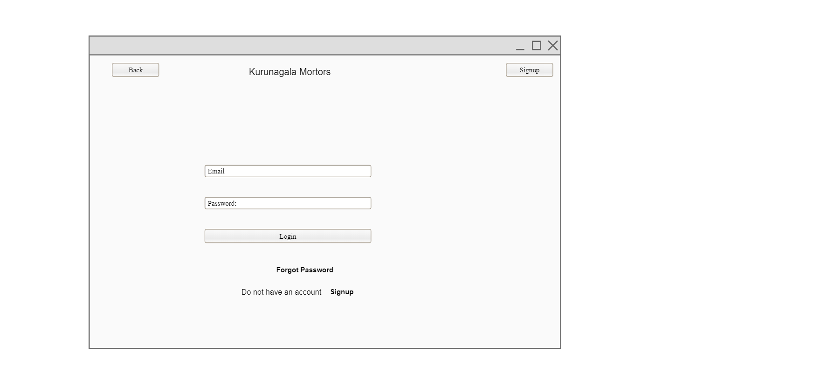

Figure 68: Login page for proposed system

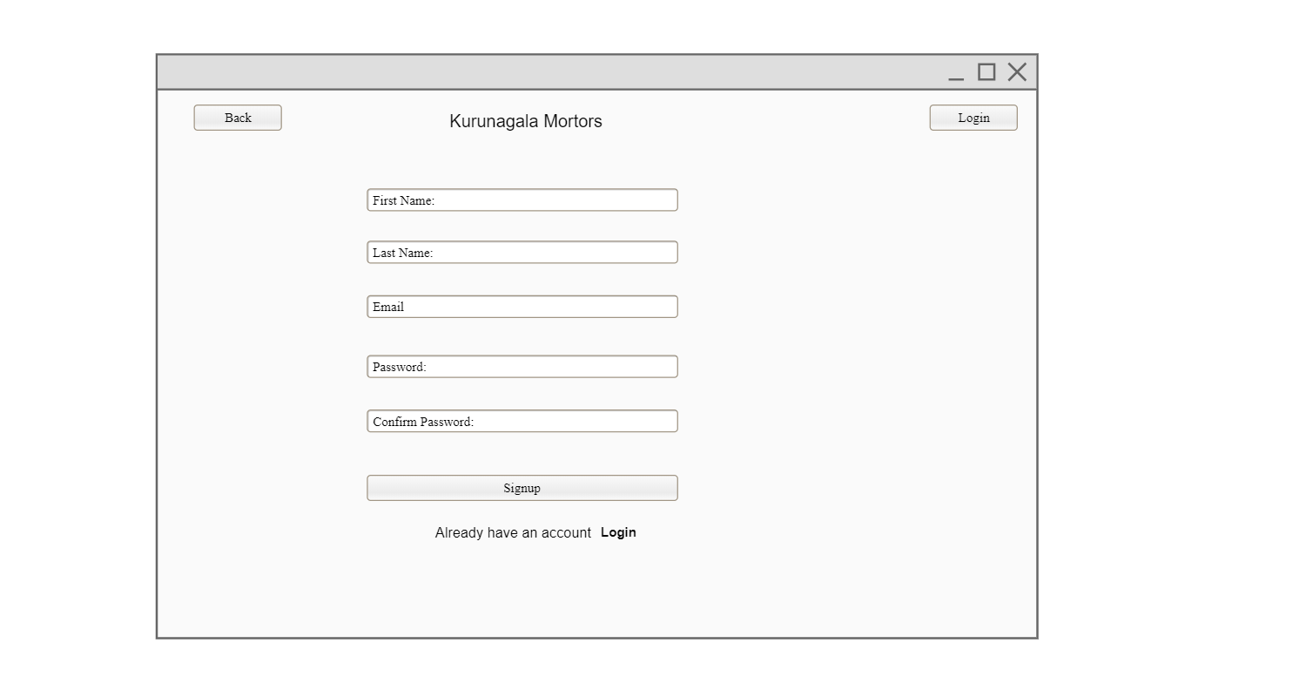

Figure 69: Register page for proposed system

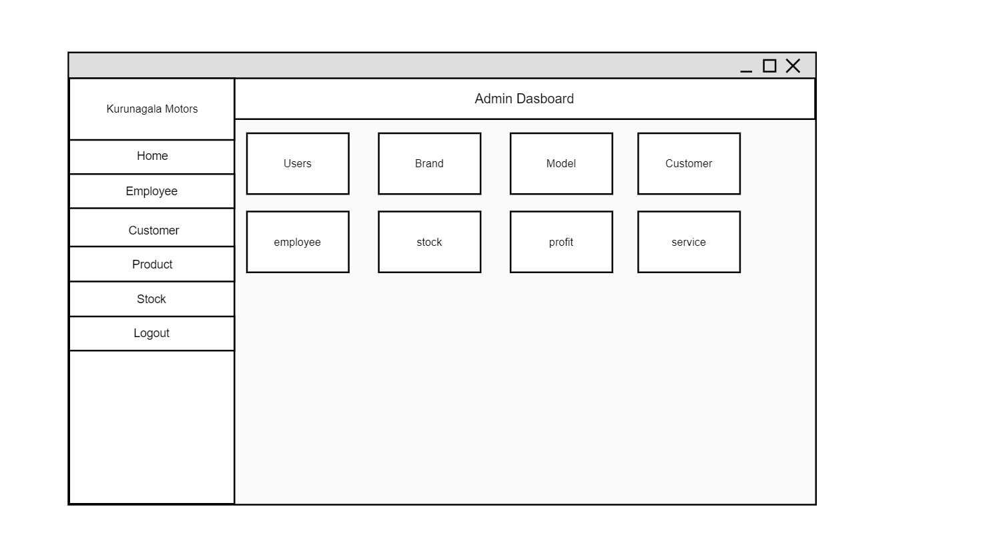

Figure 70: Admin dashboard for proposed system

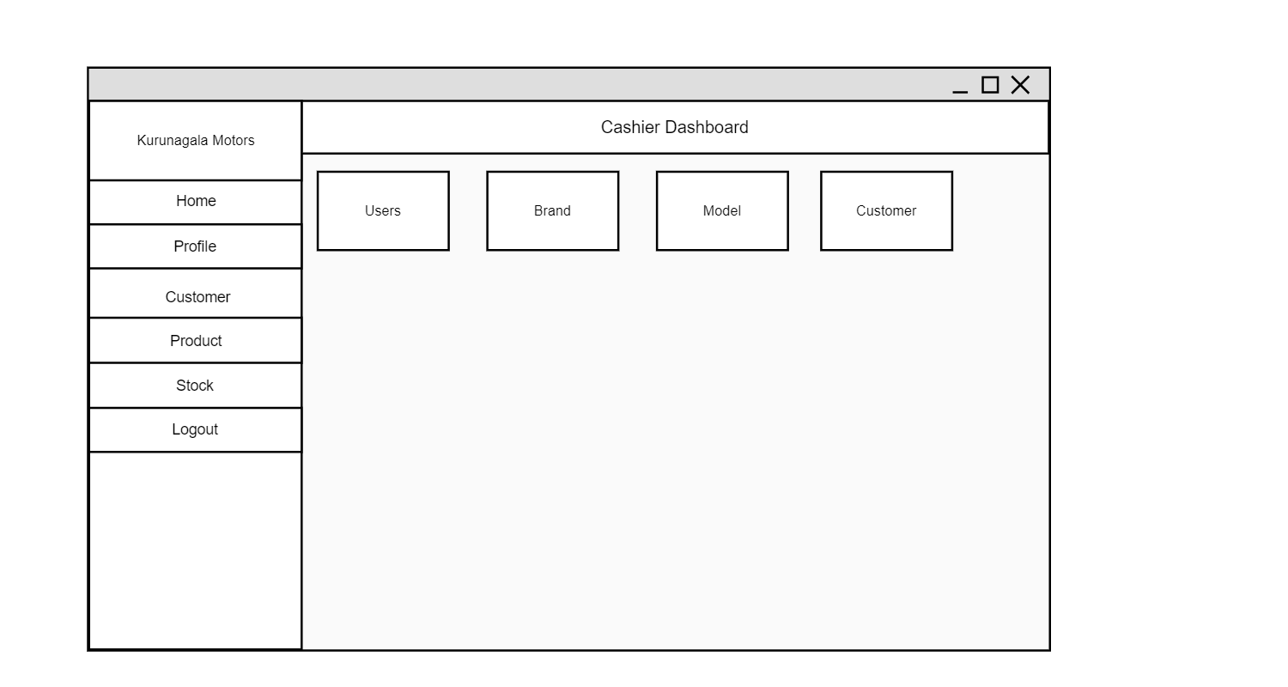

Figure 71: Cashier dashboard for proposed system

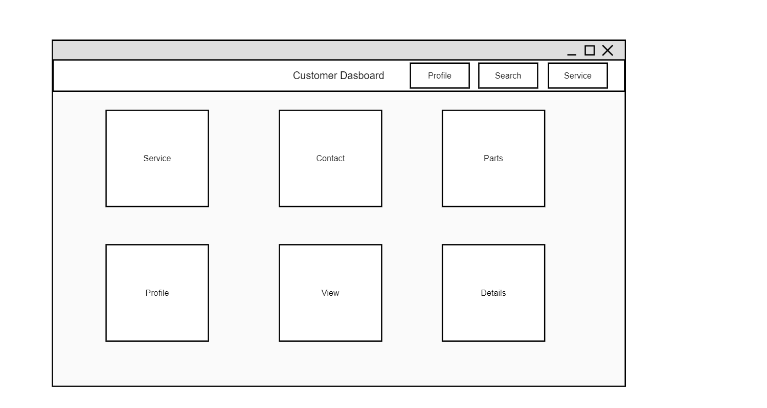

Figure 72: Customer dashboard for proposed system

**Hardware Interface**

Internet connection.

Desktop computer or laptop.

Processor i3 or above

2 GB RAM

**Software interface**

Windows 10 or newer version of windows operating system

Web browser (Chrome) for traversing information resources

Visual Studio Code - Text editor

Photoshop illustrator- image editing

PHP(Laravel Framework)/HTML/JavaScript/bootstrap

MySQL and XAMP Server must be installed.

**4.4 Communication interface**

CI-1: The Kurunagala Motors Management web based system shall user MySQL database named “motors”

CI-2: The Kurunagala Motors Management web based system users PHP(Laravel framework), JavaScript and bootstrap to generate web pages.

CI-3: When spare parts are low limit send a notification to manager.

CI-4: When customers do not pay the full bill, make notification about customer pending payments

1. **Other Nonfunctional Requirement**

**5.1 Performance Requirement**

* The allowed reaction time for system functioning is defined by performance criteria.
* The load time for user interface screens shall task no longer than two seconds.
* The login information shall be verified within five seconds

**5.2 Safety Requirement**

It's important to keep the details. A backup of the database is required. The recovery technique restores a previous version of the database that was backed up to archival storage and reconstructs a more current state in the event that a wide area of the database sustains substantial damage as a result of a catastrophic failure, such as an application crash.

**5.3 Security Requirement**

The software should be handled only by the garage manager. Only the manager has right to assign permission like creating new employee and roles. Only authorized users can access the system with email and password. The details of user must be safe and secure

**5.4 Software Quality Attributes**

Availability: the Kurunagala motors management web based system shall be available to users all the time.

Correctness: Kurunagala motors management information system should doing correct calculations in salary, bill calculation.

Correctness: The system should satisfy a maximum number of user’s needs.

Flexibility: Kurunagala motors management information system should be flexible enough to provide space to add new feature and to handle them conveniently.

1. **Other Requirements**

All the requirement have been specified

Database: All the data will be stored in a relational database.

**Appendix A: Glossary of terms**

|  |  |
| --- | --- |
| Term | Definition |
| SDLC | System Development Life Cycle |
| DFD | Data Flow Diagram |
| SRS | Software Requirement Specification |
| HTML | Hypertext Markup Language |
| PHP | Hypertext Preprocessor |
| ER | Entity Relationship Diagram |

table 42 : Glossary of term

**Appendix B: Analysis models**

1. **Use case diagram**

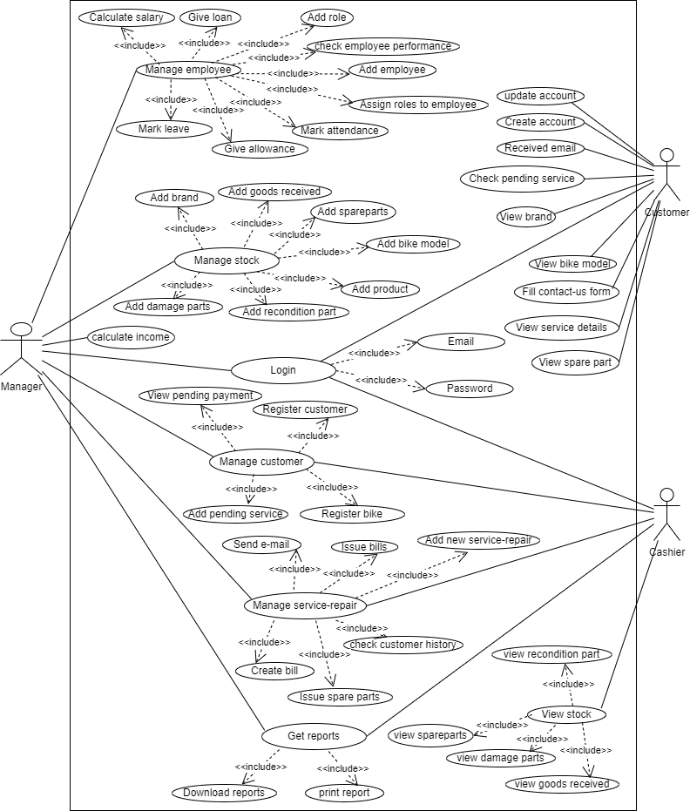

Figure 73: Use case diagram

Appendix C – Class Diagram

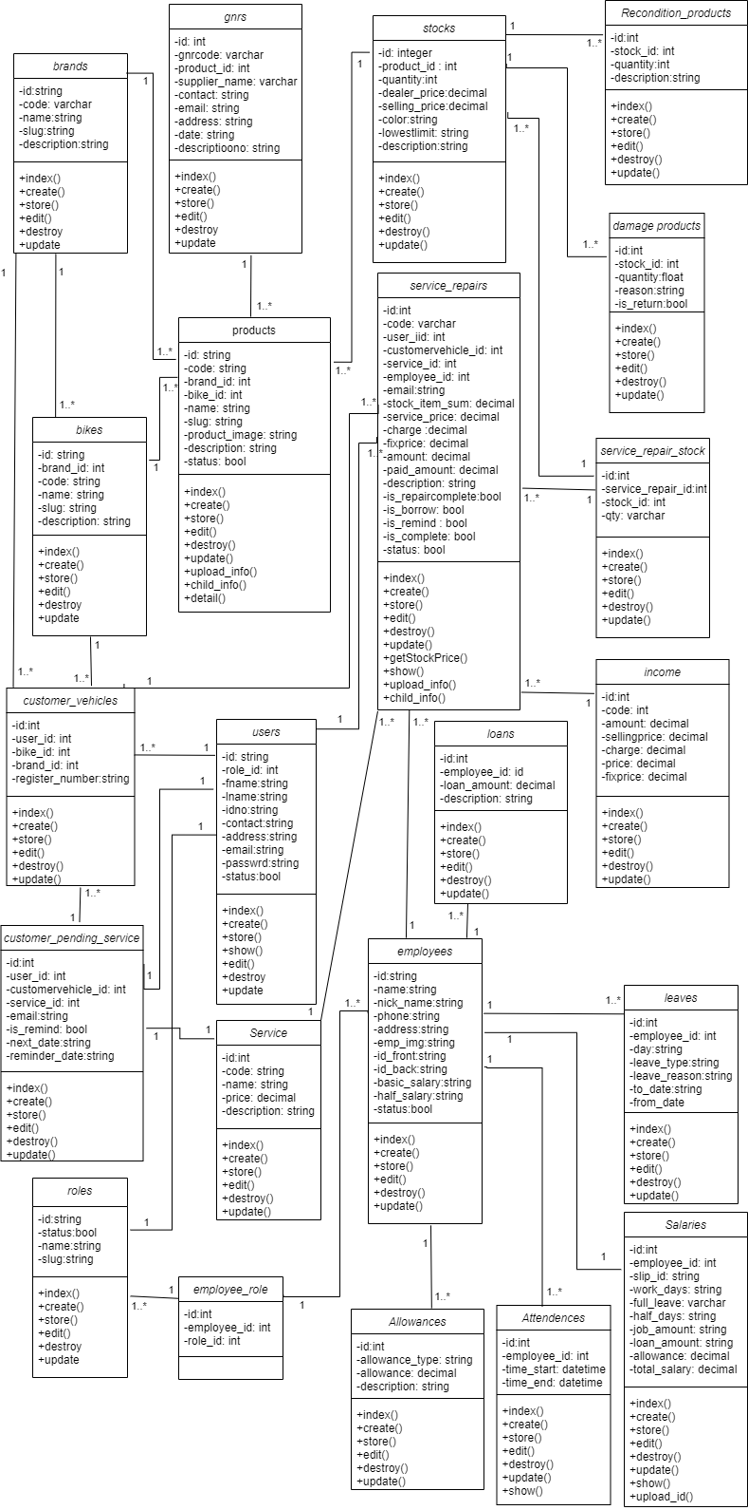

Figure 74: Class diagram

**5.4. Appendix D – Activity Diagram**

Add new employee activity diagram



Figure 75: Add new employee activity diagram

Add new product activity diagram



Figure 76: Add new product activity diagram

Add role activity diagram



Figure 77: Add role activity diagram

Add service activity diagram



Figure 78: Add service activity diagram

Calculate salary activity diagram



Figure 79: Calculate salary activity diagram

Add new user activity diagram



Figure 80: Add new user activity diagram

add service repair activity diagram



Figure 81: add service repair activity diagram

Add customer vehicle activity diagram



Figure 82: Add customer vehicle activity diagram

Add pending service



Figure 83 Add pending service activity diagram

**5.6. Appendix E – ER Diagram**



Figure 84 ER diagram